23/02/21
I am learning to convert pounds and pence.

Have a go at answering the following questions, you could write, draw or use real money to show us.

1) How many different ways can you make £1?

2) How much is each item in pence?
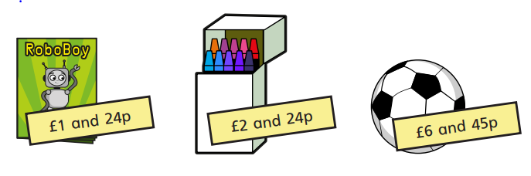
3) Write each amount in pounds and pence – 374p, 591p, 401p

4) What amount is represented in each box?
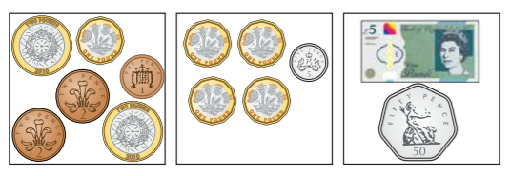

5) a) What is the fewest number of coins you can use to represent 315p?
b) Use 6 coins to make an amount that is more than £3, but less than
£4.

