RE Home Learning – Guidance from Canterbury and Rochester Diocese
KS2 - Term 4 2021
General Principles
When using the suggestions, make sure you adapt them for your context and pupils’ needs. We also suggest that you consider the following questions in making the learning ‘your own’:
- How much teacher input will there be? This will affect how specific the instructions and explanations will need to be.
- How much material is appropriate for your cohort per session? This may mean that you need to adapt the word documents provided but make sure that the learning links and thinking remain clear in doing this.
- How will practical resources be accessed? The suggestions may have to be adapted depending on home circumstances.
- How will you encourage discussion as part of the RE learning as suggested in the plans? This is an important part of developing thinking in RE.
- How much recording would be possible? It might be helpful to encourage this, it is kept simple in the suggestions.
Symbols key

Write

What questions do you have?

Look carefully

Think

Read

Questions to answer and think about

Draw

Teacher input

Tell me more … explain your thinking or answer
KS2 – What is Humanism?
This term we are going to meet Taryn and her family, who are Humanists. We are going to find out about how being a Humanist affects their decisions and choices in life.
Humanism isn’t a religion, but a way of thinking and living. Humanists do not believe in God or gods. They believe that this is our only life, so it is very important to live a worthwhile, happy life for ourselves and others.


Hi! My name is Jayden, and I am in year 2. This is my Dad Toben.
Hi! My name is Taryn, and I am in year 5. This is my Mum Sarah and my baby sister Thandi.

Week 1 - Learning question: What is Humanism?
What questions do you have about this week’s learning question? Add your thoughts and questions to the thought bubble.

What is Humanism?

Read this quote from Stephen Fry, who is a Humanist.
‘A humanist is someone who will never tell you what to believe. We will never tell you what is absolutely true. We will never make claims that cannot be proven and that you cannot find out for yourself. We believe life is an adventure and that nobody knows the answers or the destination.’
Stephen Fry, Patron of Humanists UK
What things do you think are important to Humanists? Underline any words in the quote, which help you with your answer

These statements are our beliefs as Humanists.
Read them carefully.
- We believe science provides the best way to understand the world.
We do not believe there is a god or believe we cannot know if there is a god.
- We do not believe in an afterlife, and therefore believe we should make the most of the one life we know we have, and respect different people’s choices and ways of life.
- We believe we should use reason and empathy when deciding how to behave.
- We value humanity and celebrate human achievements. (scientific, artistic, social)

What questions do you have about these beliefs and values?

Humanism is not a religion. It is a philosophy or an approach to life. Humanists don’t see any good evidence that a god or gods exist. They are therefore atheists (they don’t believe in a god or gods) or they are agnostics (they believe we can never know if a god or gods exist).

Humanism, however, is more than just not believing in a god. Humanists also have many positive beliefs about how we can understand ourselves and the world, and how we should live our lives.

For me, the most important thing is not whether I believe in a god or not, but it is how I live my life. Humanists believe we can be good and happy without the need for gods or religion.

Many humanists like to ask and think through big questions of life.
Think through these big questions with Taryn.
Add your thoughts around the question bubbles.

Does it matter whether you believe in a god or not?
Is how you live your life more important?

Week 2 – Learning question: What do Humanists value?

Read this quote by Richard Norman, a Humanist philosopher.

The satisfaction of creative achievement… the excitement of discovery…relationships with others…the life of the emotions… the enjoyment of beauty in art and nature… These, we know, are the things which enrich our experience.

What does it tell you about what he values as a Humanist?

Taryn and her family are going to share with you what they value.
Read what they say to help you answer the question ‘What do Humanists value?’
Underline the important words in each quote to help you.


I do not believe in an afterlife, so this life is everything to me. We should find what makes us happy and make the most of our lives. We should also try to help others to do the same.

For me, freedom is one of the most important things in life: freedom to live my life however I wish, as long as I do not cause harm to others. All human beings have the freedom to find their own way to make their lives feel meaningful.

The most important thing in life is forming good friendships and relationships with others. The human community is also important, and we should remember that all human beings around the world are part of one extended family. one extended family.

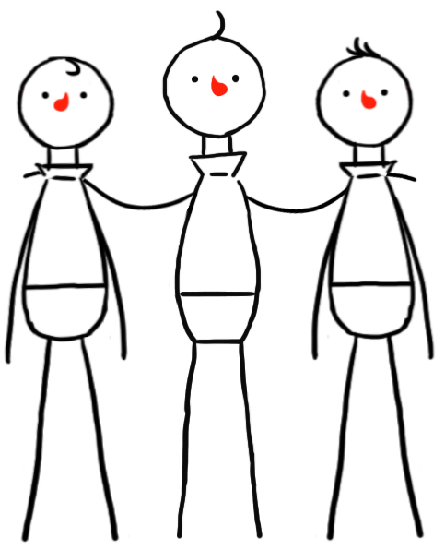


We are all part of humanity and part of the human story. We are all linked across time to our ancestors and our descendants. Human beings have made incredible progress and we should aim to help our children and their children continue that progress. That is the human spirit.

Human beings should celebrate the many intellectual and creative achievements of humankind, such as science, medicine, technology, art, music, and literature. We should try to make the most of our talents and abilities and be optimistic about what we might achieve in the future.



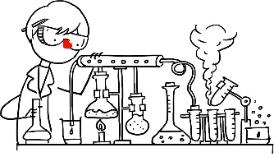

Humanists believe in a world that promotes democracy and human rights. We believe in the importance of equality and social justice. We should work to improve the quality of life for all human beings. Empathy can help me to see how I would like to be treated if I were in somebody else’s situation. We should take care of each other.


I value the natural world around me. Without it we would not survive, and this world is the only one we have. It is a source of beauty and wonder, and we should take care of it.

I value our curiosity and our capacity to ask questions. By looking for evidence, and thinking carefully about the answers, we have been able to discover so much about our world and ourselves and have been able to improve the quality of our lives.



‘What do Humanists value?’
Make a list of all the things that are important to Humanists.

Challenge - Design a humanist building
Humanists have no special places of worship. Many take great pleasure in the wonders of the natural world and believe thinking about nature can also help them to recognise their place in the world.
Many also have great admiration for the many spectacular achievements of human engineering and architecture that can be found all around the world. They stand as symbols of what human beings are capable of.
Many humanists also value libraries, schools, colleges, hospitals, museums, sports facilities, council buildings, and parliamentary buildings as places of public value.
These buildings bring people together to learn, to play, to support each other, or to work for the common good. All of these are activities and goals that many humanists believe we should pursue.

Design a building that represents things that humanists value. Think about all the things you read and learned about Humanist values to help you design this building.
- What might that building be like?
- What would the building be for?

Some questions to think about as you plan your building:
- Should a humanist building hug the Earth or reach for the stars?
- Should a humanist building focus more on humanity or the natural world?
- Should a humanist building reflect individual freedom or our connections with other humans?
- Should a humanist building fit with the surroundings or stand in contrast to them? Does it depend on what the surroundings are (e.g. urban or natural)?

Things to consider...
- Location: Where would it be?
- Exterior: What would the outside look like? What is the relationship between the inside and the outside? Should the exterior say something about the purpose of the building? How should the building be accessed?
- Interior: How would the rooms be organised inside and how might they be decorated?
- Other features: What else would there be inside and outside the building? Would there be any words, images, or symbols?
- Activities: What would the building be used for?

Look at these examples of buildings that reflect Humanist values.
What Humanist values can you spot in them?
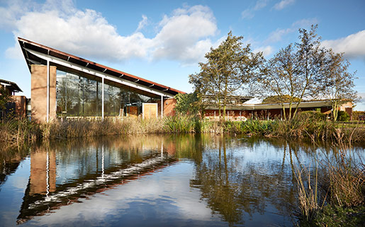
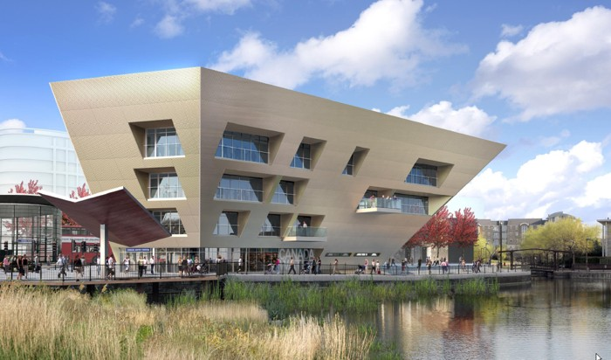

Canada Water Library
Rooted in the ground and nature. Lots of natural light.
Accessible to everyone.
Encouraging aspiration and learning.
Telford Crematorium
The glass wall in the main assembly room allows mourners to gaze out at the surrounding natural landscape, to take comfort from it, and to feel at one with it.

Designs for a humanist retreat
Hannah Flory, Chris Gaunt, and John Cox, University of Liverpool

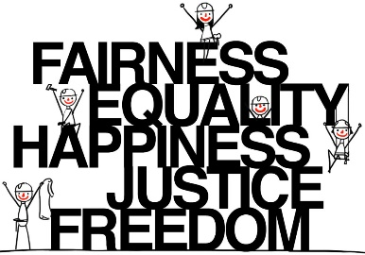
Design a building that reflects Humanist values
Tell me about your building design.
How does it reflect Humanist values?

Week 3 - Learning question: Why is happiness important to Humanists?
What does happiness mean? (You can’t use the word happy or happiness in your answer!)

How would you describe happiness?

Here are some possible ingredients of happiness.
- Do you agree?
- Would you add anything else?
- Which ones do you think might not make people happy?





£






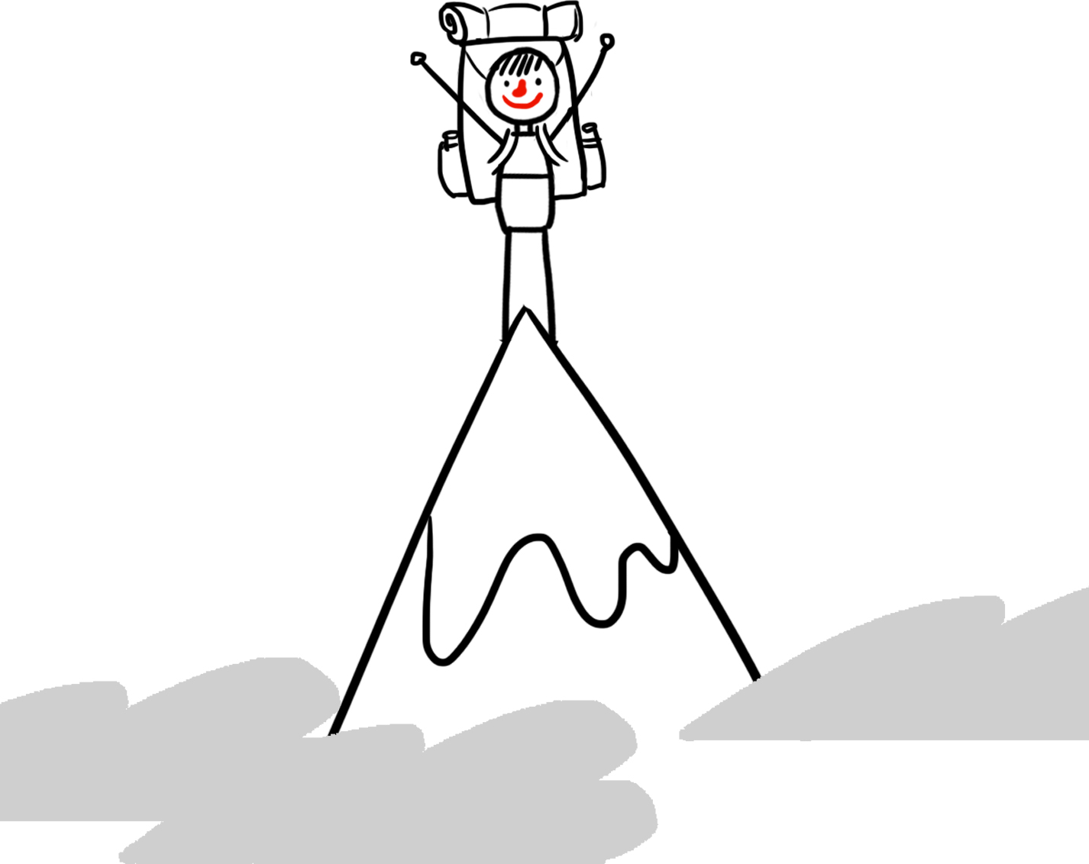










- Which of these ingredients do you think is the most important for happiness?
Tell me more about your choice

- Put a cross through the ingredients that you do not need to be happy.
Tell me more about your choices

- Which three happiness ingredients might be the most important for a Humanist?
Tell me more about your choices
Choice 3
Choice 1
Choice 2

Reason
Reason
Reason

Many Humanists like to think through big questions about life. Taryn is also thinking about happiness.
Think with her through these questions.
Write your thoughts around the thought bubbles.
Is it possible to make everyone happy?
What is the best way to stop people being unhappy?
What sorts of things stop people from being happy?

Is it ok to sometimes not be happy?
I wonder what makes you happy?

Humanists believe that we can all find our own different ways to be happy as long as we don’t harm other people or prevent others from being happy.
Food, drink, and games can be an important part of a happy life.
But more important are making good friends, learning new things, fulfilling our goals, and making others happy.

Read this poem.

‘Happiness is the only good.
The place to be happy is here.
The time to be happy is now.
The way to be happy is to make others so.’

Robert Ingersoll (1833 – 1899)
What does this poem teach you about humanist beliefs about happiness?

Think about everything you have learned in this lesson to help you answer this question: Why is happiness important to Humanists?



How and why do Humanists try to spread happiness?
Humanists do not have holy books or figures of authority to tell them what to do or how to be good. They believe reason and empathy can help them understand how they should behave.

Reason: | thinking about the potential consequences of our actions.
Empathy: | considering how others will feel.

To help us know how to behave, my family tries to follow the Golden Rule.
Treat others as you would like to be treated yourself.

Why do you think it is called the Golden Rule?

If people followed the Golden Rule, how might they be sharing happiness?



‘Treat others as you would like to be treated yourself’ is called the Golden Rule, as this teaching and expectation of behaviour is found in almost all religions, worldviews, and cultures.
I try to do good things because, treating others well makes them happy and making other people happy can make me happy.

I also believe that if everyone tries to do the right thing, we can make the world a better place.

Think through each of these stories and consider about how Taryn would behave if she followed her Humanist beliefs and values.
What would Taryn do and why?
You are playing in a football match and the score is 1:1. In the final minute your teammate crosses the ball to you. You are not confident at heading the ball, but you can reach it with your hand and punch it into the goal. The referee is looking the other way. What should you do?

There is a new boy in your class, who seems really shy and worried. At breaktime you notice they are on their own, but your friends tell you not to go over to him as you already have enough friends.
What should you do?

Your baby sister is crying, and your Mum is trying to cook dinner. You are halfway through a computer game where you are winning. Do you go and sit and play with your baby sister or do you complete the computer game first?

You really want the new album by your favourite band, but you don’t have enough money to buy it. A friend says he knows a website where you can download it for free. He says it’s not the same as stealing. What should you do?

Think about everything you have learned in this lesson to help you answer this question: Why do humanists think they should be good to each other?

I wonder what learning about Humanists has made you think about?

I wonder if you have any other questions about Humanism?

