
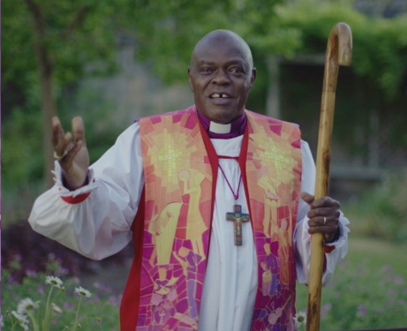
Learning question: How do Christians today try to create a world that Jesus would want?
Rev. Dr. John Sentamu was the Archbishop of York from 2005 to 2020.
The Archbishop of York is a very important role. It means you are the senior Bishop in the Church of England and oversee all the churches and Vicars in the north of England.

When Rev. Dr. John Sentamu was the Archbishop of York, he cancelled his family holiday to camp out in a tent inside York Cathedral for seven days to pray and fast.
(Fasting is when people choose to go without food for a period of time to focus on God and prayer.)

Why do you think he did that?
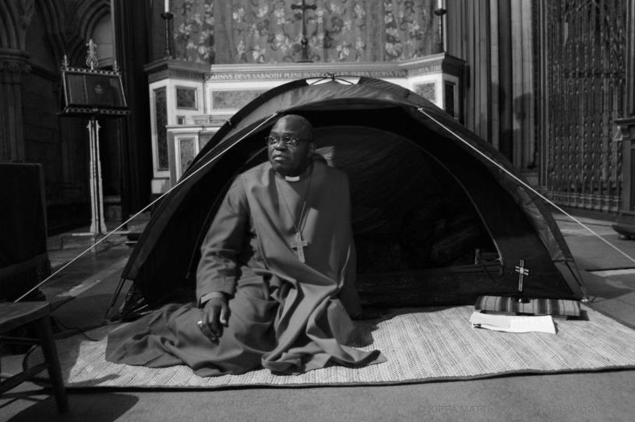


What does this tell you about who Dr John Sentamu is?


Use these clues to work out why Dr John Sentamu camped out in the Cathedral for a week.
Jesus rode on a donkey into Jerusalem as a sign of humility. | The situation in Lebanon was getting worse and many people were suffering. | John Sentamu had to flee from Uganda after threats from the government.
John Sentamu wanted people to take notice of what was happening in Lebanon. | John Sentamu believed that prayer works. | John Sentamu wanted to make politicians sit up and take notice; he cancelled his holiday.
John Sentamu thought that acting out his beliefs would attract more attention that preaching a sermon. | 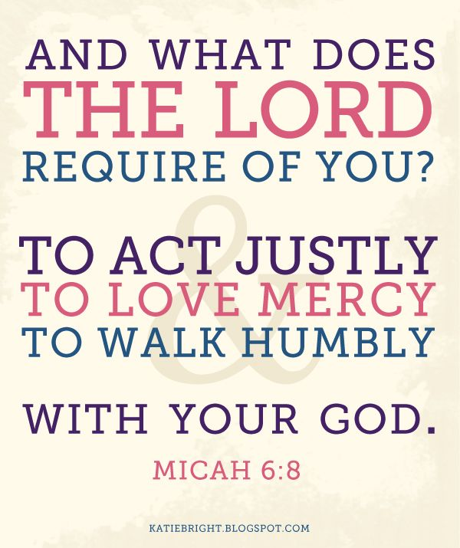 | Jesus taught that prayer and fasting was the best way of dealing with difficult situations.
‘Dear children, let us not love with words or speech but with actions and in truth.’  (1 John 3:18) | In the Old Testament prophets often acted out the messages God had for his people. | “This act is a rallying call to people of all faiths and none, to encourage them to feel that there is something that can be done”  John Sentamu
John watched a TV programme about the crisis in Lebanon. | John Sentamu decided to fast and pray for seven days to draw attention to the problems in the Middle East | Jesus taught that his followers should treat others as they would like to be treated.
Why did Dr. John Sentamu hold a vigil in the Cathedral for a week?


Read this article that explains why Dr John Sentamu held a vigil in the Cathedral.

The Archbishop of York has moved into a tent in York Minster as part of an act of "public witness" to encourage peace in the Middle East.
Dr John Sentamu will live on a liquid diet while he camps inside the Minster for seven days, to highlight the plight of people caught up in the conflict.
He has given up a family holiday in Salzburg, Austria, to sleep rough and fast while praying for peace.
To launch the vigil on Sunday he publicly had his head shaved.
Cathedral cleric Canon Glynn Webster used a pair of electric trimmers for the archbishop's haircut, carried out on the altar.
Dr Sentamu said he hoped people from all faiths would join him in praying for peace.
He will lead prayer every hour for seven days, with his fast ending at 1000 BST next Sunday.
He said his actions mirrored those of countless numbers of people caught up in the conflict between Israel and Lebanon, who were having to sleep rough and without proper food.
'Common humanity'
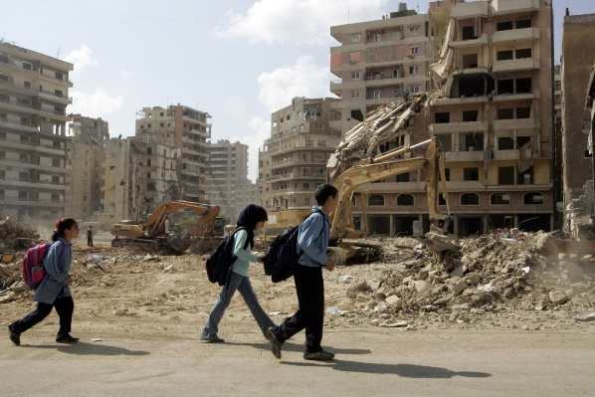
More than 1,000 Lebanese and more than 120 Israelis have been killed in the conflict since Hezbollah militants captured two Israeli soldiers on 12 July in a cross-border raid.
Dr Sentamu said: "This act is a rallying call to people of all faiths and none, to encourage them to feel that there is something that can be done.

This act is a rallying call to people of all faiths and none, to encourage them to feel that there is something that can be done
John Sentamu
"The UN has a role; diplomacy has a role, and our government has a role to play in bringing this conflict to an end.
"But we as people also have a role to play in showing our common humanity with all those who are suffering."
Dr Sentamu is also urging people to give up a meal and donate the money to charities that are working in the crisis region.

A vigil - a period of keeping awake during the time usually spent asleep, especially to keep watch or pray.
Fasting - is when people choose to not eat or drink for a period of time to allow them to focus on God and prayer.
How was Dr John Sentamu trying to create a world that Jesus wanted?

