Innovating Ideas – The story

What happens in Stone Trolls | The Underlying Plot Pattern
- Trolls hiding from people in caves  - Shouldn’t go out in day light because they will be turned to stone | • Group of characters warned not to do something
• One stormy night, Skess &  Landra go to cliffs by beach | • 2 main characters (MCs) introduced and the setting is described
- Skess sees ship in trouble at sea  - They decide to go and rescue ship | • MCs see someone or something in danger in the setting
• Skess & Landra save crew of ship | • MCs save them
- Suddenly, morning arrives – trolls turned to stone  - This explains stone pillars on beach | - Terrible things happen to MCs because ignored warning  - This explains feature in landscape

Now, let’s think about writing a new version of the story.

The ‘Stone Trolls’ could be described as a ‘Warning Story’.
The trolls are hiding from people and are warned not to go outside in the day light as they will be turned into stone. They ignore this warning!

In the ‘Stone Trolls’, the story explains where the rocks on the beach came from. There are other interesting things on the land that you could pretend were once trolls that tried to help people but were caught out when the sun came up!

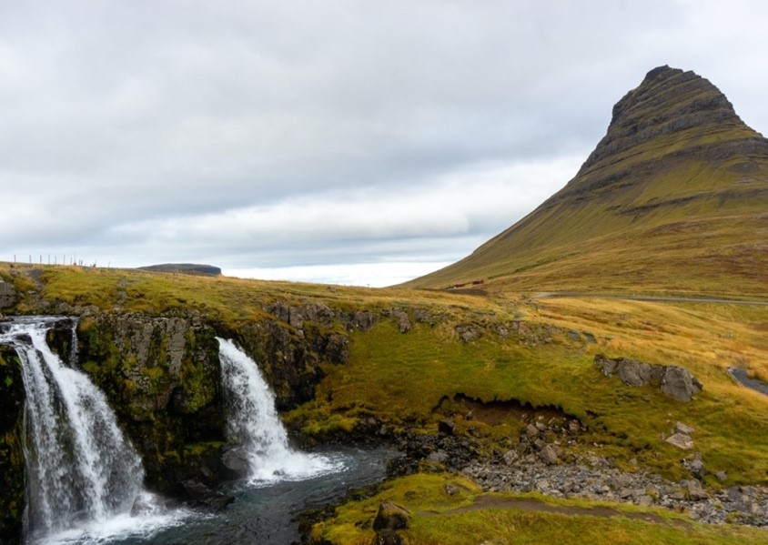
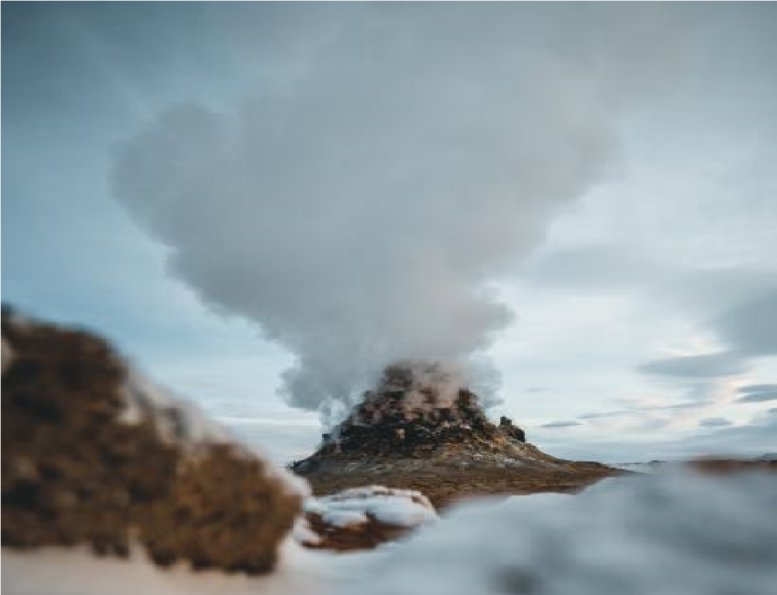
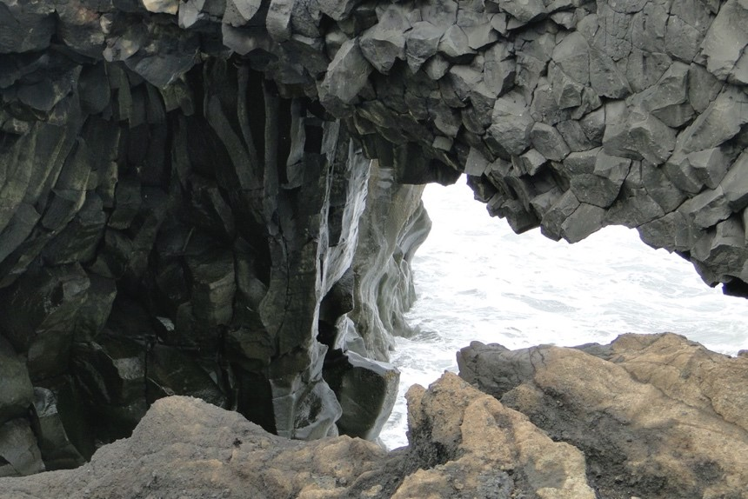
Here are some new story ideas:

Idea 1

The volcano
This could have once been a troll who was furious when the sun came up!
Troll was trying to save some walkers lost in the mountains.

Idea 2

The cave
This could have once been a shocked troll caught with their mouth open when the sun rose! Troll was trying to save some people walking near the edge of a cliff.

Idea 3

The waterfall
This could be the tears of a very sad troll caught as the sun came up! Troll was trying to save people swimming in the river.

Idea 4
The tallest rock on the cliffs This could once have been a very helpful king of the trolls who was rooted to the ground when the sun rose!
King Troll was acting as a lookout.

Idea 5
You could use where you live. Are there any interesting buildings, hills, rivers etc that you could imagine were once trolls? Is there anyone you want to turn into a stone troll!
Here is the underlying plot pattern again with my new story idea
Stone Trolls plot | The Plot Pattern | My new story plan
- Trolls hiding from people in caves  - shouldn’t go out in day light because they will be turned to stone | • Group of characters warned not to do something | - Trolls hiding deep in forest away from people  - Warned not be out in rain because will turn into tall trees
• One stormy night, Skess & Landra go to cliffs by beach | • 2 main characters (MCs) introduced and the setting is described | • One summer day,  trolls, Fir & Oak, out walking in forest, looking for food
- Skess sees ship in trouble at sea  - They decide to go and rescue ship | • MCs see someone or something in danger in the setting | - Fir sees children climbing trees - one is stuck  - Oak Fir decide to climb tree to save  them
• Skess & Landra save crew of ship | • MCs save them | • Fir & Oak save children
- Suddenly, morning  arrives – trolls turned to stone  - This explains stone pillars on beach | - Terrible things happen to MCs because ignored warning  - This explains feature in landscape | • Suddenly, there is crack of thunder and it starts to rain. Fir & Oak turned into tall  trees

Now Plan your Story!
- Use the planner below to jot down some ideas for your own version of the story.
- You could use my story idea above or the other ideas.
Stone Trolls | The Plot Pattern | Your new story plan
- Trolls hiding from people in caves  - shouldn’t go out in day light because they will be turned to stone | - Group of characters warned not to do something  - See new story ideas! | - Trolls hiding from people.  - They shouldn’t ……. because they will be turned into ……..
• One stormy night, Skess & Landra go to cliffs by beach | - 2 main characters (MCs) introduced and the setting is described  - Think of some good troll names.
- Skess sees ship in trouble at sea  - They decide to go and rescue ship | - MCs see someone or something in danger in the setting  - What might be a dangerous thing to do in your new setting?
• Skess & Landra save crew of ship | • MCs save them
- Suddenly, morning  arrives – trolls turned to stone  - This explains stone pillars on beach | - Terrible things happen to MCs because ignored warning  - This explains feature in landscape

