Learning Question: What happens at the Amrit ceremony?

For Sikhs, taking Amrit and becoming a Khalsa today is a choice, and a commitment to love God with all your heart and to be prepared to sacrifice whatever you have for God.


Watch the video clip of Taren and Jovan as they go through the Amrit Ceremony. https://youtu.be/ZIm7F0t8FrA


- Why did Taren and Jovan want to become part of the Khalsa?

- What promises did they make during the ceremony?

- How did Taren feel when feel before, during and after his Amrit ceremony?

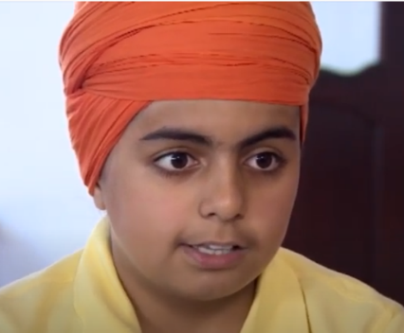


Imagine you are Taren. Write a letter to a friend, who is not a Sikh, to tell them what happened during your Amrit ceremony and how it made you feel. Make sure you tell them why you wanted to become a Khalsa Sikh and what it means to you to be a Khalsa Sikh.
Here are some words to help you.

Amrit | Sugar water | Khalsa | ceremony
Blessed | Sprinkled | Stirred with a kirpan | 5 Khalsa Sikhs
Guru Granth Sahib | Gurdwara | family | 5 K’s

Learning Question: What signs do Sikhs use to show their faith?
Some people wear uniform to identify the job they do, the school the attend or group they belong to.
Sikhs have visible symbols that show that they are part of the Khalsa and have committed their life to God.

Watch this clip as Simran and Taren tell you about the 5K’s – the outward symbol that Sikhs belong to the Khalsa community.
https://youtu.be/QYW10gv3jm0

- What are each of the 5k’s and what does each one symbolise?










- Do you think the 5K’s are important to Sikh people?


Tell me more about your answer.

