RE Home Learning – Guidance from Canterbury and Rochester Diocese
Term 3 2021
General Principles
When using the suggestions, make sure you adapt them for your context and pupils’ needs. We also suggest that you consider the following questions in making the learning ‘your own’:
- How much teacher input will there be? This will affect how specific the instructions and explanations will need to be.
- How much material is appropriate for your cohort per session? This may mean that you need to adapt the word documents provided but make sure that the learning links and thinking remain clear in doing this.
- How will practical resources be accessed? The suggestions may have to be adapted depending on home circumstances.
- How will you encourage discussion as part of the RE learning as suggested in the plans? This is an important part of developing thinking in RE.
- How much recording would be possible? It might be helpful to encourage this, it is kept simple in the suggestions.

Symbols key
Write

What questions do you have?

Look carefully

Think

Read

Questions to answer and think about

Draw

Teacher input

Tell me more … explain your thinking or answer

Year 5 – How can following God bring freedom and justice?
Introduction
The unit for this term is based on the Christian concept of People of God.
The concept People of God is the story of God’s people in the Old Testament.
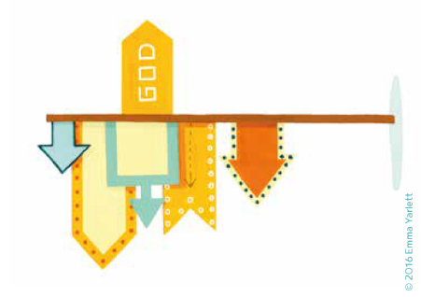
Look carefully at the icon card for the Christian concept People of God.
- What do you notice?
- What do you think it represents?
- How does it help you understanding of People of God?

Look carefully at the Big Frieze panel representing People of God
- What do you notice?
Annotate the frieze panel with your thoughts and questions about it.
- Which Old Testament Bible stories can you spot?
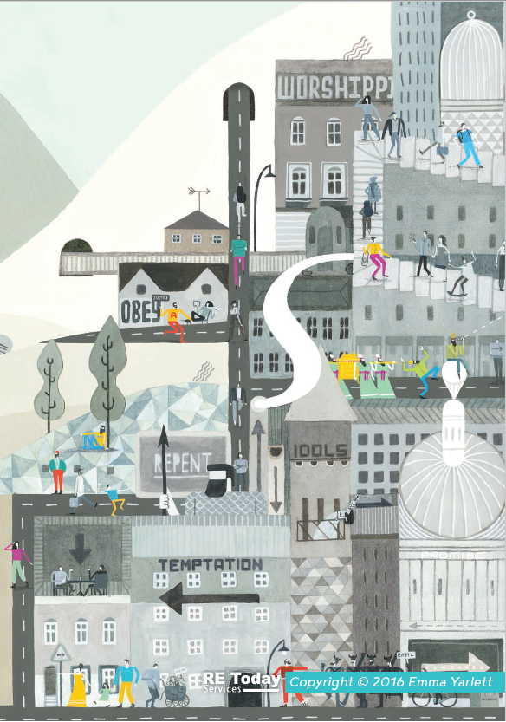
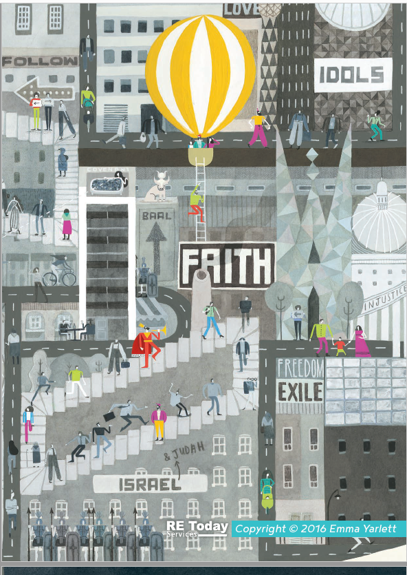

Think about the big question for this term: How can following God bring freedom and justice?
- Write a few words or phrases that come to mind when you read this question.
- What questions do you have about the big question for this term? What do you think you will need to find out to answer it?

How can following God bring freedom and justice?

Write the words ‘freedom’ and ‘justice’ on different sheets of paper. Look at the definition from the dictionary below and then write as many associated ideas around them as you can – other similar words, famous people that these words remind you of, action words associated with these key words.

Freedom | Justice
The condition or right of being able or allowed to do, say, think, etc. whatever you want to, without being controlled or limited.  People are trying to bring freedom to refugees living in Syria. | Fairness in the way people are dealt with or treated.  Black Lives Matters protestors are seeking justice for those who have been treated unfairly.
- Why might people seek for freedom or fight for justice in our world today?

- Why might Christians seek for freedom and fight for justice in our world today?

SESSION 1: Why did God’s people need freedom and justice?
God’s people, the Israelites (they were also called Hebrews) were living in Egypt as many of them had moved to live there when a famine hit Israel under the rule of Joseph. The Israelites grew strong and prospered in Egypt.
Read this Bible passage to find out what happened next to the Israelites.
Exodus 1: 8- 14
⁸ Then a new king began to rule Egypt, who did not know who Joseph was. ⁹ This king said to his people, “Look! The people of Israel are too many and too strong for us to handle! ¹⁰ If we don’t make plans against them, the number of their people will grow even more. Then if there is a war, they might join our enemies and fight us and escape from the country!”
¹¹ So the Egyptians made life hard for the Israelites. They put slave masters over them, who forced the Israelites to build the cities Pithom and Rameses as supply centres for the king. ¹² But the harder the Egyptians forced the Israelites to work, the more the Israelites grew in number and spread out. So, the Egyptians became very afraid of them ¹³ and demanded even more of them. ¹⁴ They made their lives bitter. They forced the Israelites to work hard to make bricks and mortar and to do all kinds of work in the fields. The Egyptians were not merciful to them in all their painful work.
²² So the king commanded all his people, “Every time a boy is born to the Hebrews, you must throw him into the Nile River, but let all the girl babies live.”

- Why did the Israelites become slaves? Was it their fault?
- What must it have been like to be a slave in Egypt?

- What things do you think they could not do as slaves?

This is a painting was found in Ancient Egypt. It shows the Israelite slaves working with the Egyptian slave owners watching over them.
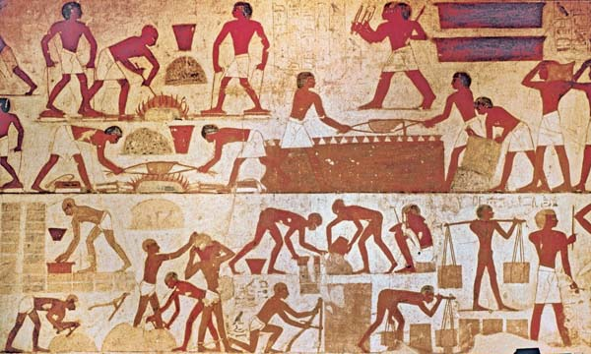

Annotate the image with some thoughts and feelings of the Israelite slaves.

Thinking about all you have learned and read in this session, answer this question as fully as you can.
- Why did God’s people need freedom and justice?

SESSION 2: How does the story of Moses from the book of Exodus help our thinking about freedom and justice?
What do you know about the story of Moses from the Old Testament?
Look carefully at this image and think about what you can remember. What do you notice? Use the words below to help you talk about this image.
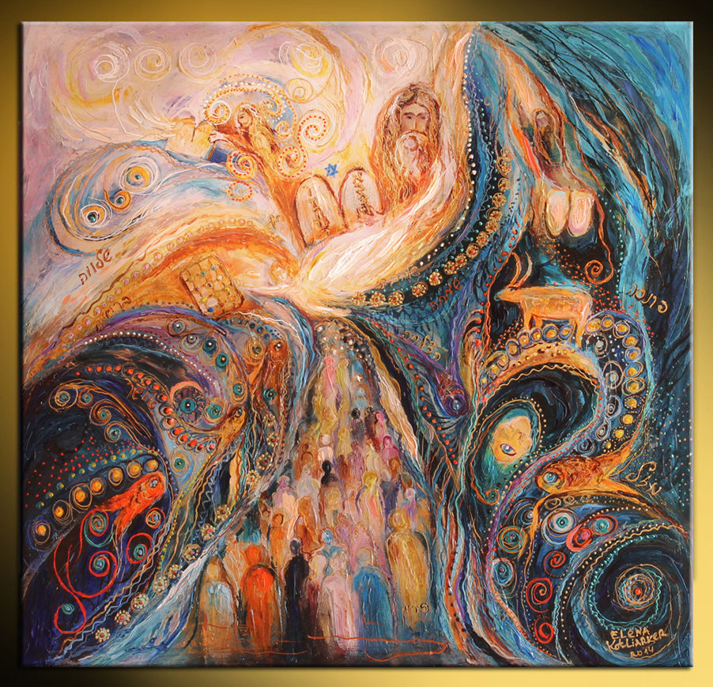

10 commandments | Prince of Egypt | Moses basket | Burning bush
10 plagues | Freed the Israelite slaves | Hebrew family | plagues

Using Bible Gateway https://www.biblegateway.com/ look up each of these Bible passages that tell the life of Moses. (Click on the hyperlink)
Read each part of the story of Moses.
Summarise and write or draw that part of the story in each box.
Exodus 2:1-10 | Exodus 2: 11-15 | Exodus 3:1 to Exodus 4:17

https://www.bibleinfo.com/en/questions/what-are-10-plagues-egypt (video summary of Exodus 7-12)

Exodus 12:33-42 | Exodus 15:1-20


Watch this video clip to help you visualise the story of Moses. Bible Quest: Moses « RE:start (request.org.uk)

- How did God, through Moses, bring freedom and justice to God’s people?

- What difference do you think freedom and justice had on the lives of the Israelites?

Think back through the story of Moses. Where can you spot these key themes in his story?
freedom | god | suffering | Leadership
vulnerability | obedience | evil | greed

Thinking about all you have learned, read and thought about in this lesson, answer this question:
- How does the story of Moses from the book of Exodus help your thinking about freedom and justice?

- Thinking about the story of Moses, how did following God bring them freedom and justice?

SESSION 3: Why did God give his people the 10 commandments?
After the Israelites left Egypt, they wandered around in the wilderness desert, waiting to go into the land God had promised them.
God spoke to Moses at the top of Mount Sinai in the wilderness and gave him the 10 commandments. The commandments were a set of rules to guide God’s people in the best way to live.
Read the Bible passage below, where God sets out the 10 commandments.
Highlight which of these rules are about God and which of them are about other people in two different colours.
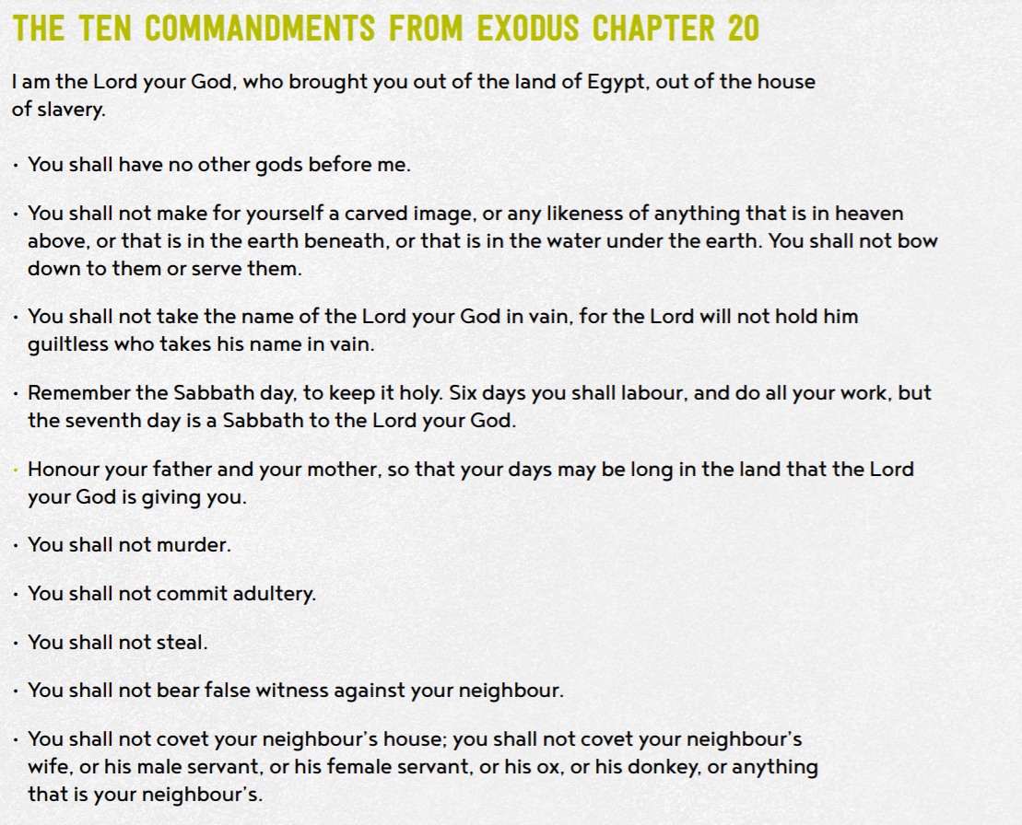

- Why do you think God gave his people these rules?
How must God’s people have been behaving to need these rules?

- Why do you think these rules might have been important for God’s people?

- What might have happened if God had not have given his people the 10 commandments?
Give 3 good reasons why Christian and Jewish people think the 10 commandments are still important today.

Give 3 reasons why an atheist (a person who does not believe in the existence of God) might think the 10 commandments are not important today.

- Do you think they are still important today?
Tell me more about your response and opinion.

- Which of the Commandments do you think would be hardest for a Christian to keep? Explain your choice.

- Which Commandments would have most impact on the world, if everyone followed them.

Thinking about all you have learned, read and thought about today answer this question:
- Why did God give his people the 10 commandments?

SESSION 4: How do Christians apply the ideas of freedom and justice to their ways of living in the world today?
In the New Testament Jesus set out his teaching on how God wanted his followers to behave and act. These were called the new commandments as they encompassed the 10 commandments from the Old Testament into two simple verses.

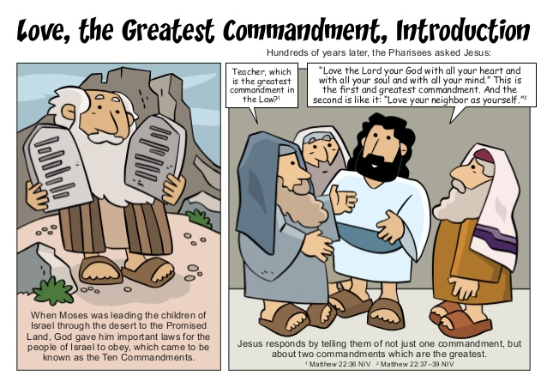
Read this Bible passage from the book of Matthew in the New Testament
Matthew 22:37-40, International Children’s Bible
³⁷ Jesus said, ‘Love the Lord your God with all your heart, soul and mind.’ ³⁸ This is the first and most important command. ³⁹ And the second command is like the first: ‘Love your neighbour as you love yourself.’ ⁴⁰ All the law and the writings of the prophets depend on these two commands.”

- What are the two rules about?

- How do they encompass the 10 commandments given to Moses?

Here are some scenarios to think about. Read and think about each one.
- How might a Christian respond to these if they follow the two commandments Jesus set out?
- How might they end differently if the two commandments were not followed?
Draw or write your responses.

Following the two commandments | Scenario | NOT following the two commandments
 | Someone never lets you join in
 | Someone is in your group for groupwork but behaves badly or messes about
 | Someone who you have never met before but who needs your help e.g. a homeless person
 | When you see a situation of injustice on the news or in your community.
 | When someone is making fun of what you believe

There are many Christian charities who seek to bring freedom and fight for justice for people all around the world.

- Why do you think Christian charities do this work?

Read Orbisa’s story – she lives in Ethiopia with her 2 children.
As you read this story, think about how freedom and justice would help this family.

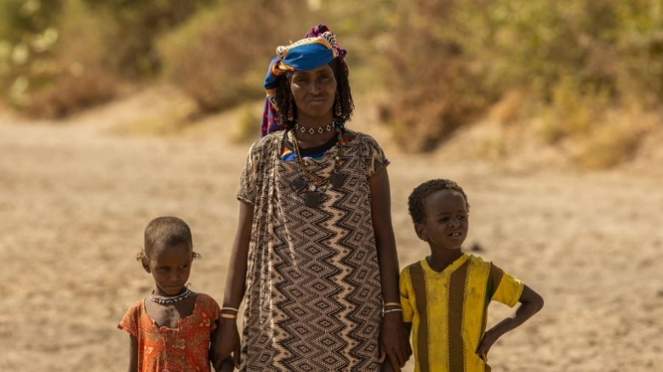

‘Life is very challenging here; we have no food and are dependent on our livestock for our livelihood. Whenever there is no rainfall, our animals die as there is no grass or water. This affects our lives significantly. We will not get money or have milk to drink. We have no other option,’ says Orbisa.
During the rainy season, Orbisa could collect water from a river just five minutes’ walk from her village. As the dry season has extended due to the changing climate, this river has now dried up and no longer provides for Orbisa and her family. ‘The water I collect is not sufficient, I am only able to collect less than half of what my family needs each day’, she says. Now, Orbisa has to walk for up to ten hours every day to collect water for her family. Due to the searing heat, Orbisa is forced to start walking before sunrise, often leaving her village at 4am. The walk is very dangerous as she faces wild animals, including hyenas and leopards.
‘The water I collect is not sufficient, I am only able to collect less than half of what my family needs each day. We need most of it for drinking, but sometimes it is not enough, and my family has to go to bed thirsty. I feel extremely sad whenever I cannot provide water for my children,’ says Orbisa.

Tearfund, is a Christian organisation committed to help Orbisa and other people in similar situations.
Tearfund is changing lives, by working with local partners, like Friendship Support Association (FSA), to set up solar-powered wells that will provide clean water closer to communities. This will help to restore hope and give new life for all who live there. Tearfund’s mission is to follow Jesus where the need is greatest, responding to crisis and partnering with local churches to bring restoration to those living in poverty.

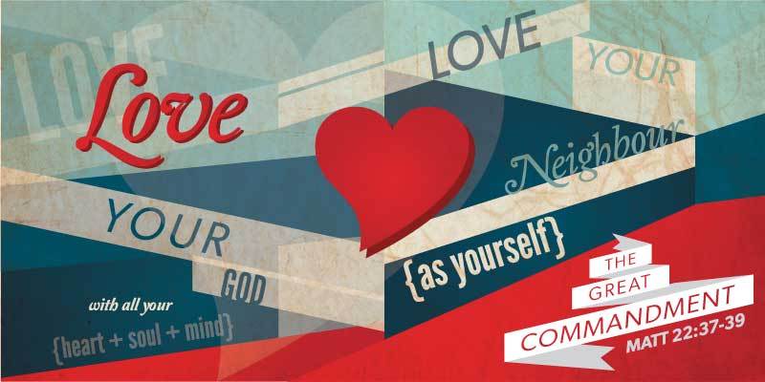

- How is Tearfund living out Jesus’ two commandments for Orbisa?

- How is Tearfund bringing freedom and justice to Orbisa?

Thinking about all you have read, thought about and learned in this lesson, answer this question:
- How do Christians apply the ideas of freedom and justice to their ways of living in the world today?

SESSION 5: How can following God bring freedom and justice?
Following Biblical teaching and the example of Jesus, many Christians around the world seek to bring freedom and justice for everyone.
They do this in many ways; for example, supporting charities who bring resources or education to communities, sponsor children or farming projects, praying with others for situations of injustice, raising money and awareness and supporting fair trade projects.

Isaiah 1: 17
Learn to do right; seek justice.
Defend the oppressed.
Take up the cause of the fatherless;
plead the case of the widow.

- What do you think this Bible verses teaches Christians about how they should act towards others?

Extreme poverty, famine, disease, and failed harvest can result in people feeling trapped or ‘enslaved’ because there seems to be no way out, freedom or hope for the future.
All these examples show how Christians are trying to bring people out of ‘slavery’ and into freedom and hope.

Many people fight for justice for those who are vulnerable, so they can have the same opportunities and resources as people living in other parts of the world.

- Why do you think Christians around the world are fighting for freedom and justice for people?



What’s Fairtrade?
Fairtrade is about better prices, decent working conditions, local sustainability, and fair terms of trade for farmers and workers in the developing world.
By requiring companies to pay sustainable prices (which must never fall lower than the market price), Fairtrade tackles the injustices of conventional trade, which traditionally discriminates against the most vulnerable. It enables them to improve their position and have more control over their lives.
With Fairtrade you have the power to change the world every day. With simple shopping choices you can get farmers a better deal. And that means they can make their own decisions, control their future and lead the dignified life everyone deserves.

- Why do you think many Christians choose to buy Fairtrade products?

Look carefully at this image. By imagining that the world is made up of 100 people, it helps to clearly see the differences in how people live.
What do you notice?
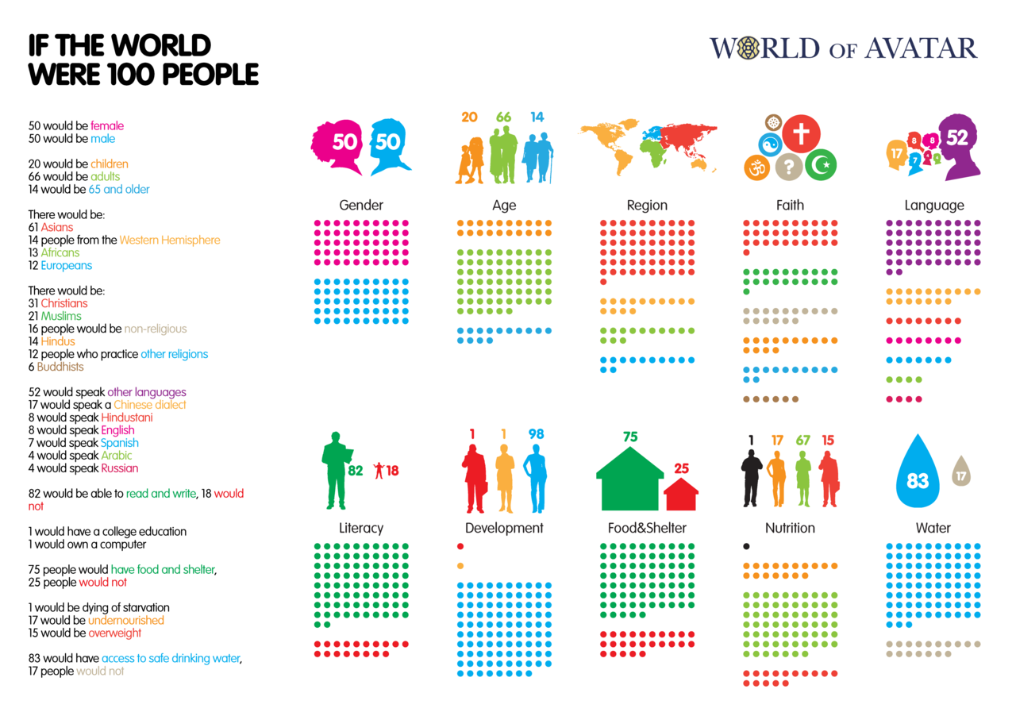

How does it make you feel when you see these figures?

Is it fair that 25 people do not have access to food and shelter?
Is it fair that 17 people do not have access to clean drinking water?
Is it fair that 17 people do not have enough to eat so are undernourished and 1 person would die of starvation?
- What response might a Christian give to these figures?

If you had to write 10 lessons for living to encourage everyone to bring more freedom and justice to others – what would they be?
RULES FOR LIVING
1
2
3
4
5
6
7
8
9
10

Tell me more about why you chose these rules for living.

Thinking about everything you have learned in this unit answer these questions:
- How does following God bring freedom and justice?

- Can people who do not follow God bring freedom and justice?

Tell me more about your answer

