When Pepys explores the Frost Fair:
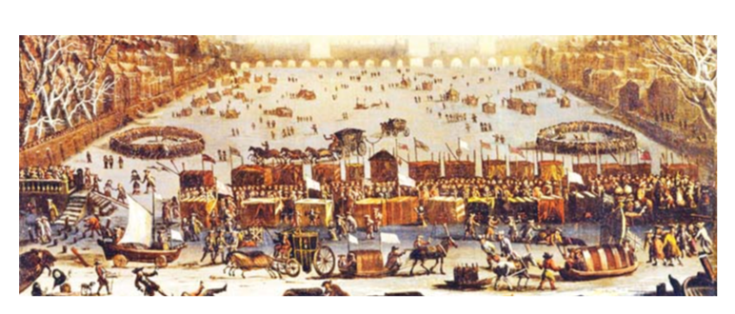
What can he see?

What can he hear?

What can he smell?

