
Learning question: How do Christians today try to create a world that Jesus would want?

Christians around the world try to create a world that Jesus would want through their actions and behaviour.
Look at this church notice board – What are these Christians doing in their community?
NOTICES






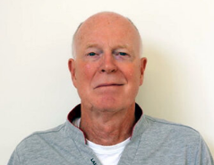
For support or more information contact Jenny at the St Cross church office 020 755 111
Weekly programme
Monday – Lunch and fellowship club for over 60’s

Tuesday – 9am – 11 am Toddler group
5.30 – 7.30pm Kids Club

Wednesday – 10 am Prayer meeting
and communion service
8pm Home group - Bible
study and fellowship.

Thursday – 9am – 11am Toddler group
9pm – Homeless soup run.

Friday – 2pm Prayer and Bible study
7.30 – 9.30pm Youth Group

Sunday – 9am Communion Service
10.30 am – All age Service
inc. Sunday School.
Can you help with the Soup Run to the homeless shelter?
Contact Julia to be part of the team preparing and serving soup each week for those living on the streets in our local community.

Here to Help!
If you are having to self-isolate due to COVID-19 and require any help (for example with shopping or collecting prescriptions etc), we would love to try to help you.
Please contact the church office.

Welcome to St Cross Parish Church
Do get in touch with Rev. Jef to celebrate a wedding, baptism, or funeral or if you need someone to talk to or pray with.
Vicar – Rev. Jef Foulger

How is St Cross Parish Church trying to create a world that Jesus would want? Look at all the things they do in the week to serve their community and reflect on what you have learned so far in this unit.

Rev. Jef is the Vicar of St Cross Parish Church.
What do you think a day in his life might look like? What activities might he be involved in?

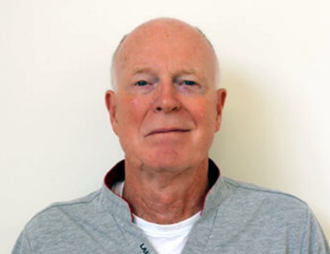
Morning

Evening
Afternoon


Look at Rev. Jef’s diary.

As you think about each activity consider: How is Rev. Jef trying to be like Jesus? How is Rev. Jef following the example of Jesus to help create the world he wanted.
7 am private prayer and Bible study
7 am private prayer and Bible study

9am pop into Toddler Group
9 am Meeting with Jenny (Church office)

Hospital visit – Liz rushed in this morning.
Visit Liz’s family

5.30pm Pop into Kids Club
2pm – Prepare for Wednesday’s communion and prayer service
11.30 am Visit Bill to plan his wife’s funeral service.
10 am Lead Collective worship at St Cross CE Primary School.
Pastoral meeting with Headteacher

7.30pm Visit Neil and Kate – Wedding preparation classes
10 am Visit Enid – deliver Holy Communion and pray with her.
4pm Sunday Sermon preparation
2pm Planning meeting for upcoming fundraising event for Christian Aid.
12.30 Visit Lunch club
11 am Prepare for Collective Worship for St Cross CE primary school

I have always wanted to be a Vicar, God called me at a young age to serve him in this role. Being a Vicar means I can love, guide, support and teach people just as Jesus did. I try to follow his example each day. When I am reading my Bible and praying, I always ask God to teach me more about how he wants me to live and how I can serve my community. I think of myself as one of Jesus’ disciples here on earth today, so like the disciples in the Bible, I am a fisher of men too.

How is Rev. Jef trying to be like Jesus?

How is Rev. Jef following the example of Jesus to help create the world he wanted.

