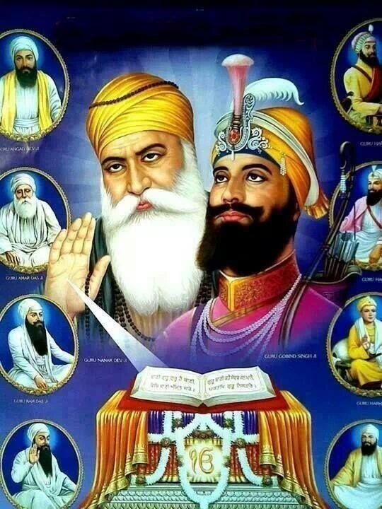
Learning question: Who followed Guru Nanak?

Look carefully at the picture

Who do you think the people are?
Look at what they are wearing and doing, what does this make you think about?

  What can you see? | What does it make you think about? | What does it make you wonder about?
I can see … | I think … | I wonder …  

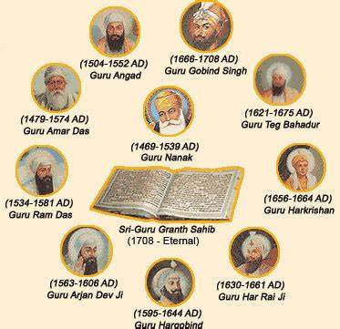
There are ten Gurus in Sikhism, who lived between 1469 and 1708. Sikhs believe that the divine spirit and guiding light of the gurus was passed on from one to the next.
Guru Nanak was the first Guru, who started the Sikh faith. Guru Gobind Singh declared that after his death, the spirit of the gurus would be passed on into the Sikh holy scripture, The Guru Granth Sahib.
Sikh people do not worship the Gurus but learn from their example and teachings.


Watch this video clip of Sikh children singing a song to help them remember the 10 Guru’s
Listen carefully for what each Guru did to grow and develop the Sikh faith and beliefs.
The Gurus Song - Sikh Nursery Rhyme | Kiddie Sangat



What did you learn about the Sikh faith and what is important to them from this song?

Learning Question: Why do Sikh people tell stories of the Guru’s?
Watch this clip -
https://youtu.be/4bUttgP4gB8

- Why do Sikh people tell stories about the gurus? What difference does it make to their lives?

- What does the story of Guru Nanak and the boulder teach Sikh people?
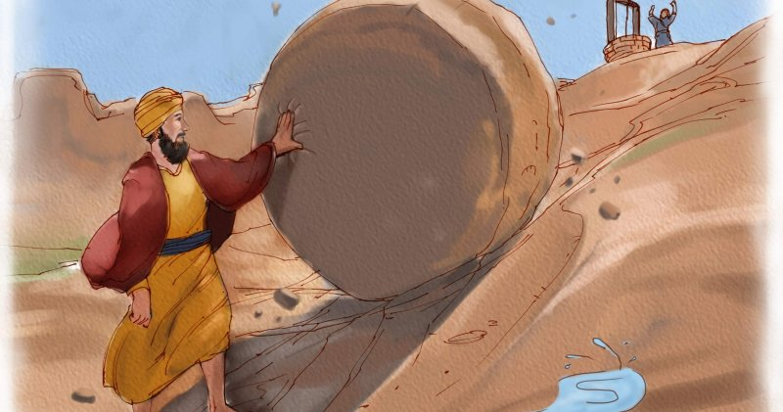

Watch this video clip that includes a couple more stories about Guru Nanak
https://youtu.be/tCVzaDGx5DM

Sikh people try to follow the example Guru Nanak gave to them by the way he lived.
What do these stories teach Sikh people about how they should behave and live?

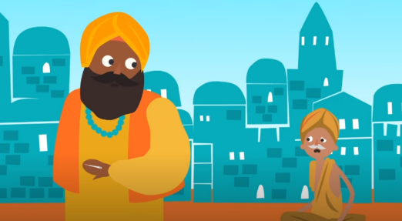
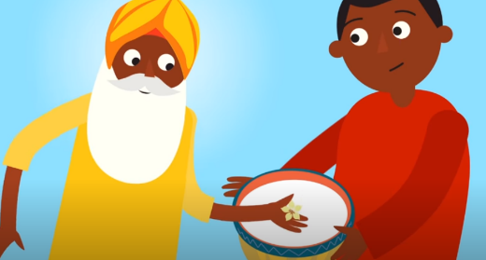

Learning Question: What is the Khalsa?

What groups do you belong to?

- Family, Cubs, Brownies, Football team, faith group?

How does it make you feel to belong to these groups of people?
Anyone who follows the Sikh faith is part of the family of Sikhs, but some Sikhs choose take part in a ceremony called Amrit so they can belong to the Khalsa community of Sikhs.
When Sikhs become part of the Khalsa they start to wear the 5K’s which are visible symbols of their faith and belonging to the Khalsa.

Watch this video clip as Simran tells you about how the Khalsa community of Sikhs was formed. https://youtu.be/FRpygummmh8
The Khalsa Sikh community was founded more than 300 years ago during the harvest festival of Vaisakhi by Guru Gobind Singh. These men were willing to die for their faith and be truly committed to the teachings of the gurus. They became known as the 5 beloved ones and the first Sikhs to be part of the Khalsa.
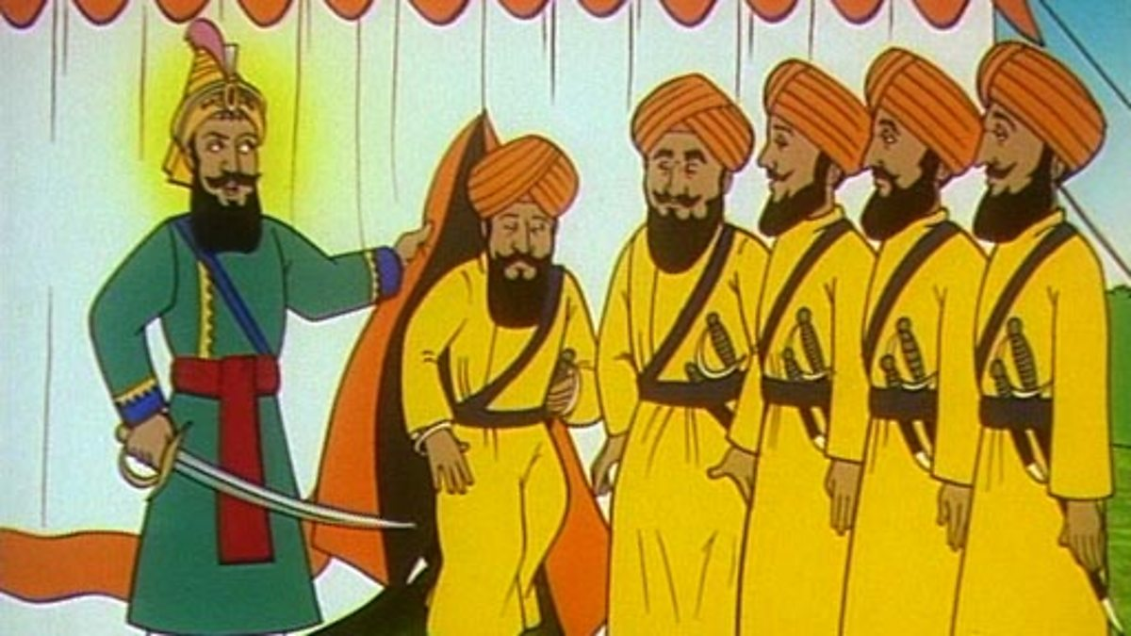

Imagine you had been in the crowd that day, what might it have been like to watch this all happen?
Why do you think these men were then called the beloved ones?

