What do the words mean?
- Re-read The Stone Trolls story. All of the words below are in bold in the story. See if you can work out what they mean and jot down your ideas here.
- If you are stuck, there is a list of similar words below to help you. If you are still stuck, you could ask someone else in your home or use a dictionary or the internet.

Target Word | Definition that fits with the information text
cover of darkness
venture
mischievous
ebony beach | 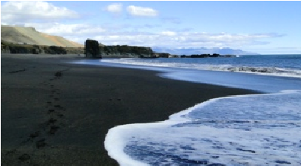
hoard
pitching
wade
stricken
hefty
clambered
shielded

 | Similar Words Help Box
protected | heavy paddle catch or supply black risk or dare
naughty | plunging climbed wrecked at night-time

