
The Stone Trolls

Year 3
By Dean Thompson

Introduction : Background information to the story


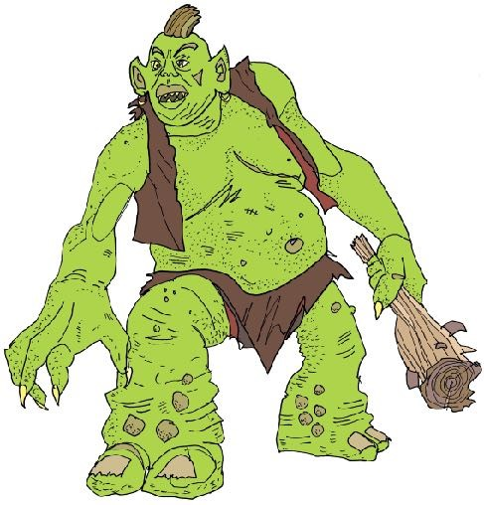
There are many tales about the legendary troll that have been told and retold for centuries. Trolls are often thought to be very large, ugly creatures, like giants or ogres, that live in the mountains and are
dangerous to human beings. But are all trolls like this? On a trip to a country called Iceland, I found some great stories about Icelandic trolls. I discovered that there are some terrible trolls but there are also some that are peaceful, friendly and helpful.

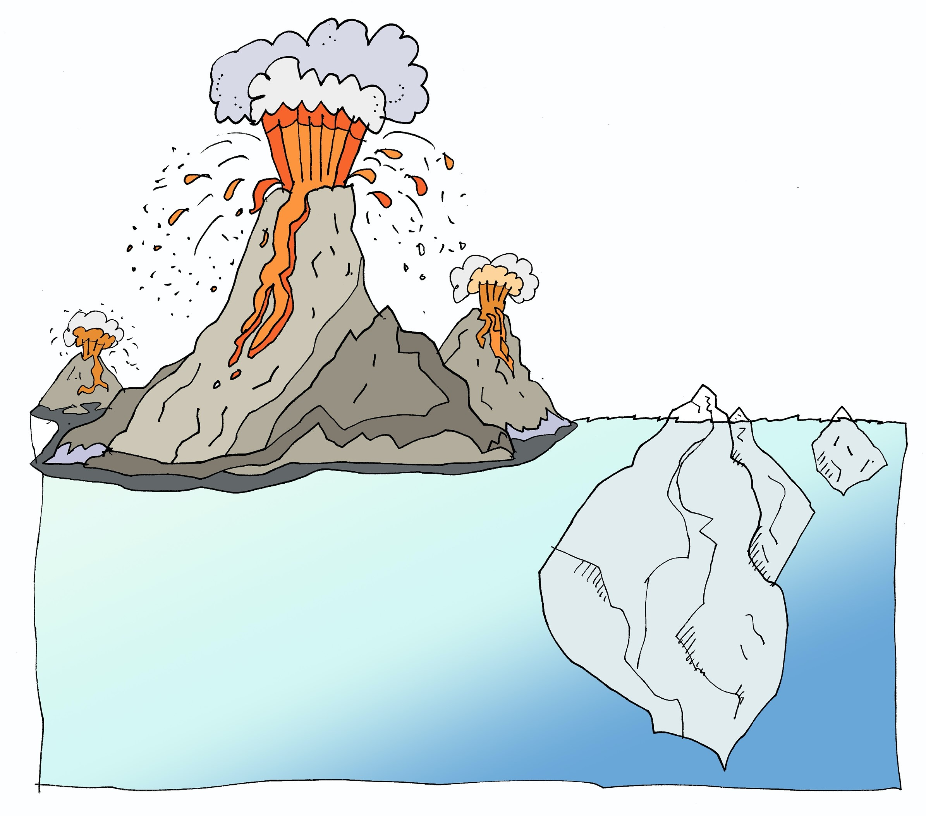
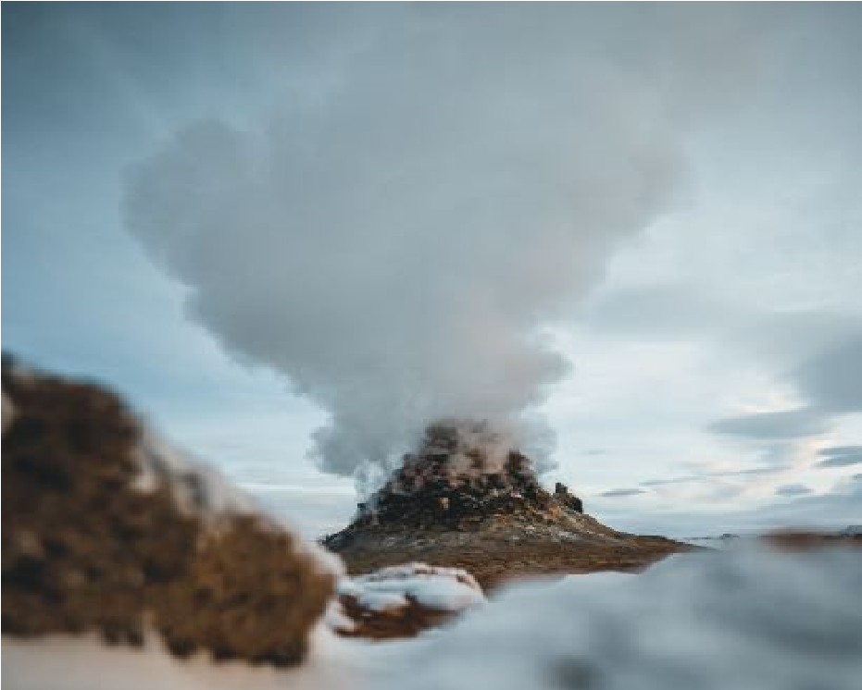
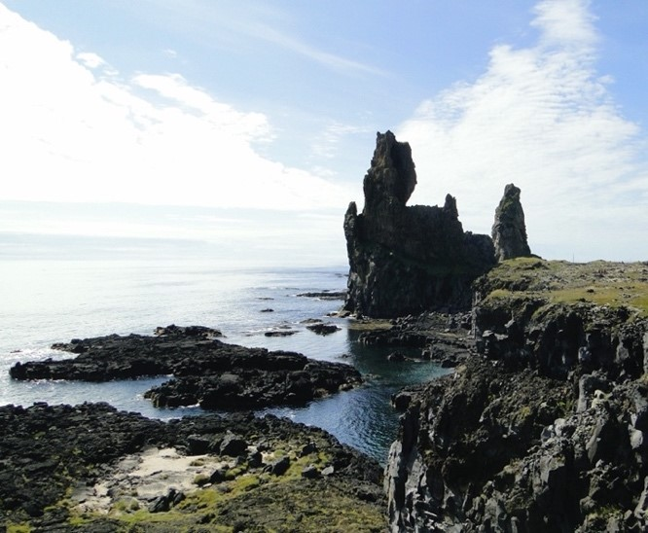
Where

is

Iceland?

Iceland

is

an

islan
d

in

the

very

north

of

the

Atlantic

Ocean

just

below

the

Arctic

Circle
,

between

Canada

and

Norway.

It

has

many

large

mountains,

live

volcanoes,

amazing

waterfalls

and

beaches

made

of

black

sand

from

volcanic

lava.

It

also

has

lots

and

lots

of

glaciers

and

ice
,

plus

masses

of

moss

but

very

few

trees!

In Iceland, stories about trolls have been told to explain some of the many interesting rock shapes that can be found all over the island.

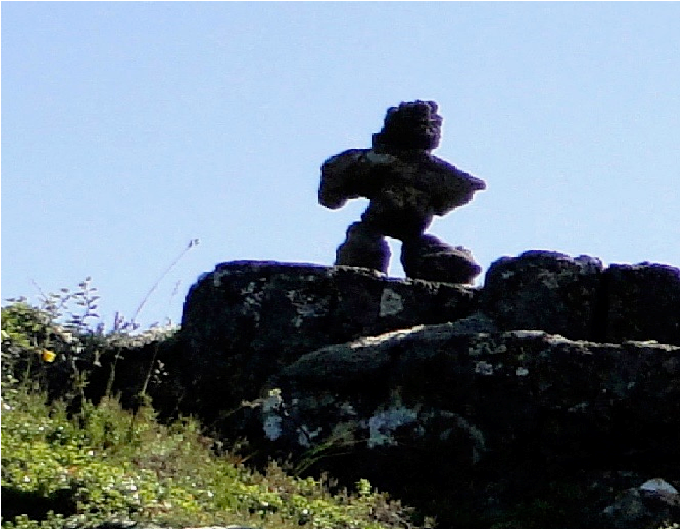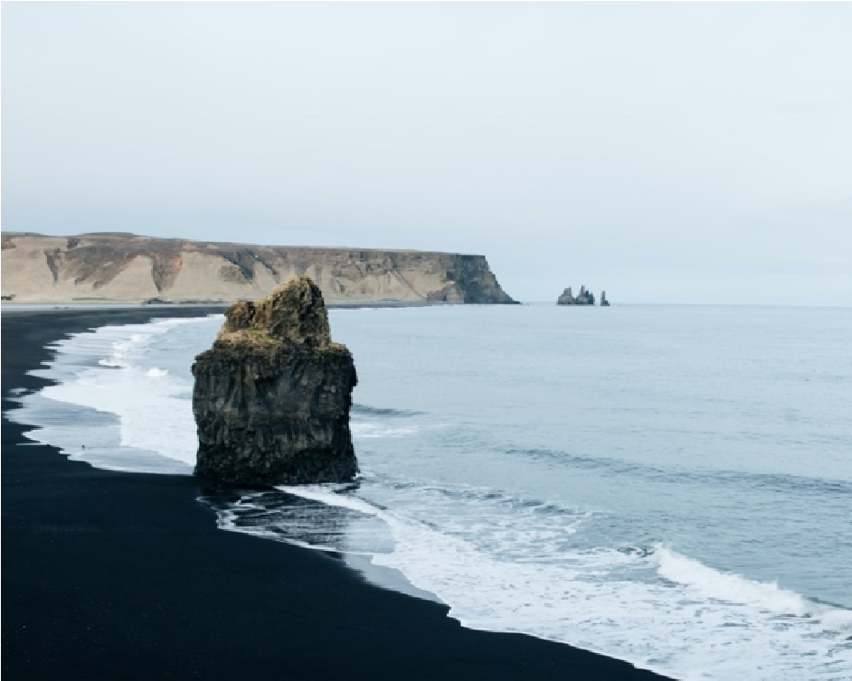
The story in this pack has been inspired by a traditional Icelandic folktale. The names have been simplified to make it easier for you to read because the Icelandic alphabet is a bit different from ours. The story explains how some amazing rocks called ‘sea stacks’ were created. This story has been told many, many times over the years.
Before we read the story, let’s make sure we know some of the technical words.

Glossary
volcano: a mountain, usually shaped like a cone, with a large hole in the middle (called a crater), where hot, molten rock (called magma) and hot gas from the centre of the Earth erupts. Volcanoes can cause terrible destruction.
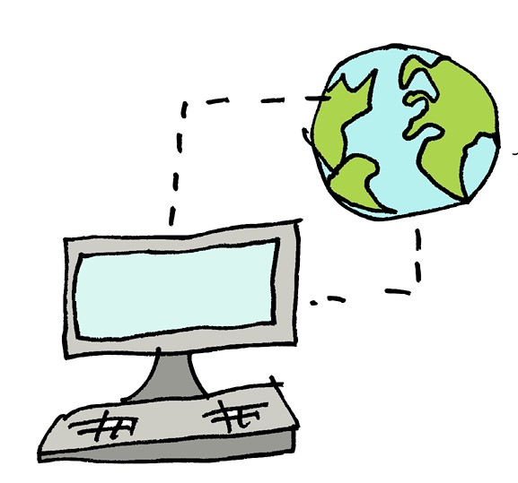
Further Background Information on Volcanoes from BBC Bitesize. Type in the link below to learn more: www.bbc.co.uk/bitesize/topics/z849q6f/articles/zd9cxyc

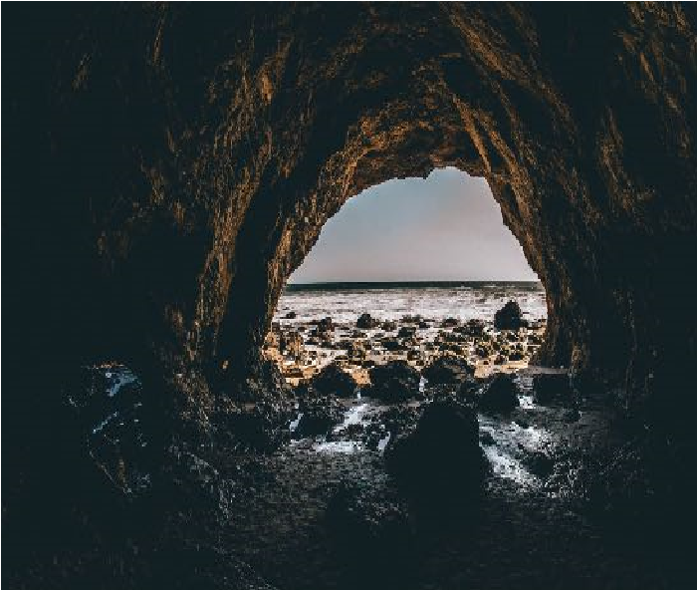
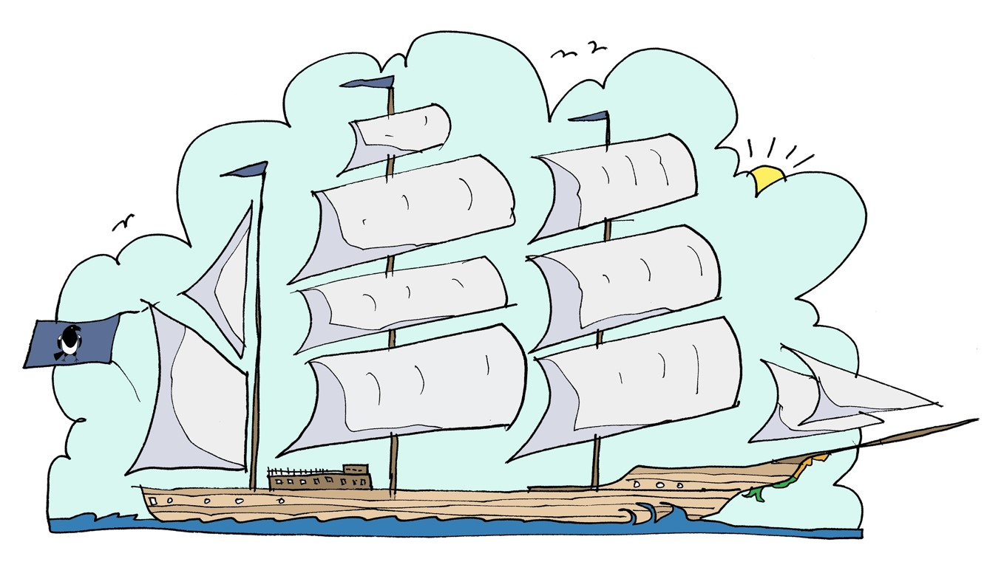
cave: a hole in rocks or mountains big enough for a person (or a troll!) to go into.

three-masted ship: large sailing ship powered by the wind with three masts for the many sails.

Let’s now read our story…
You can listen to an audio version of the story here https://soundcloud.com/talkforwriting/stone-trolls/s-bGWn1yz5NrI

The Stone Trolls
On the southern coast of Iceland, near the small village of Vik, there once lived a band of trolls. They were huge, ugly creatures who were feared by humans and hid away underground in the dark caves of the nearby icecovered volcano. All trolls knew that if they ever got caught outside in the daylight, they would immediately be turned to stone. So, each night, under the cover of darkness, they would venture outside to hunt and fish. One stormy night, two mischievous trolls called Skess and Landra perched together on the craggy cliff, watching. Below, the sea bubbled and foamed. Above, the full moon glared down, casting a long shadow across the ebony beach. In the distance, they could hear the low rumble of other trolls, feasting on their hoard of freshly caught fish.
Suddenly, Skess jumped up, pointed at the horizon and roared. “Landra, look, a three-masted ship. I think it’s in trouble!” Landra followed his gaze and stared at the magnificent ship, pitching and rolling on the bubbling sea. “Let’s wade out and pull it into shore,” Skess said, setting off down the beach. Landra frowned as it was already very late and the sun rose earlier and earlier in late spring, but then he jumped down from the cliff and followed close behind.
Slowly, they waded out into the sea until, at long last, they reached the stricken ship. Together they started to haul it towards the distant shore, which was now just a strip of silver moonlight.
For the rest of the night they heaved, and they heaved, and they heaved , but the ship was hefty and the sea was rough. Time passed. The two trolls didn’t notice the moon slipping slowly away. Finally, they reached the blackened beach where the sailors quickly clambered to safety. At that moment, the first glimmer of sunlight appeared. Shocked, Skess and Landra shielded their eyes and then stared at each other in horror. Their mouths widened. Their legs stiffened. Their arms ground to a halt. Their eyes closed. Both trolls and the remains of the ship instantly turned to stone … forever.
© Talk for Writing
To this day, what remains of the stone trolls and the ship can still be seen just off the coast of Iceland near the small village of Vik.
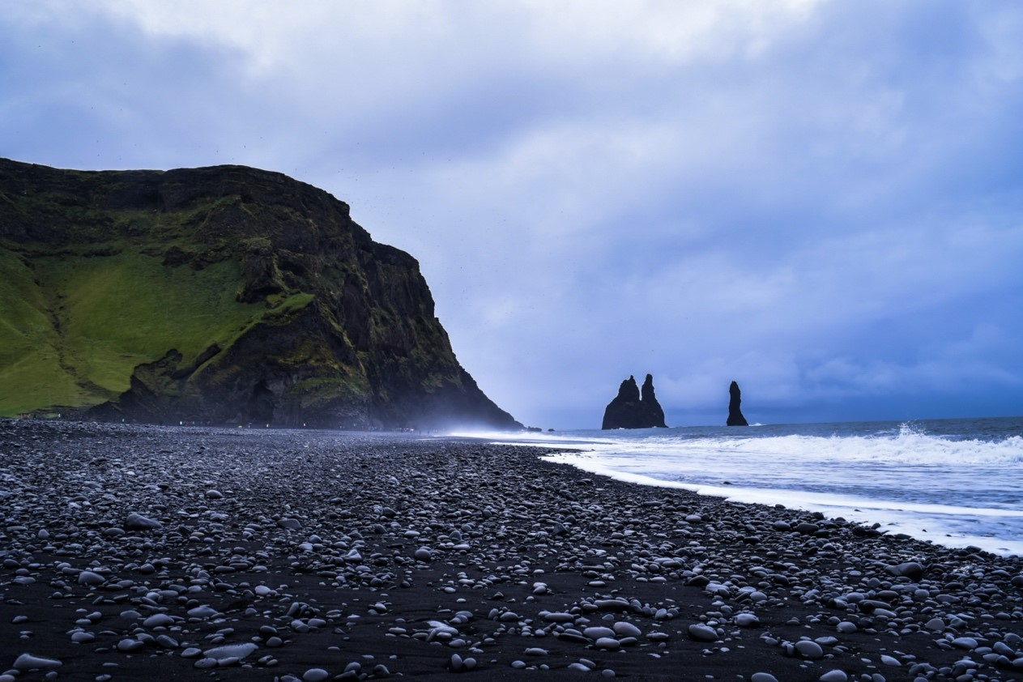

©

Dean

Thompson

2020

Photo by Rostyslav Savchyn on Unsplash
The rocks in the distance are actually basalt sea stacks. Glossary basalt: volcanic rock. Here it is very dark in colour.

sea stacks: pillars of rock, formed by the wind and the waves. These
were once thought to have been arches of rock attached to the nearby cliffs.

These rocks or sea stacks have real Icelandic names:

Skess in the story is actually called Skessudrangur in Icelandic. Landra in the story is actually called Landdrangur in Icelandic.

