The Adjective Game

Adjectives are used to describe nouns.

Let’s make a list of all the things (nouns) you can see in these pictures of Iceland. For example, I can see rocks and clouds … what else can you see? Add your ideas to the table on the next page.

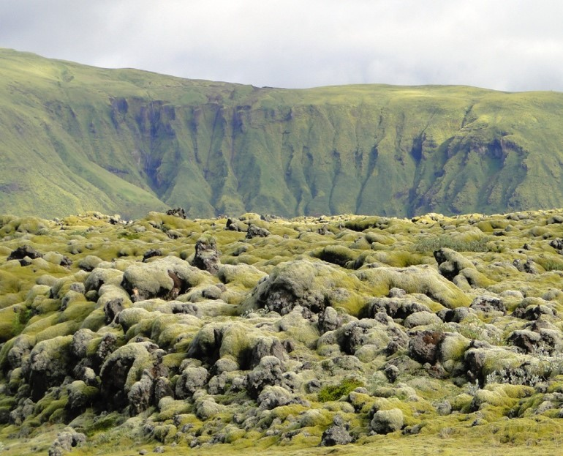
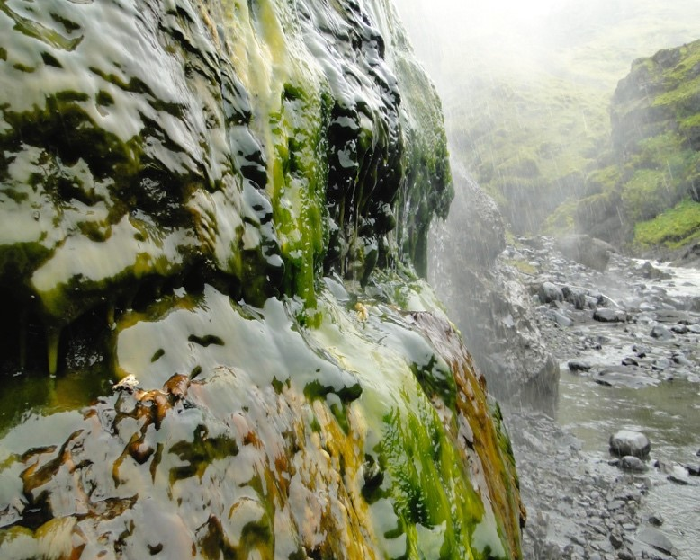
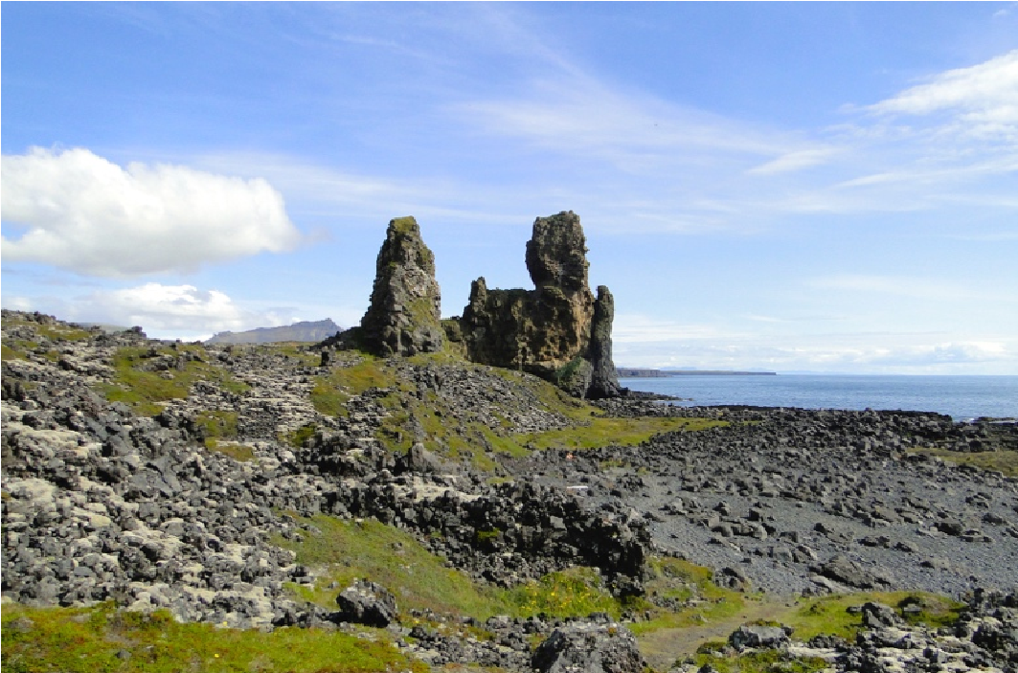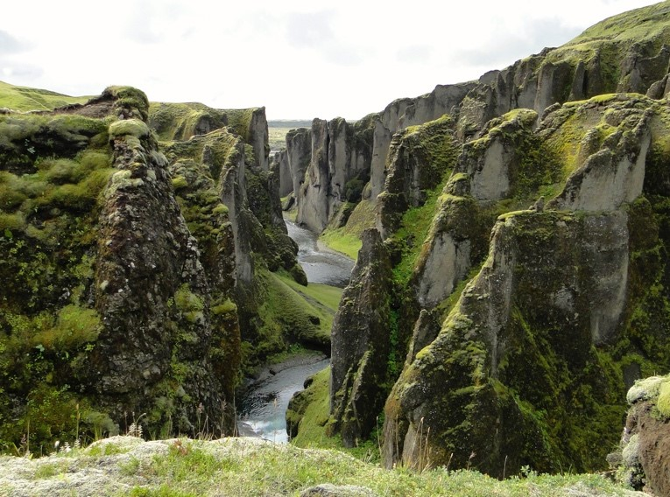



Now

try

and

think

of

some

interesting

adjectives

to

describe

the

things

in

the

pictures

of

Iceland.

Remember

you

can

always

magpie

some

of

the

words

in

the

story

to

get

started!

Writing

Tip

–

try

and

think

about:

•

What

is

the

colour?

•

What

is

the

size?

•

What

is

the

mood

(
for

example,

a

calm

sea

or

lonely

clouds

or

a

terrifying

crater)

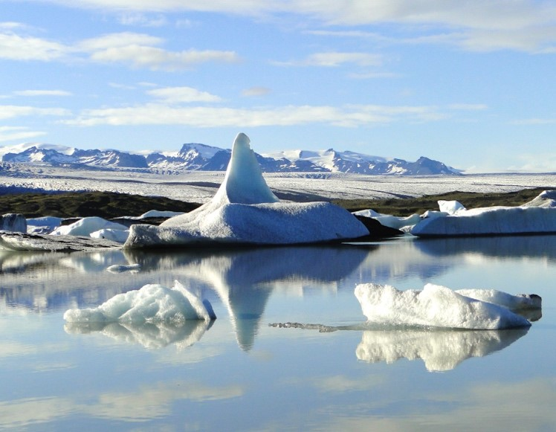

Now think about using some of the other senses:
- What might it feel like?
- What might it smell like?
- What might it sound like?

For example:

Nouns | Adjectives
1. rocks | grey tall craggy sharp rounded lifeless slimy
2. clouds | white grey | wispy thin silver | soft
3.
4.
5.
6.
7.
8.
9.
10.
11.
12.
13.
15.

Challenge 1: Now use the adjectives you have thought of and have a look in a thesaurus or just type alternative word for xxxxx online to find some other words that are similar. These are called synonyms.

For example: Rocks could be described as tall.
When I looked in my thesaurus (a book that gives you alternative words), I found some more alternative words (synonyms) that I could use to describe the rocks.

The rocks could also be described as: towering soaring giant colossal
Remember to make sure the new words make sense. The trouble is the thesaurus also said another word for tall is lanky. Lanky cannot be used to describe the rocks because lanky is only used to describe someone or some creature that is very thin and has long legs!

Now use some of your best adjectives to fill in the gaps to describe the setting. Read your sentence out loud. Does it work? Does it sound right?

The __________________ rocks stood and stared down on

the ___________________ canyon.

The __________________ rocks steamed above the

__________________ valley.

Challenge 2: Now try using 2 adjectives with a comma to describe the nouns – make sure both adjectives work, and they are not just saying the same thing!

The ______________ , ____________ iceberg shimmered
in the _________________ lake.

I stared towards the ______________ , _________________
crater across rocks carpeted in _______________ moss .

Challenge 3: Now try writing your own sentences to describe the setting using your best adjectives. Remember to read your sentence out loud first. Also use a capital letter, a full stop and, if you use 2 adjectives, remember the comma!

