
How do Christians try to put Jesus’ teaching and example into practice?

Look at these images. What story are they telling?
Can you tell the story using the words below the images?
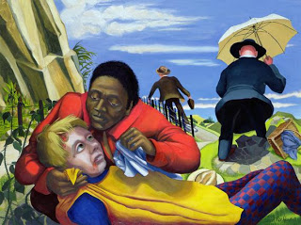
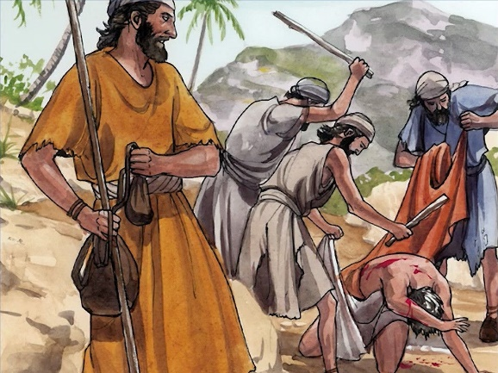

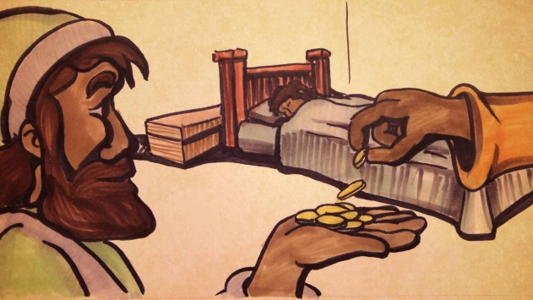
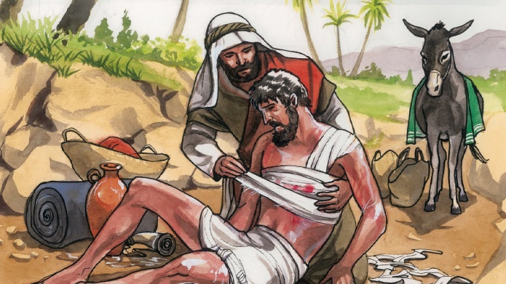

Samaritan | Jerusalem to Jericho | robbers
Walked past | helped | left for dead
Priest | ignored | Enemy
2 denarii (coins) | Inn | cared for

Read the parable in the book of Luke in the New Testament.

Luke 10: 29 - 37
²⁹ But he (an expert in the Jewish law) wanted to justify himself, so he asked Jesus, “And who is my neighbour?”
³⁰ In reply Jesus said: “A man was going down from Jerusalem to Jericho, when he was attacked by robbers. They stripped him of his clothes, beat him and went away, leaving him half dead. ³¹ A priest happened to be going down the same road, and when he saw the man, he passed by on the other side. ³² So too, a Levite, when he came to the place and saw him, passed by on the other side. ³³ But a Samaritan, as he travelled, came where the man was; and when he saw him, he took pity on him. ³⁴ He went to him and bandaged his wounds, pouring on oil and wine. Then he put the man on his own donkey, brought him to an inn and took care of him. ³⁵ The next day he took out two denarii and gave them to the innkeeper. ‘Look after him,’ he said, ‘and when I return, I will reimburse you for any extra expense you may have.’
³⁶ “Which of these three do you think was a neighbour to the man who fell into the hands of robbers?”
³⁷ The expert in the law replied, “The one who had mercy on him.”
Jesus told him, “Go and do likewise.”

Watch BBC Two - Watch, Christianity: Friends, Parable of the Good Samaritan (animation)

- Why do you think Jesus told this parable?

- What was the lesson he wanted to teach his followers through this parable?

- What do you think it means to love your neighbour in reality?

Look at these modern images.
- How are these examples of ‘Love your neighbour’?









Think about the 3 Bible stories you have looked at in this unit.
- What were the messages Jesus taught through his example or telling of parable?
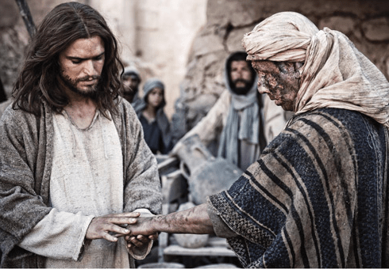
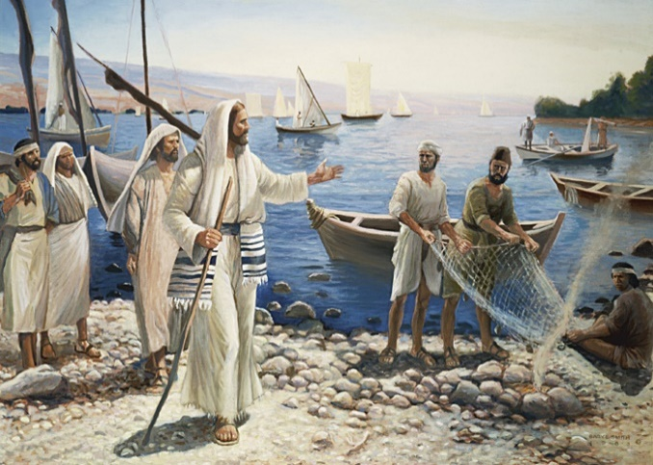

Jesus touched and healed the man with leprosy.
Message:
Jesus calls the disciples
Message:

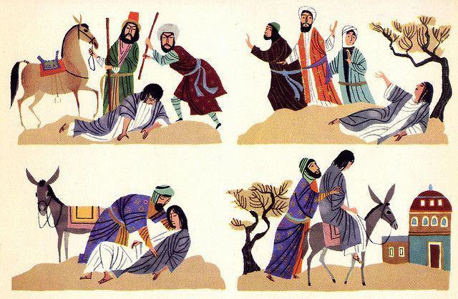

The parable of the Good Samaritan
Message:


Thinking about all of these stories, see if you can complete a triptych (3 connected images).
- In the middle panel, put an image of something that you think is wrong in the world around you – something that people are doing or causing that you do not think is right with a sentence to say what is happening
- In the left hand panel, draw and write what Jesus might do using what you have learnt so far about the world Jesus would want
- In the right hand panel, draw and write what you might do in that situation to make it right or better (it does not have to be the same as what Jesus would do!

