How To Make A Flapping Bird

What you need:
Printer & Paper Scissors
Glue or Tape String
Crayons, Markers or Coloured Pencils

What you do:

1. First print out the bird template attached to the blog (or draw your own version).

2. Then decorate your bird. You could decorate it in the style of Romero Britto who he learnt about last week.

3. After that cut out the wings and bird.

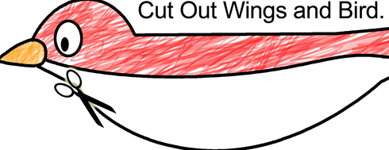

4. Next fold the wings in the middle.

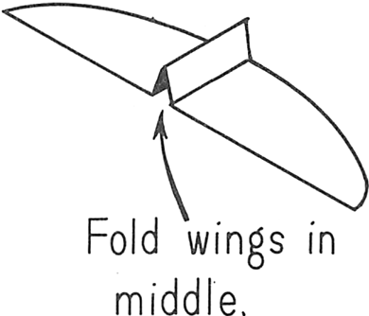
5. Then glue or tape the wings onto the bird’s body.
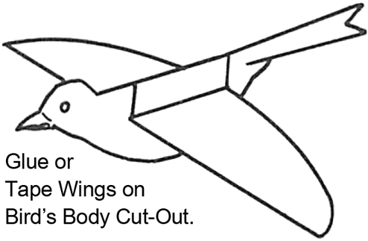
6. Finally fasten string to the top of the bird. Raise the string up and down to flap the birds wings.


