RE Home Learning – Guidance from Canterbury and Rochester Diocese
Term 3 Week 4 2021

Week 4 – How do Christians share the Good News with others?

Matthew 18: 21- 22
Jesus, how many times should I forgive someone who is unkind to me?
7 times?
One day Peter came to speak to Jesus.



No not 7 times, but 70 times 7!




Do you think Jesus thinks forgiveness is important?

The Bible tells Christians that Jesus wants his followers to forgive other people, not just 7 times, but 70 x 7 times.
Forgiving people can be hard sometimes, but Christians know this is what God wants his people to do and he promises to help them to forgive.

How do you think the children in this picture are feeling?




Do you think the little girl found it easy to forgive her brother?

Do you think forgiving people can bring you peace?
How?

How do you think this girl felt when she had forgiven her sister?

Thank you for saying sorry, I forgive you.

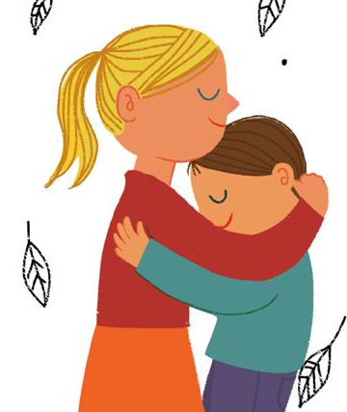

When you have been forgiven and made friends again, does it make you feel peaceful?

I wonder, is forgiving others Good News? What do you think?

Christians know that when they say sorry to God, they will be forgiven.

Do you think this can make them feel peaceful?

Read these sorry prayers.
Do you think praying these prayers made the people feel more peaceful?

Lord Jesus, thank you that when we say sorry, you forgive us.
Help us to put things right. Amen.

Dear God,
I am sorry for the times I was unkind to my brother today, help me to be kinder tomorrow. Amen
Dear God, I got really angry today and hurt someone. I am really sorry, please forgive me.
Help me to be calm and think more before I speak or act. Amen

Write about a time when you needed someone to forgive you. It could be in the form on a prayer or an explanation of what happened and what you would do differently next time.

________________________________________________________________________________________________________________________________________________________________________________________________________________________________________________________________________________________________________________________________________________________________________________________________________________________

