
What challenge does Jesus give people about how to treat others?
- What does this phrase mean?

- What does it mean to judge someone?

To judge – To form an opinion or conclusion about someone or something (positive or negative) without information or understanding.

Read this Bible passage from the book of Mark in the New Testament.
Mark 1:40-44, International Children’s Bible
⁴⁰ A man who had a harmful skin disease [leprosy] came to Jesus. The man fell to his knees and begged Jesus, “I know that you can heal me if you will.” ⁴¹ Jesus felt sorry for the man. So, he touched him and said, “I want to heal you. Be healed!” ⁴² At once the disease left the man, and he was healed. ⁴³ Jesus told the man to go at once. But Jesus warned him strongly, ⁴⁴ “Don’t tell anyone about what I did for you. But go and show yourself to the priest. And offer a gift to God because you have been healed. Offer the gift that Moses commanded. This will show the people that you are healed.”

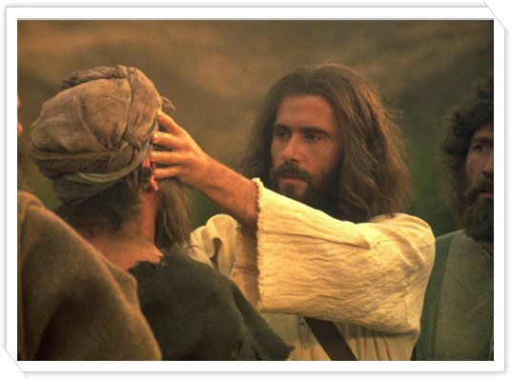
Leprosy, or Hansen disease, is a disease of the skin and nerves. In advanced cases, the disease disfigures the body, or ruins its normal appearance.
In Bible times, those suffering from the disease used to be called lepers and were often separated from the rest of society, living away from their families, on the outskirts of the towns or villages to prevent other people from catching it. People believed it was highly infectious, so would not touch or go near people out of fear of becoming infected themselves. There were no cures for Leprosy then, so those suffering lived a miserable, painful life unable to work or spend time with their families. They were also not thought of being good enough to meet with God because of this disease. Those few who did get better had to prove they were free of Leprosy by being checked by the Temple Priest. It is actually quite hard to catch leprosy from someone else. Today, there are very few cases of leprosy as it can be treated effectively with antibiotics.


- Why was it so surprising that the leper came to Jesus?


- Why did Jesus touch and healed the leper? Why was this surprising?

- What might this account teach Christians about how God wants them to treat people?

- If everyone didn’t judge people for how they looked and ‘loved their neighbour’ how might the world be different?

Thinking about all you have thought about, learned and read answer this question:
- What challenge does Jesus give people about how to treat others?



Look back at your thoughts and responses to the big question ‘What kind of world would Jesus want?’ can you add anything to this following these two lessons?

