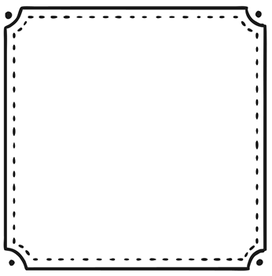
_________________________________________________________________________________________________________________________________________________
_______________________________________________________________________________________________________________________________________________________________________________
Mammals_____
Interesting facts:
__________________________________________________________________________________________________________________________________________________________________________________________________________________________________________________________
__________________________________________________________________________________________________________________________________________________

