

Read this article about how the Sikh community in Gravesend, Kent provided food for the lorry drivers stuck on the M20 before Christmas.
Watch the clips, that were featured on Meridian News, showing how the community prepared and served those stuck in their lorries.
Sikh community prepare hot meals for stranded lorry drivers on M20 | Meridian | ITV News
The Sikh community from Gravesend in Kent have come together to make fresh hot food for lorry drivers stuck at Dover.
The closure of French ports and the Euro tunnel has led to chaos in Kent as nearly 1,500 lorries were forced to queue up for miles along the M20.
Volunteers at the Guru Nanak Darbar in Gravesend have been making curry and pasta and delivering it to lorry drivers all day. They've made 800 meals so far today.
The president of the Gurdwara, Manpreet Singh Dhaliwal says helping people in need is a fundamental concept of Sikhism.
Khalsa Aid are working with Kent Police to make sure food is safely reached to those stuck in lorries for a second day.




- What does this practical action teach you about the Sikh faith and what is important to them?

What do Sikh people believe about God?
The Mool Mantra is found at the start of every section of the Gur Granth Sahib and affirms to Sikh people their belief and understanding of God.

The most common name for God is Waheguru, which means wonderful Lord.
Read the Mol Mantra carefully. What does this text teach you about what Sikh people believe about God? Annotate the text with your thoughts.
The Mool Mantra
Ikoaŉkār saṯ nām karṯā purakẖ nirbẖao nirvair akāl mūraṯ ajūnī saibẖaŉ gur parsāḏ.

One Universal Creator God. The Name Is Truth. Creative Being Personified. No Fear. No Hatred. Image Of The Undying, Beyond Birth, Self-Existent. By Guru's Grace

- Why do you think Sikh’s recite the Mool Mantra every day and at the beginning of each section of the Guru Granth Sahib?

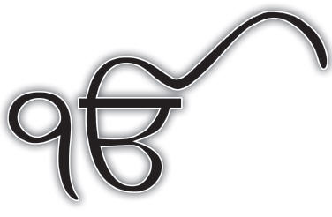

The Ik Onkar symbol, represents the Sikh understanding that there is only one God. It also depicts the first line of the Mool Mantra.
- Why do you think Sikh people display the lk Onkar symbol in their homes, on the walls of the Gurdwara and as a necklace?


