
: How do Christians try to be like Jesus?
- What are your 3 favourite possessions?

- What you might an ‘ordinary day’ look like for you?


The Bible tells Christians that God had given Jesus an important job to do. He wanted him to spread the Good News of God to the whole world. Jesus did this through stories and by his example.
Jesus knew he could not do this work alone, so he called ordinary people to come, follow him and be his disciples.

Read this Bible story of an ordinary day, which suddenly became extraordinary.
It comes from the book of Matthew in the New Testament.
Matthew 4: 18-19, Jesus was walking by Lake Galilee. He saw two brothers, Simon (called Peter) and Simon’s brother Andrew. The brothers were fishermen, and they were fishing in the lake with a net. 19Jesus said, “Come follow me. I will make you fishermen for men.” 20At once Simon and Andrew left their nets and followed him.


Write down your thinking about these questions:
- What would you think if someone asked you to give up your favourite possessions and your day to day life as you know it?

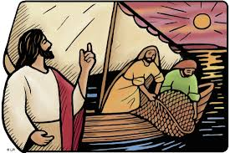
- What do you think Jesus meant when he said, “I will make you fishermen for men”.
Are they really going to catch people with nets?

Being a fisher of people is a practical action Jesus wanted his disciples to help him do. It did not mean they were going to go around with nets actually catching people!
By following the example of Jesus, loving your neighbour, and sharing the teachings and love of God, the disciples then and Christians today brought people into God’s family. These new followers of God want to follow God because of all they had seen and heard.


- What do you think a ‘fisher of people’ might actually do?

- How might being a fisher of people help to create a world that Jesus wanted?

