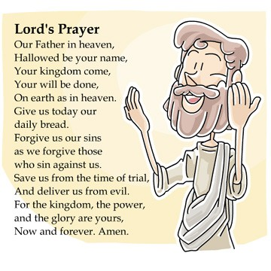
Week 2 - Learning question: How is God like a Father?


Think: The Lord’s prayer opens with ‘Our Father in Heaven’
Why do you think Christians call God father?



Read the second half of the passage from the Bible we read last week. It was a message spoken by Jesus and can be found in the New Testament of the Bible.

Luke 11:11-13

¹¹ If your children ask for a fish, which of you would give them a snake instead? ¹² Or, if your children ask for an egg, would you give them a scorpion? ¹³ Even though you are bad, you know how to give good things to your children. How much more your heavenly Father will give the Holy Spirit to those who ask him!”


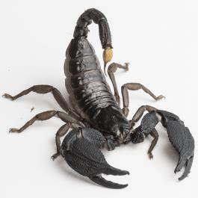
- What is the message Jesus is sharing with those listening?
- How did Jesus want the parents listening to treat their children?
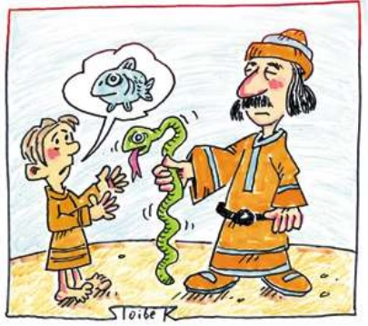
- What do you think this passage teaches Christians about God?


Christians believe that God acts like a loving father to all his children, giving them what they need not what they want.
The Bible tells Christians that they should ask God for what they need. They should ASK, KNOCK and SEEK God for help.
Christians believe that God loves each human so gives them gifts to enjoy.

Look at each of these images which Christians know are gifts from God.

Which one do you think is the best gift? What order would you put them in?
Give each image a number from 1 – 10, with 10 being the best gift and 1 being the lowest on your list.

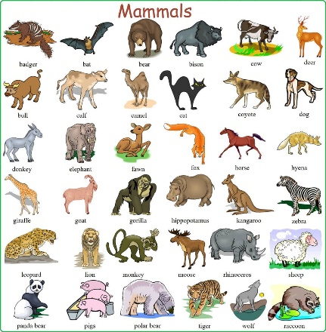







Sunny days
Family
Water
Friends
Nature

Our brain
Animals

Love
The Earth


Food


Tell me more about the order you put the gifts in.

I put _____________________ at number 10 as the best gift because …

I put _____________________ at number 1 as my least favourite gift because …


Thinking about the things you have thought about and read in this lesson –
- Why do you think Christians call God father?

