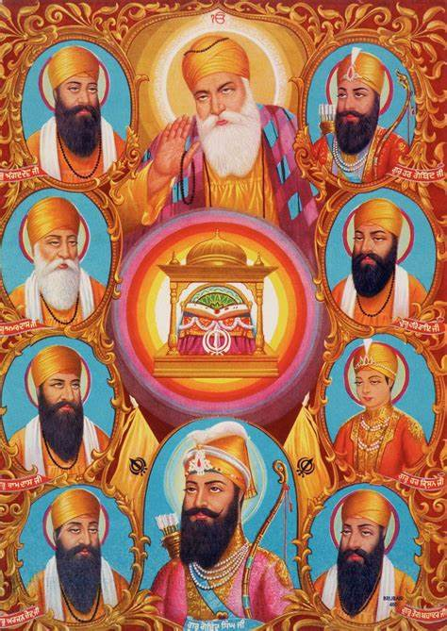
Sikhism Year 3 Knowledge organiser
What is important to Sikh people?
Sikhism |   Name of the Sikh religion
Sikh | disciple or learner
Waheguru | Wonderful Lord  Sikh name for God.
Guru | Sikh name for teacher
Guru Nanak | The first Sikh Guru, who began to speak the message of God’s oneness and universal love.  Sikhs are people who follow the religion Sikhism
Khalsa | 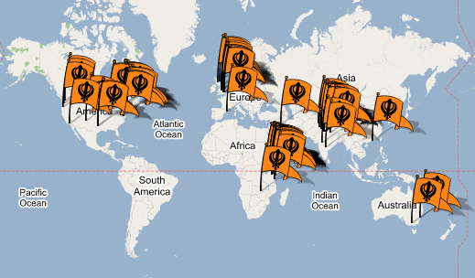  Special group of Sikhs, who have taken part in the Amrit ceremony.  Sikhs believe there were ten human gurus. They all had the same role to share the light of God.  Gur
5 K’s | Khalsa Sikhs wear 5 symbols, which represent different elements of their faith.

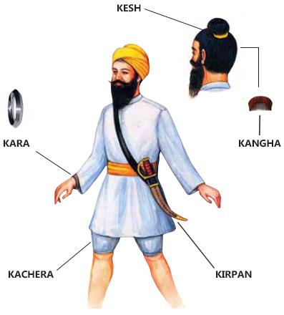
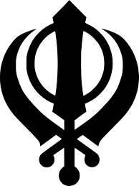
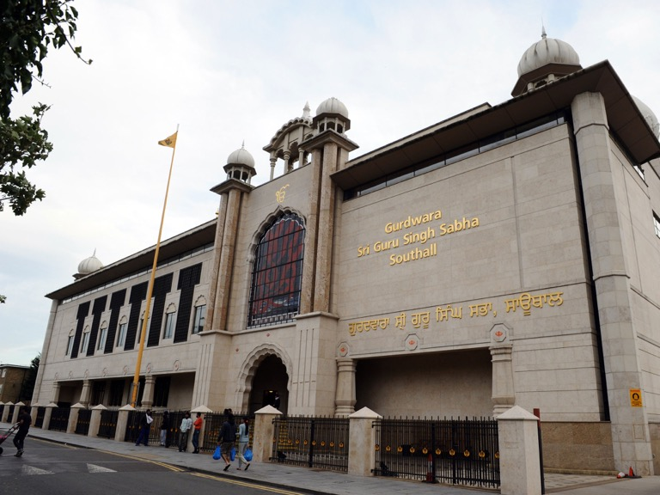

The Sikh holy book is called the Guru Granth Sahib
Khanda
The symbol of Sikhism.

Sikh people worship in a Gurdwara.

Sikh people live all around the world. The religion started in Punjab, India
Some Sikh men and women wear a Turban to cover their hair
Ik Onkar symbol describes the Sikh belief that there is only one God’


Watch this clip as Simran tells you more about the Sikh faith. Use the knowledge organiser to help you understand and listen out for the vocabulary she uses to describe her faith.
https://youtu.be/qXhV3dMxSzE

Watch the video again.
What information did Simran teach you about the Sikh faith? Record it on this page.



Without looking at the Knowledge organiser can you fill in the gaps in the table below?

name |  |  | Guru Granth Sahib
definition | Symbol that represents the Sikh belief that there is only one God. | Place of worship and teaching
image

name | Guru Nanak | The Kanda | 10 Gurus
definition |  | The symbol of Sikhism
image | 

