When Toby looks out over the burning city of London:
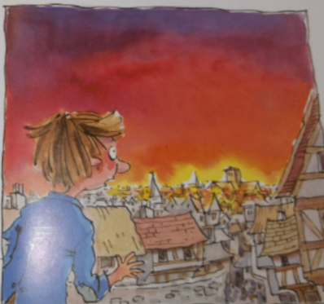
What can he see?

What can he hear?

What can he smell?

