Year 4 – What kind of world did Jesus want?

Introduction
The unit for this term is based on the Christian concept of Gospel.
As we learned last term:
Gospel means ‘Good News’.
There are 4 books in the New Testament of the Bible that make up the accounts of the Gospel, Matthew, Mark, Luke and John. The 4 Gospel accounts recount the life of Jesus, the stories he told and the example he set to his followers. So, for Christians, the 4 accounts of the Gospel share the Good News that Jesus brought to Earth.

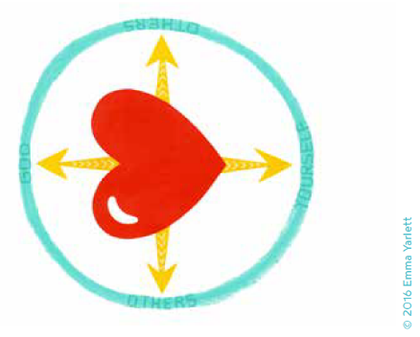
Look carefully at the icon card for the Christian concept Gospel.
- What do you notice?
- What do you think it represents?
- How does it help you understanding of Gospel?

