
Year 1 - What is the Good News Jesus brings? CORE LEARNING

This term we will be learning about the Christian faith through the Christian concept of Gospel. The Gospel stories are found in the New Testament of the Bible.
The New Testament is the second part of the Bible that starts with the birth of Jesus and tells the stories of Jesus’ life.
Gospel stories
Creation








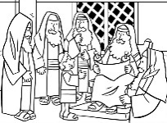
New Testament Stories Term 3
Salvation
(Easter)
Term 4

Old Testament

New Testament


Here are some words you will need to help you in this unit.
Christians | God | Jesus
People who follow the religion Christianity are called Christians. | Christians believe in God, who created the world and all the things on it. Christians learn about God by reading the Bible, which is their holy book. | Christians believe that Jesus is the son of God, who was born as a baby at Christmas time.
 |  | 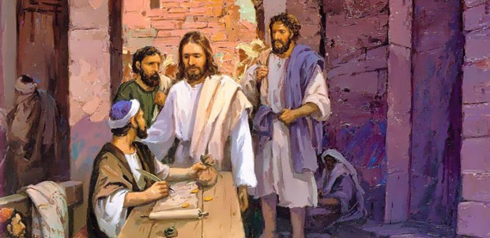

Bible | Disciple | Gospel
The Bible is the Christian holy book. It is made up of 66 different books that are split into two sections.  The Old Testament – which tells the stories of God’s people before Jesus was born.  The New Testament – which tells the stories of Jesus, his life. | A disciple is the name given to someone who followed Jesus.  Jesus had 12 disciples who travelled with him as he told people stories about God. | Gospel means Good News.  There are 4 books at the beginning of the New Testament that are called The Gospels, because they tell the stories of Jesus as he shared the Good News of God with those on earth. The Gospel books are Matthew, Mark, Luke and John.
 | 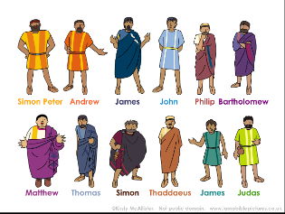 | 

Week 1 - Learning question: What does Jesus teach Christians about how to treat others?

If you needed to create a team of people to change the world, who would you choose?
Why these people?

Would you choose any of these people? Why / Why not?

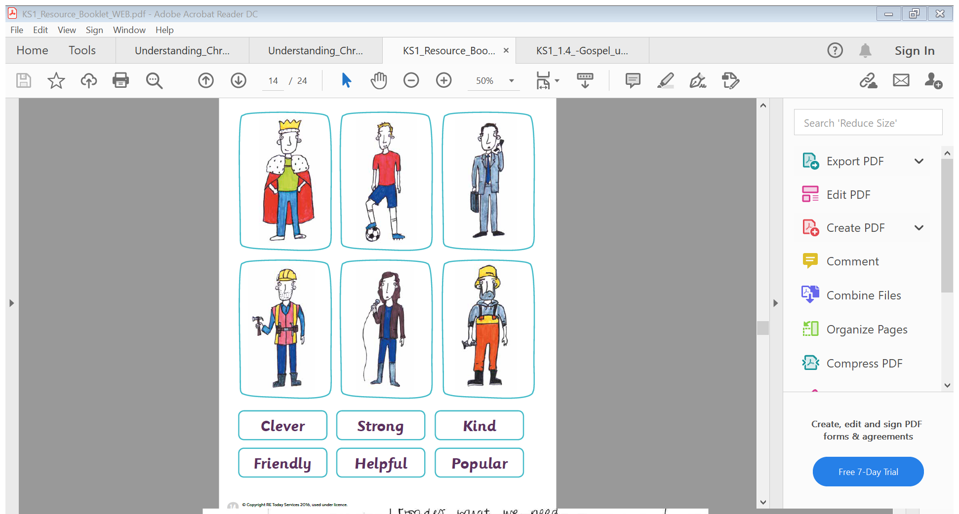

How would you describe the people you have chosen?

Jesus chose 12 men to be on his team to help him change the world and they were not the kind of men you might have expected.
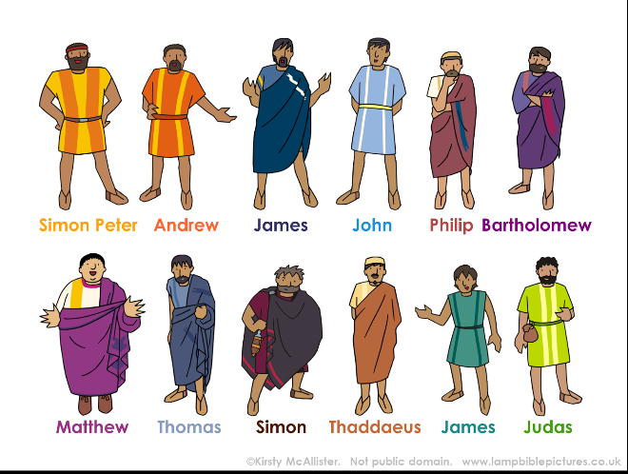
The 12 men he chose were called disciples. A disciple is the name given to a person who followed Jesus.


Look carefully at the picture.
- What do you notice? Who do you think the characters are?
- What do you think they are doing?


This is Matthew, he was a tax collector and worked for the Roman Government. Tax collectors were not very popular, as it was their job to take some of people’s money and give it to the government. The government used the money it got from the taxes to pay for the soldiers in their armies and for the wages for those in the Roman government.
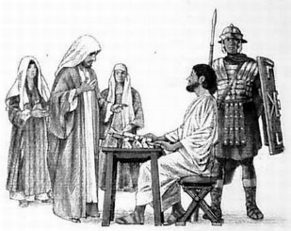
Because of this, Matthew did not have many friends and often spent time alone. Many people did not like paying taxes as they thought they were being asked to pay too much and because they didn’t like the Roman government. The Romans had taken over Israel, the land where Jesus lived and didn’t treat those living in Israel very fairly.

Read this passage from the Bible really carefully. It a recount of when Jesus met Matthew and called him to be one of his disciples. This story can be found in the book of Matthew in the New Testament of the Bible.
Matthew 9:9-13

Jesus Chooses Matthew
⁹ When Jesus was leaving, he saw a man named Matthew sitting in the tax collector’s booth. Jesus said to him, “Follow me,” and he stood up and followed Jesus.
¹⁰ As Jesus was having dinner at Matthew’s house, many tax collectors and “sinners” came and ate with Jesus and his followers. ¹¹ When the Pharisees saw this, they asked Jesus’ followers, “Why does your teacher eat with tax collectors and sinners?”
¹² When Jesus heard them, he said, “It is not the healthy people who need a doctor, but the sick. ¹³ Go and learn what this means: ‘I want kindness more than I want animal sacrifices.’ I did not come to invite good people but to invite sinners.”


Watch this video clip of the story of when Jesus called Matthew to be one of disciples.
https://youtu.be/xgy6TWuUkK0



- How do you think Matthew felt when Jesus spoke to him, went to his house for dinner and asked him to be one of his disciples?
- Why do you think people were cross with Jesus for speaking to Matthew?
Did he listen to those who were being unkind?

People were unkind to Matthew, they chose not to be his friend and would not spend time with him, just because he collected taxes for the Roman government.
Jesus spent time with Matthew and asked him to be one of his friends and become a disciple. Jesus did not listen to those who were cross with him for being Matthew’s friend. He knew it was the right thing to do, as God wants his followers to love everyone.

Try answering these questions with an adult:

- What does this story of Jesus being a friend to Matthew teach you about him?

- How do you think Jesus wants his followers to treat others?
- How might Jesus being a friend to the friendless be good news?

