Year 2 - What is the Good News Jesus brings? DIGGING DEEPER
Week 1 - Learning question: What is good news?

Where are the good news stories? Have you heard any on the news? Maybe you have had some good news in your family?

Write some good news stories on the template below.

GOOD NEWS!

January 2021


This term we will be learning about the Christian faith through the Christian concept of Gospel. The Gospel stories are found in the New Testament of the Bible.


The big question for this term is: What is the Good News Jesus brings?
- What questions do you have about this big question? Write them on the diagram below.
- I wonder what the good news might be for Christians?

What is the Good News Jesus brings?


The concept for this term is ‘Gospel’ which means GOOD NEWS!
Look at the Gospel Big Frieze image.
- What do you notice?
Write your thoughts around the image.
- What stories from the New Testament can you spot in the picture?
- Can you spot the large heart? Why do you think there is a heart at the centre of the Gospel panel of the big frieze?

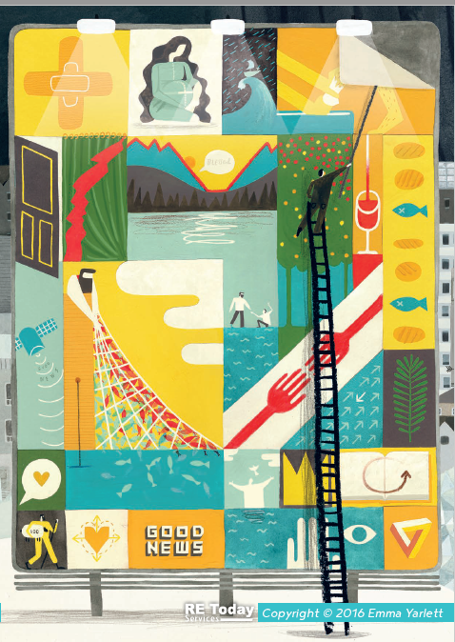


Think: What do people do to show they love someone?





Read this passage from the Bible really carefully. It was a message spoken by Jesus and can be found in the book of Luke in the New Testament of the Bible.

Luke 11:9-10
⁹ So I tell you, ask, and God will give to you. Search, and you will find. Knock, and the door will open for you. ¹⁰ Yes, everyone who asks will receive. The one who searches will find. And everyone who knocks will have the door opened.


- What do you think this passage is about?
- Why did Jesus tell it?
- What do you think this passage teaches Christians about God?
- How might this message be Good News?


Draw an image to represent this Bible passage.


Tell me more about your drawing and choices behind your design.

