Wider Curriculum Home Learning Matrix:
Year 2 Term 3: The Great Fire of London
 | Design | Create | Investigate | Explain/Perform
Science and Computing | In science this term, we are testing everyday materials to see if it is suitable for a specific purpose.  Collect a selection of everyday materials and design an investigation to test a property of these materials.  For example:  Which material is the strongest?  Which material is the most flexible?  Which material is the most waterproof?  Design a way of clearly recording your results. | Once you have the results of your materials investigation:  (For example- ‘I have found out that plastic is the most waterproof material’ )  Now think of a way of using this material which makes the most of this property. | Can you use Venn sorting hoops to sort household materials according to a single property?  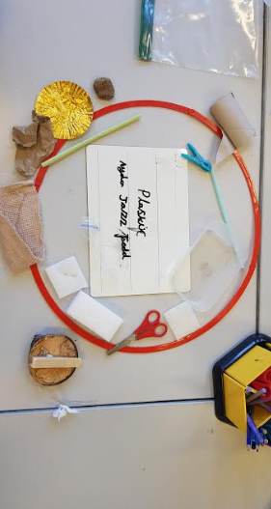  Can you use Venn sorting hoops to sort household materials according to two properties?  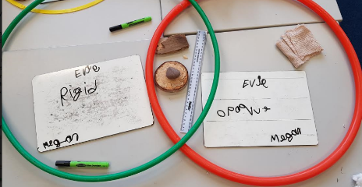 | Explain to a member of your family the meaning of the following material properties:  strong  flexible  rigid  transparent  opaque  waterproof  flammable
Time and Place | After the Great Fire of London, fire insurance was invented. The insurance companies started up fire brigades to fight fires. If people paid money, their houses would be protected by these fire brigades- but only if they had a fire mark on the front of their house.  Imagine you were setting up a fire brigade. What would your fire mark be? | Make a timeline sequencing the main events in the Great Fire of London.  Use the Great Fire of London game to help you  Game - The Great Fire of London | Learn about the Great Fire of London by playing this interactive game.  Game - The Great Fire of London  See if you can answer the following questions:  When was the Great Fire of London?  What caused the Great Fire of London?  How was fire fighting in 1666 different from today?  How was the Great Fire of London brought under control?  How did the Great Fire of London change the city of London? | Explain to someone in your family what you have learned about the Great Fire of London. Think about how you want to present your ideas.  Do you want to say them? If so how will you remember what to say?  Do you want to write them? If so how will you present your work?  Do you want to use pictures or a digital presentation?  It is totally up to you!
Design and the Arts | Design a model of a house from 1666. Think about the materials and building techniques that were used at the time. How will you recreate these using objects and materials that you can find around the house?  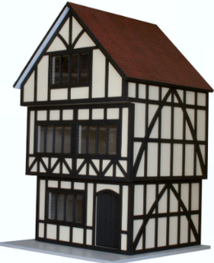 | Once you have designed your house from 1666. Build it! | Follow this link to find a selection of paintings of The Great Fire of London.  History: Picture Gallery - The Great Fire of London and Its Affect of London's Development - Londontopia  What can you learn about the fire from from looking at these paintings? | Follow this link to find a selection of paintings of The Great Fire of London.  History: Picture Gallery - The Great Fire of London and Its Affect of London's Development - Londontopia  These paintings were created by all sorts of different people. Some of them were actually there and saw the fire, others were not there. Some people who painted these pictures were not even born when the fire happened?  With this in mind, find a grown to discuss the following question.  Are paintings a useful way of finding out about the Great Fire of London?
Religion and Values | Activities relating to salvation and gospel | Activities relating to salvation and gospel | Activities relating to salvation and gospel | Activities relating to salvation and gospel
Sport Exercise and Health | This term we are learning to play invasion games. An invasion game is where one team or player tries to get an object (such as a ball or person) into an area (goal for example) defended by another team or player.  Examples of invasion games include:  Football  Netball  Hockey  Rugby  Can you design your own invasion game?  How many players on each team?  What is the pitch like?  What object is used?  What are the goals like?  How does the team attack the goals?  How does the team defend the goals?  What are the rules?  Finally think of a name for your game. | Create a set of rules for the invasion game that you have invented. | Pick an invasion game that you know already. Examples of invasion games include:  Football  Netball  Hockey  Rugby  Use the internet to investigate where these games come from.  Top Tip: You might want to use the word ‘origins’ in your key word search.  This activity will be best completed with the support of an adult. | Explain where an invasion game of your choice started and how it has changes over the years.  You may want to create a timeline to help explain your findings.

