Beech Homework: Term 1: Week 7
(Due in Mon 2nd November)

This week we have been writing action sentences to retell an exciting part of Aaron Becker’s Journey. We are writing about the scene where the girl steals the bird, runs through the airship and releases it.

For your homework, we want you to use simple action sentences to recount what happens in this part of the story.
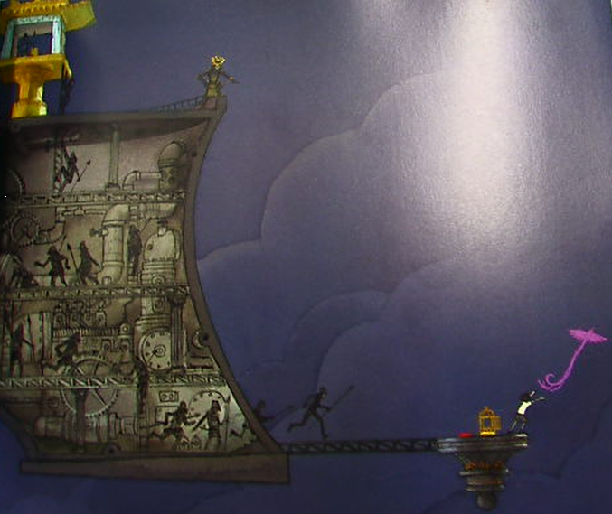
5

4
2
3

1
5
We would like you to write a least one action sentence for each of these five parts of the scene. E.g.

I snatched the golden cage.
The guards chased after me.
I ran though the hallways.
The guards chased me on to a platform.
I released the purple bird.

Extension: Can you use adverbs to add extra detail to your action sentences? E.g.
Sneakily, I snatched the golden cage.

Extension: Can you use the and/but/so/because conjunctions to add extra clauses? E.g.
The guards chased after me so they could get the bird back.

