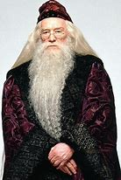
Alfie’s Nonsense Alphabet

A is for Albus Head of Hogworts.
B is for Bottoms hairy and Round.
C is for Clone Troopers marching.
D is for Dinosaurs huge and extinct.
E is for Eggs for my breakfast omelette.
F is for Frogs all slimy and wet.
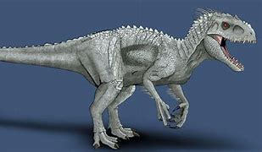
G is for Giants like the BFG.
H is for Hippo’s all muddy and grumpy.
I is for Indominous Rex from Jurassic World.
J is for Jabberwocky with claws that catch.
K is for Kookaburra in the old gum tree.
L is for Lego with endless imagination.
M is for Monsters as scary as can be.
N is for the Nile full of crocodiles.
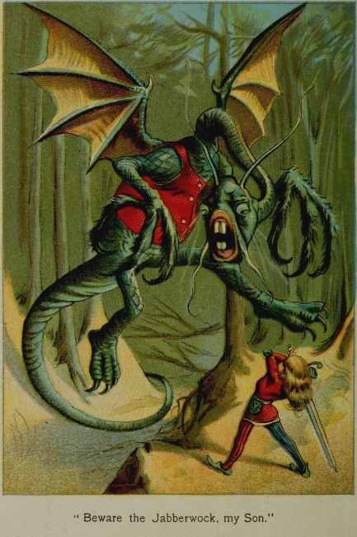
O is for Orangutan swinging from tree to tree.
P is for Pants which my dog like to eat.
Q is for Quest as in the books of Beast Quest.
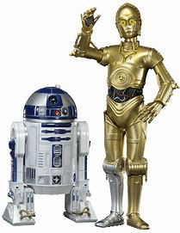
R is for Robots like R2D2.
S is for Sausages my favourite dogs.
T is for Tyrannosaurus Rex king of the dinosaurs.
U is for Udders all dangly and pink.
V is for Voldemort the one with no nose.
W is for Walkers, Imperial walkers.
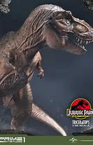
X is for X-ray to check that your bones are not broken.
Y is for Yeti found in the snow.
Z is for Zombies that come out at night.

