Pond Life in Grosvenor and Hilbert Park
By Megan Andre
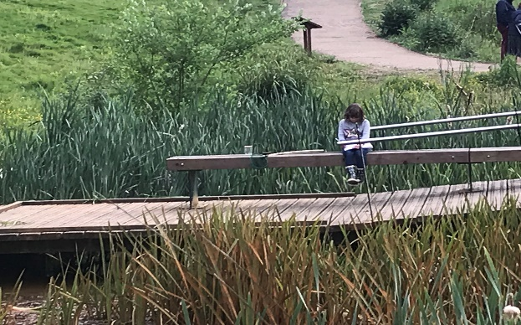
We visited he ponds in the middle of the park.
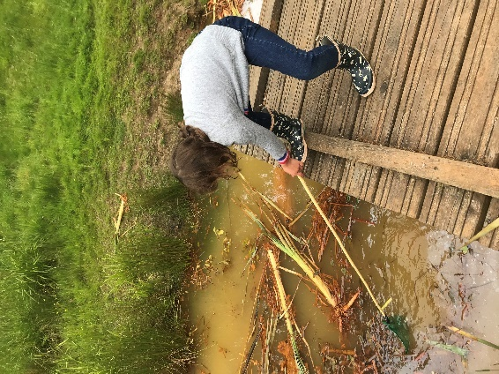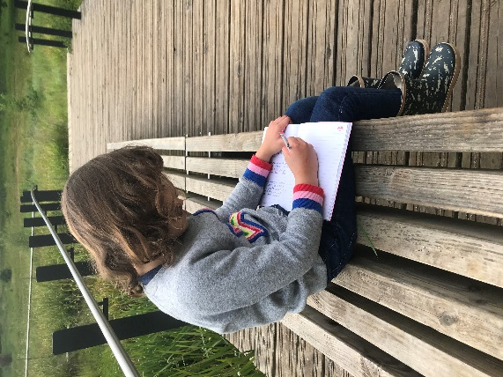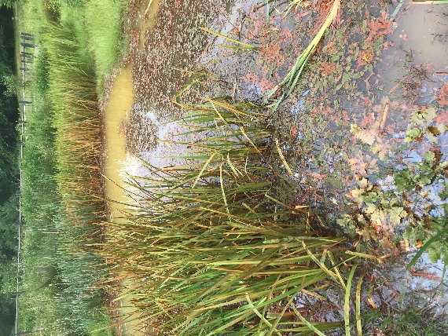
The water is very murky and a little bit red from Ferric iron. Ferric iron is called red water iron because it gives water a cloudy reddish/orange appearance. We took a sample of water in an empty jam jar. The top of the water has an oily texture.
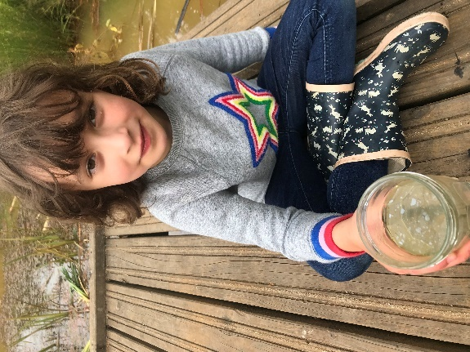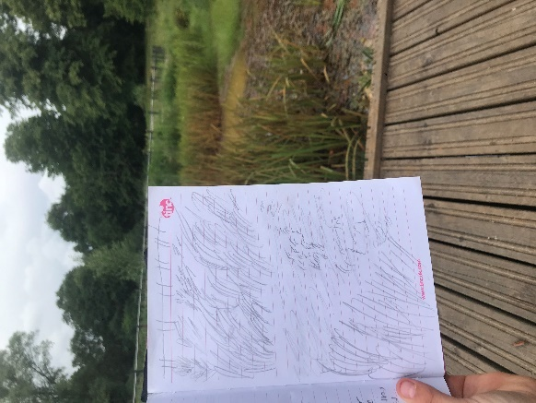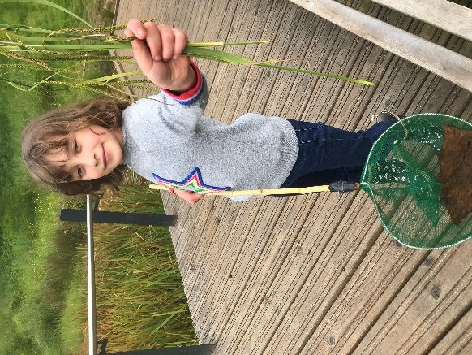
Because it is Spring there is a lot of plant life in and around the water. Lots of animals use the plants to hide in because they can protect themselves from danger of predators.
Sadly, many of the plants have been pulled up by people. I also spotted a lot of litter, bottles and crisp packets left by careless people. This is very bad for the pond life.
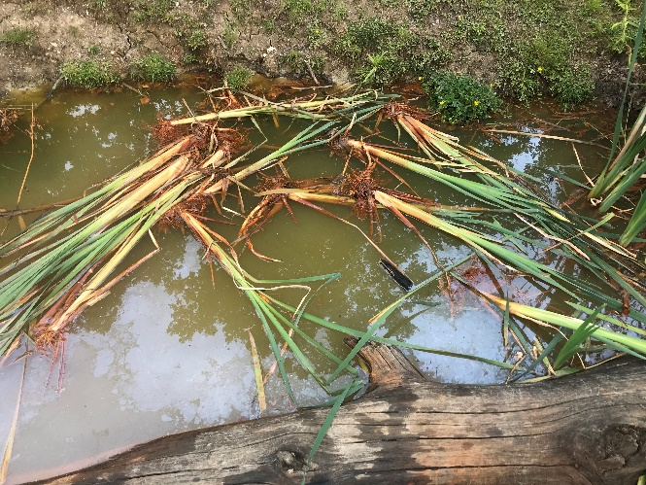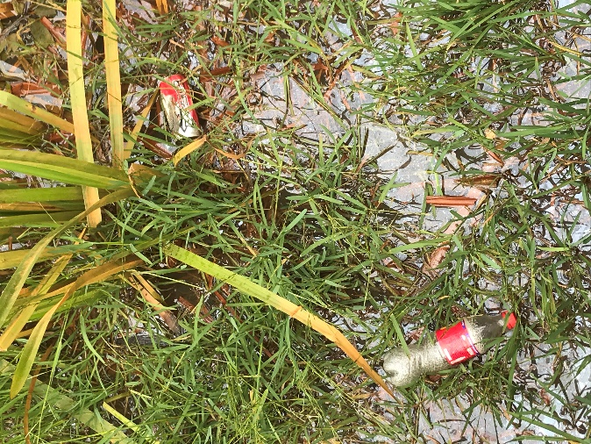

We also visited the big duck pond closer to the road. Here we saw a family of coot’s with cute and fuzzy babies. They build nests in the reeds to protect their eggs from predators.
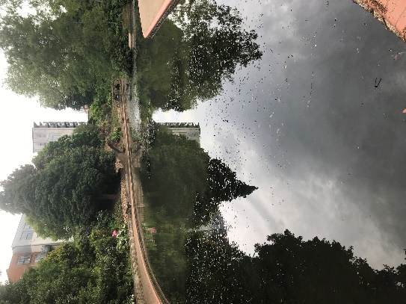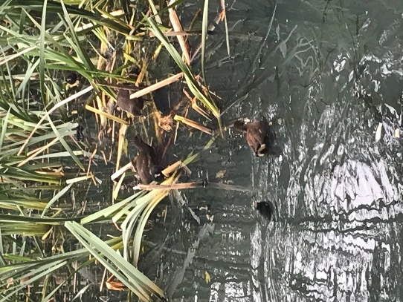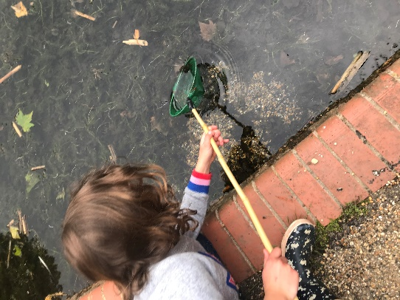

There were lily pads but not frogs!
We saw lots of tiny fish hiding in the pod week. They were too fast to catch!

