My Trip to Brittany
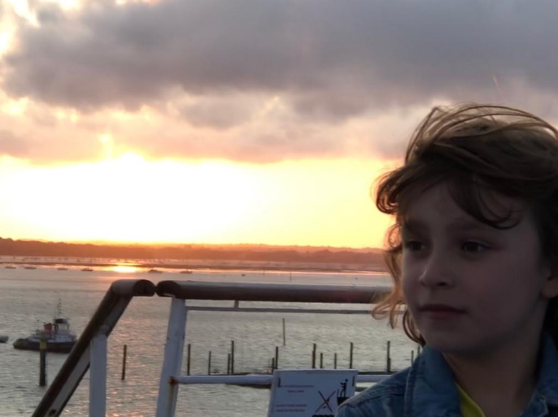

Last summer me and my dad went on a fantastic holiday to see our family in France.
Firstly, my mum packed all my clothes and I gathered my books and my favourite toy. In the afternoon we drove to Portsmouth to catch the ferry. When we arrived at passport control, my passport was missing. I had my mum’s passport and my mum had my passport. What were we going to do? My dad urgently called my mum. Luckily, she drove all the way to bring me my passport. Phew…
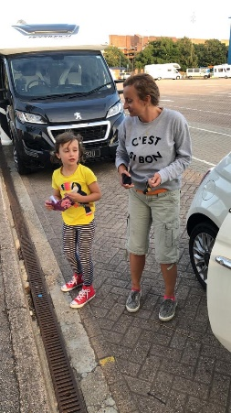
After we got our tickets, it took a while to find our cabin. After we had found it, we went out on to the outside deck to watch the sun set. At 9 o’clock we had delicious fish and chips and a huge piece of disgusting and tasteless chocolate cake. Yuk!
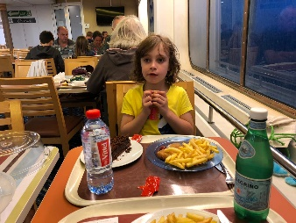
Finally, we went back to our cabin and I got ready for bed.
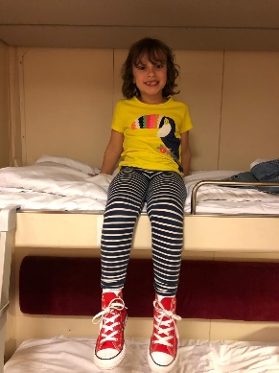

The next morning, we arrived in St Malo and drove to my cousin’s house, just outside St Malo, for a fun holiday.
Over 3 weeks, my cousins and I splashed around in their huge pool and we put up tents and played in them. I was going to sleep in my tent, but I was worried about being bitten by nasty mosquitos. Do they scare you?
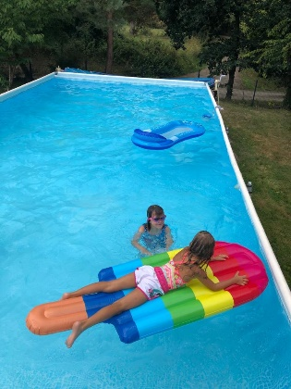
One day we went to the seaside and went on a speed boat called a Rib. We had a very bumpy ride. The boat was very fast, and I was very scared.
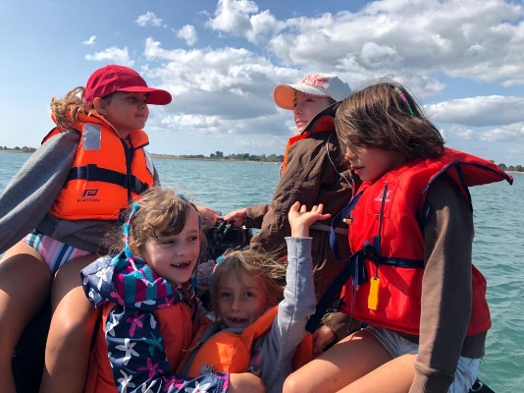
Another time, we went to an amazing water park. I was very frightened of the big slide because it was so high. I went with my Daddy and we went very fast because there were two of us. We landed with a big splash.
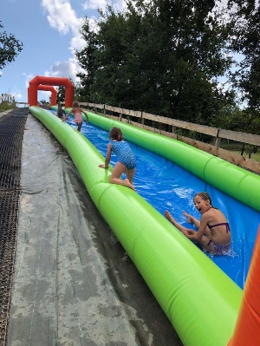
I loved being with my cousins, playing with them every day. What a fantastic trip we had! The best holiday ever! What’s the best trip you have had?


