Supported Independent Group 
Friday 25th January 2019
L.O. To solve division problems.

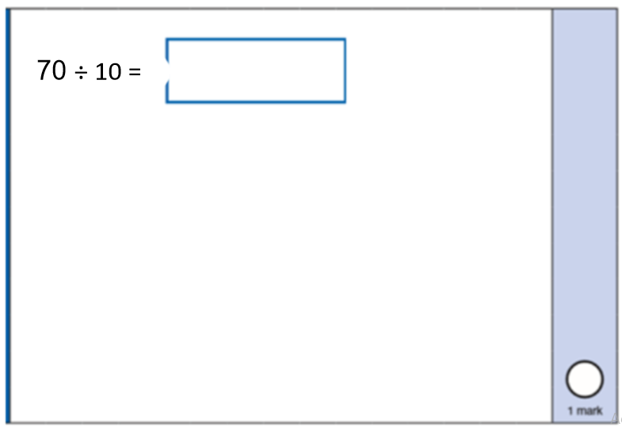 | 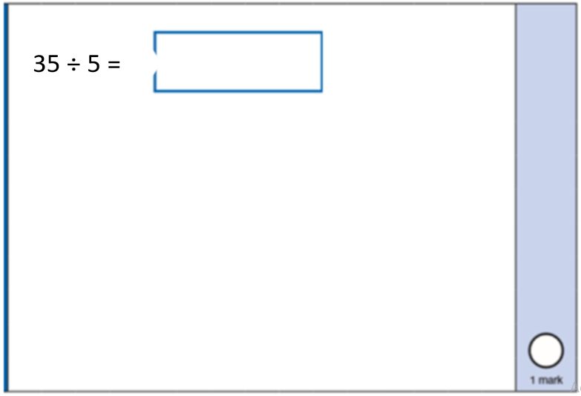
Mr M has 20 socks. He puts them into groups of 2. How many groups does he have?

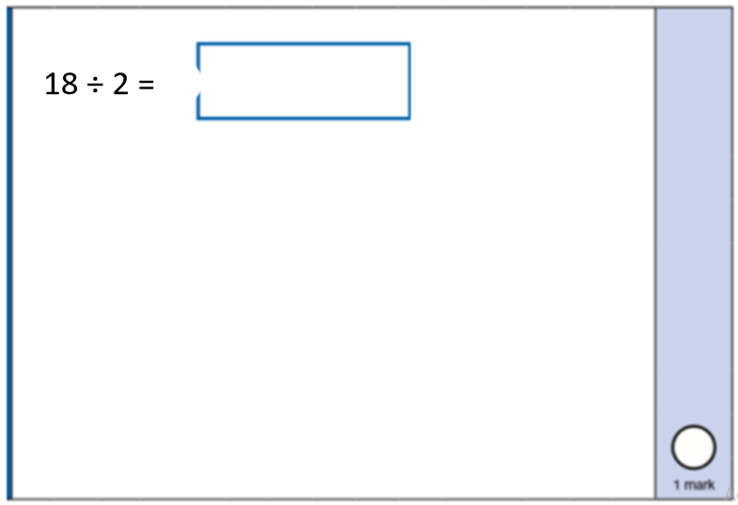 | 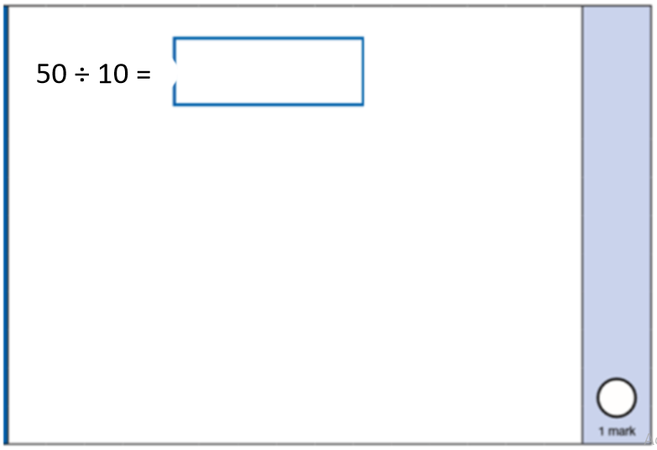
Mrs B has 30 children in the class. She splits them equally onto 5 tables. How many children are on each table?

