Supported Independent Group 
Wednesday 9th January 2018
L.O. To use words and symbols to record equal groups.

Supported Independent Group
Wednesday 9th January 2018
L.O. To use words and symbols to record equal groups.

Supported Independent Group
Wednesday 9th January 2018
L.O. To use words and symbols to record equal groups.

Supported Independent Group
Wednesday 9th January 2018
L.O. To use words and symbols to record equal groups.

Supported Independent Group
Wednesday 9th January 2018
L.O. To use words and symbols to record equal groups.

Supported Independent Group
Wednesday 9th January 2018
L.O. To use words and symbols to record equal groups.

 | 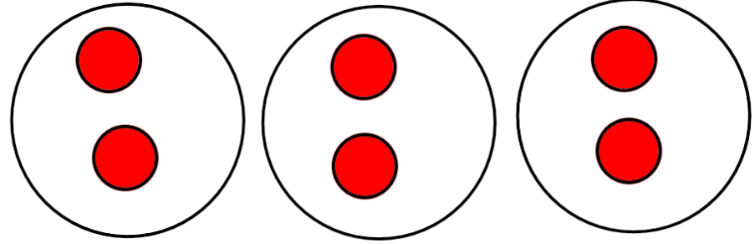
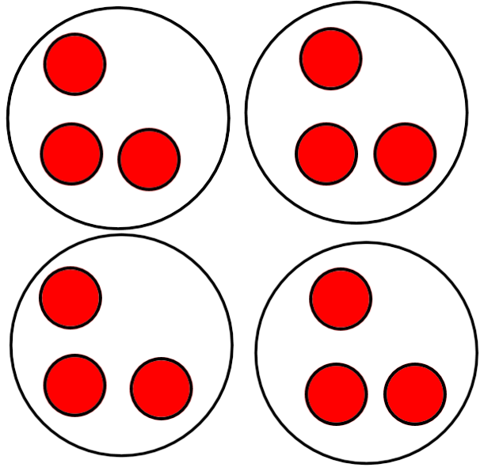 | 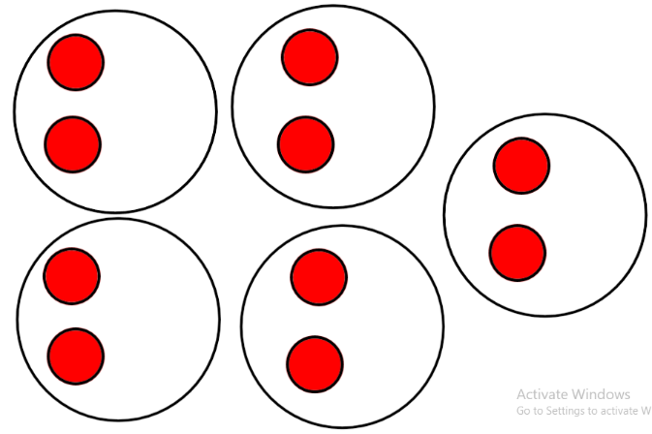
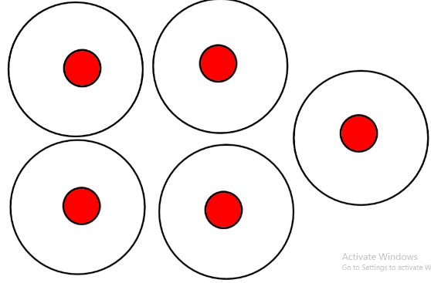 | 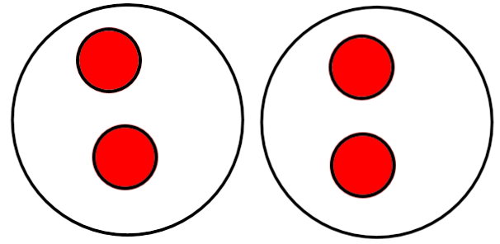
 | 

