Beech Homework: Tuesday 30th October (to be handed in 6th November)

Here is Mr Mackinnon’s half term diary entry. Please read the diary and answer the comprehension questions. If you need help reading the diary, ask a parent or older sibling to help you.

Our Trip to the Zoo
We were driving in the countryside when we saw the sign for the zoo. Carefully, we parked the car and joined the queue. Excitedly, we got our tickets so we could enter the zoo. With our eyes wide open, we walked into the zoo and saw all the amazing animals. In front of me, I spotted a small, beautiful, brown monkey with its baby on her back.
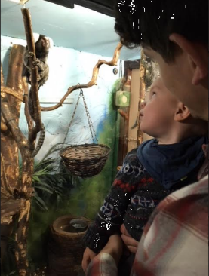
To my left, I identified a large, brown sloth with a smile on his face. My hands trembled with excitement as we rushed from enclosure to enclosure. Slowly but surely, we walked around the zoo because we wanted to see all of the amazing animals.
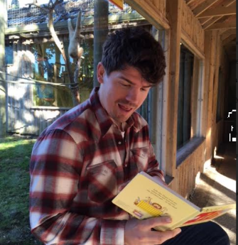
We tried to look in every enclosure but there were too many to see in one day. Eventually, we had to take a rest because we had been walking for so long. With a smile on my face, I read a book about the zoo to my baby Alfred. Behind me, a cheeky, brown monkey swung from tree to tree.
With our legs feeling tired, we left the zoo so we could make it back for Alfred’s naptime. What a fantastic day it was!

Comprehension Questions

1) Where did Mr Mackinnon go?
__________________________________________________________________
2) How did Mr Mackinnon get there?
__________________________________________________________________
3) How did Mr Mackinnon feel as he went into the zoo?
__________________________________________________________________
Pick 2 words or phrases that prove this? One has been done for you:
- “excitedly”
-

4) Name 2 animals that Mr Mackinnon saw at the Zoo.
-
-

5) Mr Mackinnon used the exclamation sentence:

“What a fantastic day it was!”

Pick a different adjective to create your own exclamation sentence to finish his diary entry:

“What a _____________________________________________________ day it was!”

Home Learning Videos
Exciting News! Mr Mackinnon has started making a set of home learning videos. These videos are designed to help children and parents in Beech Class better understand the skills and techniques that we use in the classroom. Here are the videos we have published this week:
-Maths- Number bonds to 10
-Maths- Adding single digit numbers to multiples of 10
-Maths- Bridging through 10
Links to these videos can be found on the Beech Class Blog.

