Here are the skills that I tried to include in my diary entry. I have highlighted some examples of how I have used them in my diary.

I can mix verb tenses to create an ‘interrupted action’ sentence.
I can create ‘simultaneous action’ sentences which show how I was feeling.
I can use the simple past tense to explain what I did.
I can use ‘how’ sentence openers to begin sentences.
I can use ‘where’ sentence openers to begin sentences.
I can use adjectives to create expanded noun phrases.
I can use the and/but/so/because connectives to add clauses.
I can use exclamation sentences.

Our Trip to the Zoo

We were driving in the countryside when we saw the sign for the zoo. Carefully, we parked the car and joined the queue. Excitedly, we got our tickets so we could enter the zoo. With our eyes wide open, we walked into the zoo and saw all the amazing animals. In front of me, I spotted a small, beautiful, brown monkey with its baby on her back.
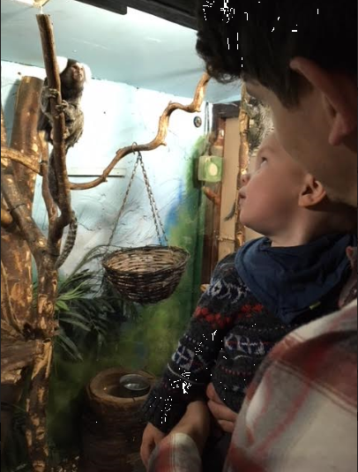
To my left, I identified a large, brown sloth with a smile on his face. My hands trembled with excitement as we rushed from enclosure to enclosure. Slowly but surely, we walked around the zoo because we wanted to see all of the amazing animals.
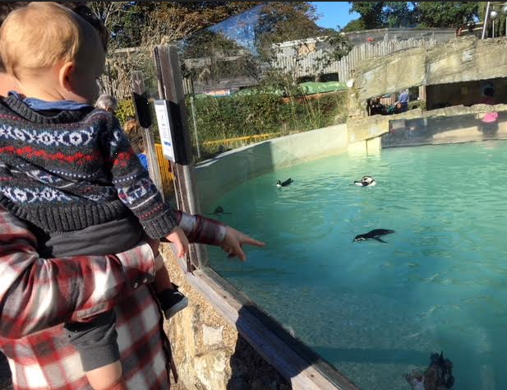
We tried to look in every enclosure but there were too many to see in one day. Eventually, we had to take a rest because we had been walking for so long. With a smile on my face, I read a book about the zoo to my baby Alfred. Behind me, a cheeky, brown monkey swung from tree to tree.
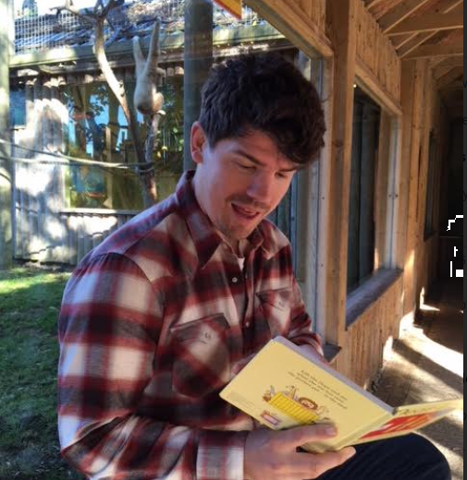
With our legs feeling tired, we left the zoo so we could make it back for Alfred’s naptime. What a fantastic day it was!

