Home Learning Plans
Oak Class
Week Beginning: Monday 23rd March
Reading:
- Read chapters 9-12 of The Boy in the Striped Pyjamas (PDF attached in folder) and answer the questions for each chapter from The Boy in the Striped Pyjamas workbook.
- Complete two of the challenges from The Boy in the Striped Pyjamas challenge cards.
- Complete the non-fiction reading practise paper – answers are included. Check through ONCE YOU HAVE FINISHED to see how you did.
- When completing guided or supported reading of an age appropriate text, focus on factual recall. Use the factual section of this questioning tool to generate questions to ensure that your child has fully understand what they are reading.

For example:
-When did the character go to the shops?
-What did they do next?
-Who is in the shop?
-Where are the characters going?
Spag:
- Complete the KS2 Grammar Test E on spag.com.
- Log on to Purple Mash and complete the spelling ‘2Dos’ which have been selected for you.
- Complete the two spelling activities attached.

Writing: This week we are carrying on with writing our letters home from WW2 evacuees.
- There are several resources for you to use as research:
  - Evacuees PowerPoint
  - Evacuees testimonials
  - https://www.iwm.org.uk/history/the-evacuated-children-of-the-second-world-war
  - https://www.bbc.co.uk/history/ww2peopleswar/categories/c1162/
- Look at the example letter I have written in the folder and think about what grammatical techniques I have used:
  - Interesting vocabulary and punctuation.
  - A mix of sentence styles.
  - Passive voice
  - Emotions
  - Senses – sight, sound, smell, taste and touch.
- Write your own letter home to your mother and include as much of the above as possible. If you like, you could write another letter from a contrasting point of view (if they had an awful time in the first letter, they could be really enjoying themselves in the second letter). Feel free to email the letters to me so I can see how your writing is getting on!

Maths: This week we are recapping our work on area, perimeter and volume and completing our work on ratio and proportion.
- Complete the introductory activity and volume of cuboids activity on Maths with Parents Activities- class code 957389
- Complete the ‘Perimeter’, ‘Area’ and ‘Nets shapes and Volume’ Genius maths reasoning questions.
- Complete the ‘Always, Sometimes, Never’ worksheet.
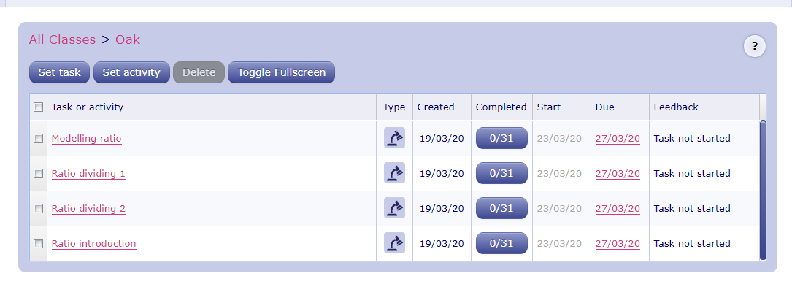
- Log on to MyMaths- https://www.mymaths.co.uk/ Complete the following MyMaths activities

Wider Curriculum
- Pick activities of your choice from the Wider Curriculum Home Learning Matrix.

