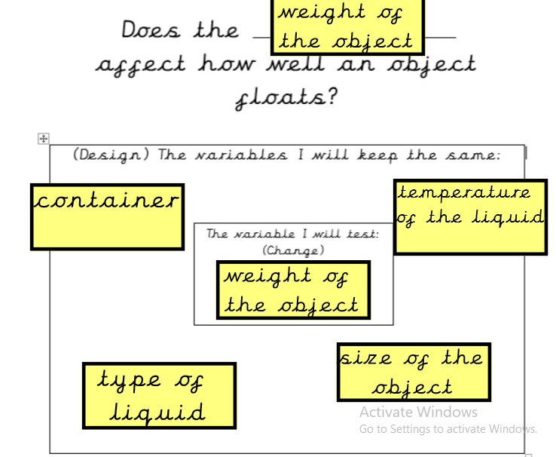

Method
I will add a stone into the bottle, place it in the water and observe it to see if it floats or sinks.
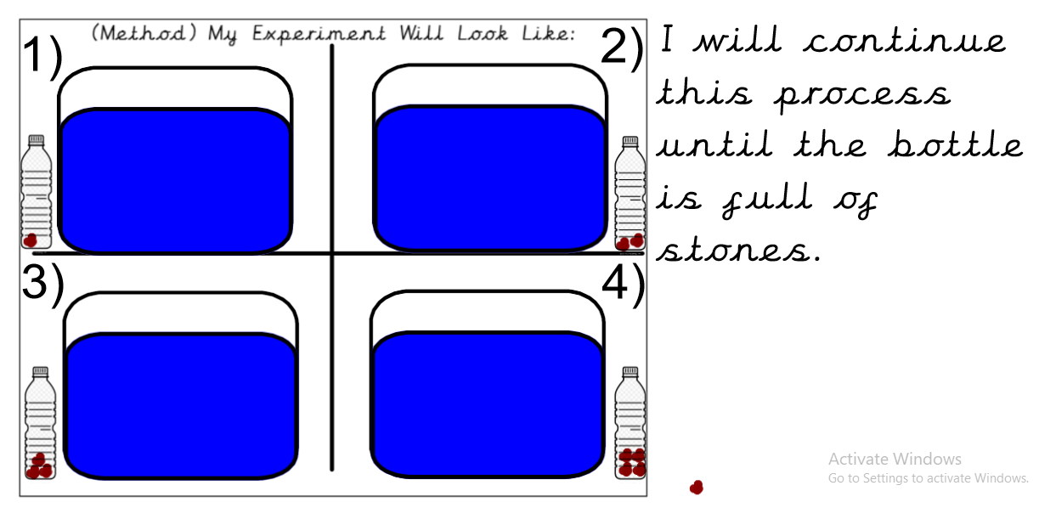

I will measure:
I will observe the bottle and determine if it is floating or not. I will record my findings in a table.

Prediction
I predict that the weight of an object will affect how well it floats. I think that if you put enough stones into the bottle, its weight will increase so that it becomes negatively buoyant. When this happens, the bottle will sink. I predict it will take approximately 5 stones for this to happen.

Results
Number of Stones | Did it float?
1 | Yes
2 | Yes
3 | Yes
4 | Yes
5 | Yes
6 | Yes
7 | Yes
8 | Yes
9 | Yes/No
10 | No
11 | No
12 | No

Conclusion
I spotted a clear pattern in my results. When there were less than 9 stones in the bottle, it floated. When there were more than 9 stones in the bottle, it sank. Therefore, I can conclude that the weight of an object does affect how well it floats.

These results occurred because the weight of the bottle increased each time a stone was added. Initially the weight of the bottle was less than the weight of the water displaced by the bottle. Therefore, the bottle was positively buoyant and floated. However, by the time that 10 stones were added to the bottle, the weight of the bottle was greater than the weight of the water it displaced. Therefore the bottle was negatively buoyant and sank.

I stopped the investigation after 12 stones even though the bottle was not full. I did this because I knew that there was no way that the bottle could be made positively buoyant by adding more weight to it.

I did identify one unusual/anomalous piece of data. When 9 stones were added, the bottle remained suspended underwater but did not sink to the bottom. I believe this occurred because the weight of 9 stones was equal to the weight of the water that the bottle displaced. Therefore the bottle was neutrally buoyant.

Evaluation

I believe that I created a fair test. I changed only one variable and worked hard to keep all the other variables the same. However, there were a few occasions where variables which were designed to remain constant were slightly changed. The temperature of the water increased steadily throughout the investigation because it was a sunny day. Also, there were times when the size and shape of the bottle changed because I squeezed it when I was closing the lid. In order to make my investigation more fair, I would try to keep these variables constant.

I believe that the observations that I made were accurate. However, perhaps I could have made my investigation better by measuring amounts of sand rather than using stones. This would have ensured that the weight of the bottle increased by the same amount each time.

The findings from my results will be useful in the real world because it could help people to design things that float- like boats for example. My advice would be, if you want your boat to remain positively buoyant and float, try to make it weigh as little as possible,

