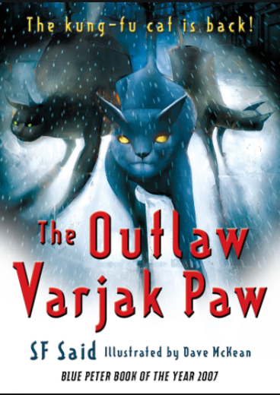
CHAPTERS 5 AND 6
P44 What does ‘gawped’ mean?

P46 How were the people moving along the pavements?

P47 How does the author describe the 3 cats?

P47 What are their names?

P50 Why do you think the Scratch Sisters stopped when they heard Varjak’s name?

P51 What is your impression of the Scratch Sisters?

P55 How are Mrs Moggs’ group of cats different from Sally Bones’s gang and the Scratch Sisters?

P58 Why do you think Old Buckley doesn’t sound impressed by Varjak?

P59 What made the atmosphere change?

P60 Where does Mrs Moggs say Sally Bones may have come from originally?

P61 How many of the Bones gang appeared in the harbour. You can use the exact words from the text.

P61 Who does Mrs Moggs think they are after?

P62 Which word is used to describe the panic? What does it mean?

P63 What is the effect of using the words ‘roughest, toughest’?

