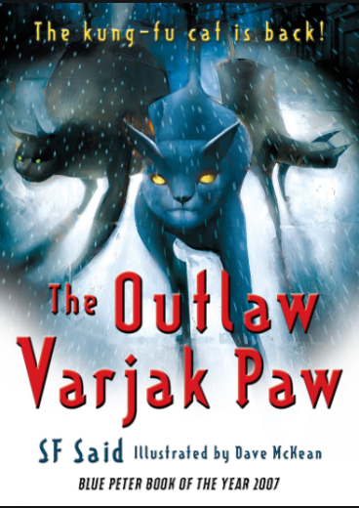
CHAPTER 3 AND CHAPTER 4
QUESTIONS
P31 What does the word neon tell you about the scene in the streets?

P32 ‘We’ll lie low’ - what does this phrase mean?

P33 Why doesn’t Cludge have a family?

P33 What does the word ‘neutral’ mean?

P34 ‘Holly shimmed past the rubble’ - what does that tell us about her movement?

P34 and 35 - How would you describe Cludge’s character based on these 2 pages. Try to think of at least 3 adjectives.

P36 What might Sally Bones’s punishment be?

P37 Who is Mrs Moggs and what does she say?

P40 Where are Varjak and Jalal?

P41 How does Jalal describe Varjak when he refers to his first trip to Mesopotamia?

P42 ‘sheer faces’ - what does this tell you about the mountain?

P42 What could Jalal be trying to tell Varjak?

