MAKING A WHOLE FROM DECIMALS - REASONING
Refresh your memory by asking yourself these questions:
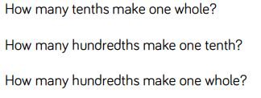

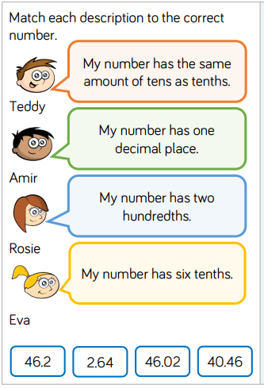
USE YOUR UNDERSTANDING OF MAKING A WHOLE TO TACKLE THESE REASONING TASKS!


