MAKING A WHOLE FROM DECIMALS
Refresh your memory by asking yourself these questions:
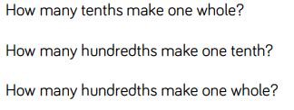
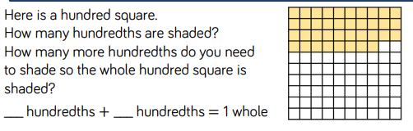
Next, practise making a whole by adding tenths and hundreds.
Colour in the first lot of tenths and hundredths in one colour. Colour in the rest in another colour. Then write down the number sentence you have represented.
- 0.87 + ? = 1 whole
- 0.34 + ? = 1 whole
- 0.09 + ? = 1 whole
- 0.5 + ? = 1 whole
- 0.22 + ? = 1 whole
- 0.99 + ? = 1 whole


