DIVIDE 2 DIGITS BY 10
This follows on from the work you did last week - dividing 1 digit by 10
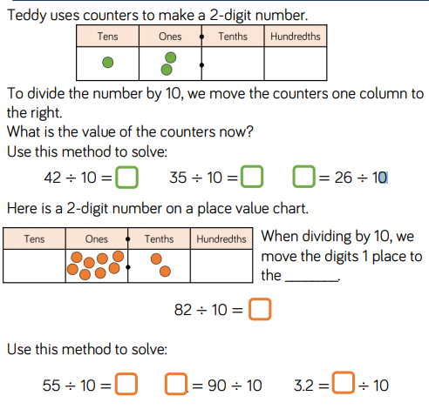
Now try this reasoning exercise – try out a range of numbers to prove or disprove your idea!



