Anglo Saxon Food and Drink

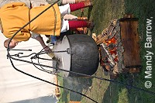
The Anglo-Saxons loved eating and drinking and would often have feasts in the Hall. The food was cooked over the fire in the middle of the house; meat was roasted and eaten with bread.
They drank ale and mead - a kind of beer made sweet with honey - from great goblets and drinking horns.
After the feast a minstrel would play a harp and sing songs of battles and heroes.
Anglo-Saxons ate what they grew.
They grew
- cereals - Wheat and rye for bread, barley for brewing and oats for animal food and porridge.
- vegetables - carrots, parsnip, cabbages, peas, beans and onions.
- fruit - such as apples, cherries and plums
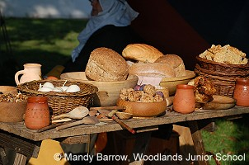
Exotic foods such as potatoes, tomatoes, bananas, pineapples - fruits and vegetables of the New World, were unknown to the Anglo-Saxons.
Drink
Barley was used to make weak beer, which was drunk instead of water. River water was often polluted. wine was imported from the Mediterranean but only drunk by the very rich.
Most Anglo-Saxons were vegetarians because they could not get meat very often. Wild animals such as deer and wild boar were common but could only be killed by the people who owned the land. Only a few Anglo-Saxons were wealthy enough to pay for a slaughter of an animal.
Animals
Pigs were important for food because they produce large litters, which would quickly mature and be ready for slaughter. They were the only animals reared just for their meat. Every other kind of animal served other purposes and were only killed when they became old or ill. Sheep were reared for their wool and meat. Cows were used for their milk and, when they were old, for hides, meat and glue. All animal fat was valuable for making oils for lamps.
Fish
The Anglo-Saxons ate fish which they caught in the rivers and the seas.

