Wider Curriculum Home Learning Matrix: (2 Weeks)
Weeks Beginning: 4th and 11th May
Friday 8th May is a very important day, it marks the 75th Anniversary of VE Day. We invite all members of the St Barnabas Community to learn about VE Day and take part in the VE Day 75th Anniversary ‘Stay at Home Street Party’. As well as your regular wider curriculum activities, we have added some VE Day specific activities on to this planning grid.
You can give your child a quick introduction to VE Day by watching the following video: https://app.parentpay.com/PPProfile/Activation/Activated.aspx?activationToken=leOeqahF%2bku48gfPtRrAoJzaf6%2fd%2fdmQhMl5GcH2BpnY

 | Create | Investigate | Explain | Perform
Science and Computing | Since the end of WWII, graphic designers and artists have created a variety of posters to celebrate VE Day.   Use a digital designing tool such as publisher to create a poster to celebrate the 75th Anniversary of VE day. | Simple test – What happens when we chew food?  What do you think happens to bread when we place it in our mouths?  Chew some bread for a minute (do not swallow). Stop chewing and think about what is the liquid that has mixed in with the food. Leave the ball of food in your mouth for three minute and then observe its taste. It should have become sweeter as saliva contains a chemical (an enzyme, salivary amylase) which digests food to a sugar. This is a chemical change. Swallow the chewed food and immediately eat another piece of bread. The sweetness should be easier to detect now. | Introducing the whole digestive system  http://www.e-learningforkids.org/Courses/Liquid_Animation/Body_Parts/Digestive_System/  The link above is an animation. See what happens to Lenny’s burger once he has eaten it. This will introduce the main parts of the digestive system and their functions.  The video below is animation of the digestive system; explaining the processes with the correct scientific terminology:  http://www.bbc.co.uk/learningzone/clips/the-digestive-system/4180.html  Use this to help you create diagram of the digestive system with the key features labelled | Drama/modelling – Acting out the digestive system  Ask one person to act as food while others form a line, each of them holding a label of one of the parts of the body involved in digestion:  - The food is chewed up in the mouth (i.e. the chain of children begin to break up)  - Digestive juices lubricate the food and break it down further  - The stomach will secrete gastric juices that contain hydrochloric acid and the enzyme peptin to break down the proteins.  - The small intestine produces enzymes that break down the food further.  - As the food passes along the small intestine into the large intestine the products of digestion are absorbed into the body.  - In the colon excess water is reabsorbed.  - The remaining material passes into the rectum where it is stored until ready to passed out of the body
Time and Place | On the Morning of the 8th May 1945, many people woke up and discovered the war was over by reading the newspaper.  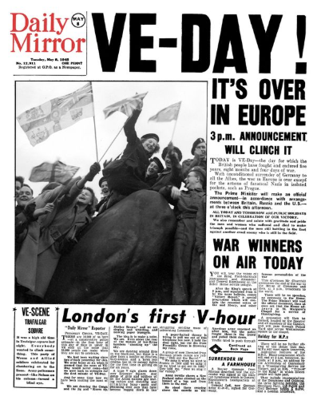  Design your newspaper front cover for 8th May 1945. | Use secondary sources of information to investigate World War II. Pay particular attention to the way that the war ended. | Use your knowledge of WWII to answer the question:  What is VE Day and why do we still celebrate it today? | On 8th May 1945 the Prime Minister, Winston Churchill, addressed the nation. Listen to his speech. Can you learn a section of his speech and perform it as part of your very own ‘Stay at Home Street Party’.
Design and the Arts | Create your own piece of art inspired by Henry Moore’s shelter drawings.  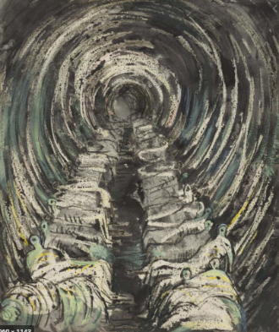 | The War Artists Advisory Committee (WAAC) was established in 1939. Find out about this organisation and answer the question: Why was the British Government interested in art during a time of war?  The following web page might be useful in answering this question:  https://www.iwm.org.uk/history/the-secret-purpose-of-the-war-artists-advisory-committee | Research Henry Moore’s shelter drawings. What can you learn about the reality of spending time in a bomb shelter from examining Moore’s drawings? | Set up a bomb shelter scene in your house. Sketch what you see in the style of Henry Moore.
Religion and Values | Create a collage of all the things you think are special in the world and that we should be looking after. | Hindus believe in the idea of BRAHMAN - God in everything  Learn more about this using this link and then take the quiz!  https://www.bbc.co.uk/bitesize/topics/zh86n39 | Explain how belief in BRAHMAN might affect the way a Hindu chooses to live - remember it is the belief that there is a spark of God in everything, very much like ‘soul’. | Share the song ‘Colours of the wind’ from the Disney film Pocahontas: https://www.youtube.com/watch?v=O9MvdMqKvpU  Think about what the message is behind the song in relation to your work on BRAHMAN
Sport Exercise and Health | Think about the wartime phrase ‘make do and mend’. Create your own recipe based on the ingredients you are able to find at the moment. | Investigate the kind of food that was eaten in Britain around the time of VE Day. There are many websites to search. This one has a huge range of recipes:  https://the1940sexperiment.com/100-wartime-recipes/ | Explain your recipe from the ‘create’ section to members of your family. Were you inspired by any of the wartime recipes you investigated? Did you manage to create something that had a good balance of nutrients? | Dances such as the swing were very popular in the 1940s. See if you can master some of the moves and show your family! Perhaps perform for them at your VE Day home picnic.
Outdoor Learning | Use the RSPB website to research bird feeders. See if you can make one or design your own.  https://www.rspb.org.uk/fun-and-learning/for-teachers/lesson-plans-and-supporting-resources/food-and-water-for-nature/ | When you get the chance to go for a walk, take the RSPB Spot It sheet with you and see how many birds and mammals you can identify. | Explain what birds need at this time of year and why | Choose a few of the birds you managed to identify on your walk. Research the calls they make and see if you can imitate them. Can your family tell which bird you are trying to mimic?

