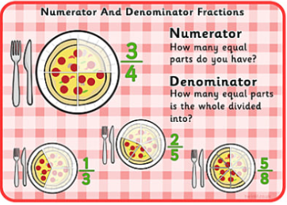
Label the numerator and denominator
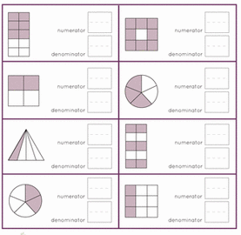
Can you think of your own way of remembering the correct names for the parts of the fraction?
A fraction has 2 parts.
The bottom number is the DENOMINATOR – it tells you how many EQUAL parts something is divided into.
The top number is the NUMERATOR – it tells you how many of the parts have been selected.
EXAMPLE: A cake has been cut into 8 pieces and 3 have been taken.
The NUMERATOR will be 3 and the DENOMINATOR will be 8 – The fraction is ⅜

