Home Learning Plans
Maple Class

Week Beginning: Monday 20th April
I hope you have had a lovely Easter. In the Summer Term, Maple Class’ topic is ‘Cool Britannia’, an exploration of the country we live in. A lot of our learning will be based around exploring Great Britain.
75 years ago the second world war ended. It was one of the most important celebrations our country has ever had. So, on Friday 8th May, we would like to encourage all members of our school community to join in the VE Day 75th Anniversary Celebrations by taking part in the ‘Stay at Home Street Party’. We would like to encourage everyone to decorate their homes in red, white and blue and have a celebratory picnic in their garden. We will encourage people to take photographs of their party and send them into the school so we can put them on to our website and various social media outlets. I do hope you can find ways to enjoy this important celebration of life in Britain and I am looking forward to seeing how we commemorate it.
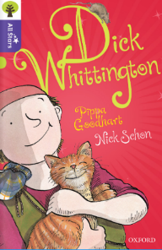
Reading:
Carrying on with whole class reading, please go to the Oxford Owls webpage https://www.oxfordowl.co.uk/ login through the ‘My Class Login’ button.
Username: st barnabas maple (make sure you leave spaces)
Password: Books
Find the book, ‘Dick Whittington’ written by Pippa Goodheart, illustrated by Nick Schon. It is a version of a traditional story based on a real historical character.
If you have problems logging in, there is a copy of chapter one in the week three folder.
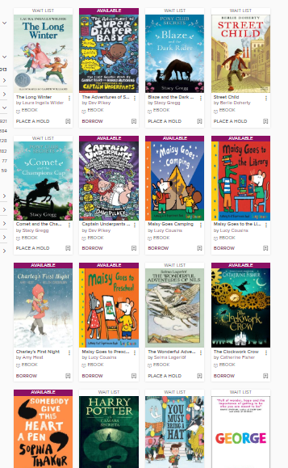
On Monday, either listen to chapter one by pressing the play button, or read the story to your child. Pause and help if there are any words or ideas your child does not understand. There is a chapter one glossary in the week three folder.
On Tuesday, ask your child to read the story to you. Help them if they get stuck.
On Wednesday, complete the comprehension, ‘Streets Paved with Gold’.
On Thursday and Friday, read your own book for pleasure.

Remember, if you enjoy David Walliams, you can hear him read some of his own stories at https://www.worldofdavidwalliams.com/elevenses/
If you have a copy of the book, read along.

Kent Libraries have a great selection of books to read online or to listen along to. You can sign up for free at https://kent.spydus.co.uk/cgi-bin/spydus.exe/MSGTRN/OPAC/JOIN
Some books you need to wait for but there are loads available now. Here is a picture of some children’s books they have.

Spelling
- First, use the, Look Say Cover Write Check, resource. Many of these words have suffixes (word endings) that are –ure or –tion. Remember that –ti- can make a ‘sh’ sound. When you are feeling confident logon to Purple Mash, there is a to do: Y3 SUM1 WK1-quiz.

Writing
- Our country is called, ‘The United Kingdom of Great Britain and Northern Ireland’ it is made of four countries: England, Scotland, Wales and Northern Ireland. First, complete the ‘Countries-of-the-United-Kingdom-Labelling-Activity-Sheet’. Choose one of the four countries and try to find out a bit more about it by using the internet or asking a grown-up. Do you have any family that lives there? Have you ever been there? What is its capital city? What is its flower or plant symbol? Can you find out about a famous place in that country?
- Write a short description of the country (England, Scotland, Wales or Northern Ireland) you chose. Use bullet points but remember you still need capital letters and full stops.

Maths: This week we are continuing to learn about fractions
- Log on to Maths with Parents and complete the ordering fractions activity
- Log on to Purple Mash and complete the maths ‘2Dos’ about equivalent fractions
- Try the equivalent fractions worksheets

Wider Curriculum
- Pick activities of your choice from the Wider Curriculum Home Learning Matrix.

