Mr Macrae’s Woodland Flower Walk
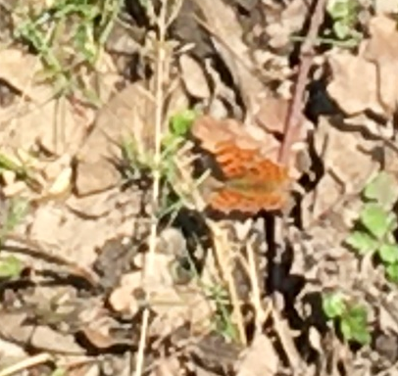
I have been going out once a day to walk my dog. I am lucky because there are some woods near my house. I have seen lots of interesting things, like a silver washed fritillary butterfly, which is the first butterfly I have seen this year. I also saw a humming-bird hawk moth.
Challenge: Try to find out about these two creatures.
I have also seen a lot of flowers that you can find in woodland. Match up the pictures of flowers with their names. You could ask a grown up for help, or research them on the internet if you don’t know them.
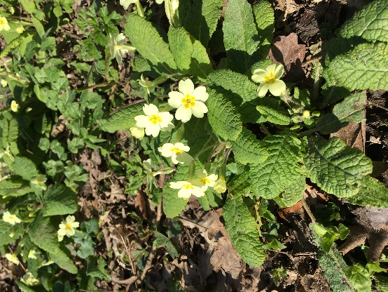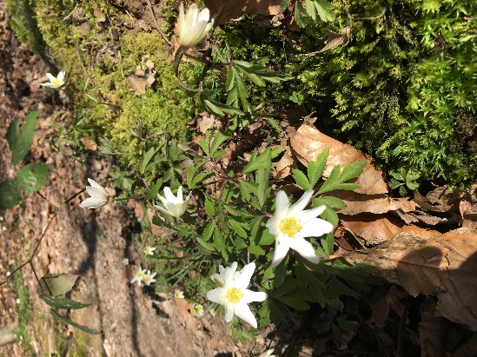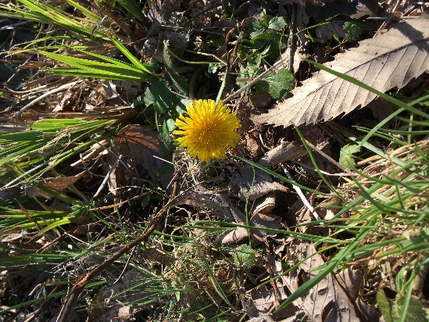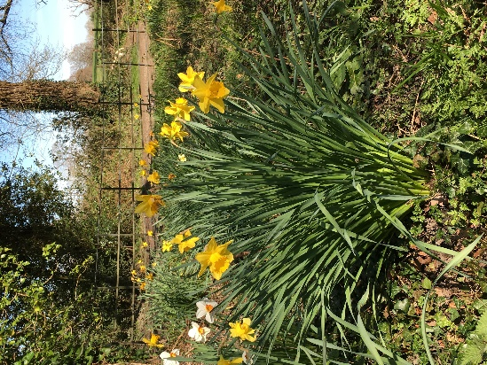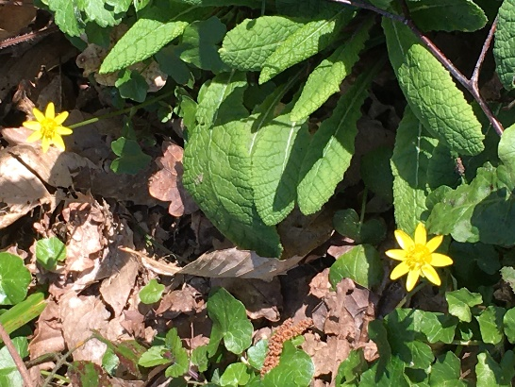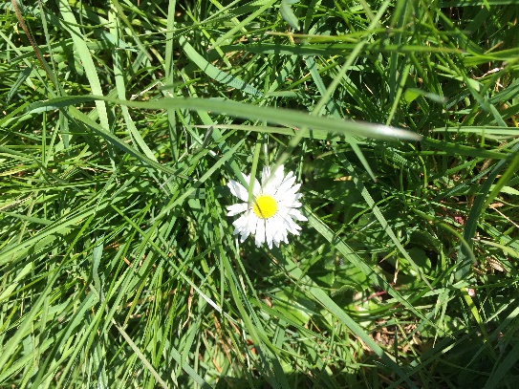
The Flowers are, Lesser Celandine, Daffodil, Primrose, Dandelion, Wood Anemone, and Daisy.
Challenge: Pick one flower and find out more about it. Draw a picture, find out when it appears.
I will share the flowers I find after Easter. Do you think they will be the same?

