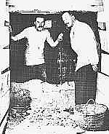
Tutankhamen’s Treasure Found
By H.V. Morton, Archaeology correspondent
This week, it has been revealed that the missing tomb of Tutankhamen, an Egyptian Pharaoh who died more than three thousand years ago, has been discovered.
The Famous Egyptologist and the Earl
The discovery was made by renowned researcher Howard Carter along with the support of Lord Carnarvon. After carefully searching the dusty Valley of the Kings in Egypt’s baking desert for over two years, Howard Carter’s team made the discovery of a passageway leading down to a hidden tomb. Along with Lord Carnarvon and his daughter, Lady Evelyn Herbert, Howard Carter found a door that had remained locked for thousands of years. He broke a small hole in the sealed door, and shining an electric torch through the hole, he peered through. When Lord Carnarvon asked him what he saw, he replied, “Wonderful things!”
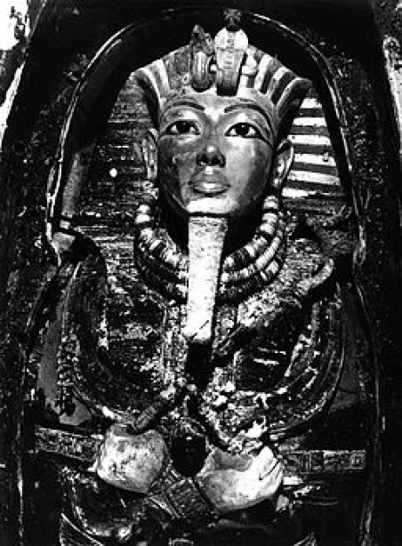
The Treasure in the Tomb
It was Lady Evelyn who, because she was limber enough to squeeze through the narrow space, was the first to fully understand the wonder that was inside the tomb. Howard Carter and his team are still sorting through all the things they found. However, among the most important are the boy king’s sarcophagus and death mask. Made of gold and studded with precious stones, it has hieroglyphic carvings of protective spells and is topped with carvings of a cobra and a vulture. It is certainly one of the most beautiful things any archaeologist has ever found. Along with the mask, the tomb contained a senet board so the Pharaoh could enjoy playing a board game in the afterlife, a solid gold coffin, thrones, archery bows, trumpets, food, wine, sandals, and fresh linen underwear! It seems the dead king was prepared for anything! There will be a display of the treasures visiting Britain in the New Year.

