Home Learning Plans
Beech Class
Week Beginning: Monday 13th July
Reading:
- This Wednesday, at 9:30am, we will use Google Meet to continue our class story. We will be reading Chapters 9 and 10 of Matilda. We will send out a parent-pay message with a link, which you can use to join our meeting. (Alternatively, you can watch a recorded version of Chapters 9 and 10 on the school YouTube channel.)
- Unfortunately, these will be the final chapters that we read live and post on YouTube. You all now have a copy of Matilda at home (If you have not yet managed to collect your copy- we will do our best to arrange delivery). Please read the remaining chapters at home over the summer holidays. Pester your parents and persuade them to read the chapters aloud. Who knows, you might even persuade them to do the voices!
- Sign up for this year’s Summer Reading Challenge. It started on Friday 5 June and runs throughout the summer holidays, finishing at the end of September. It is aimed at children aged 4 – 11 and is completely free! The challenge features games, quizzes and downloadable activities to incentivise and encourage children and their families to take part in reading related activities at home. Children can choose their own reading goals, create book reviews, play games and collect virtual rewards. Parents and guardians can register their children online at www.sillysquad.org.uk
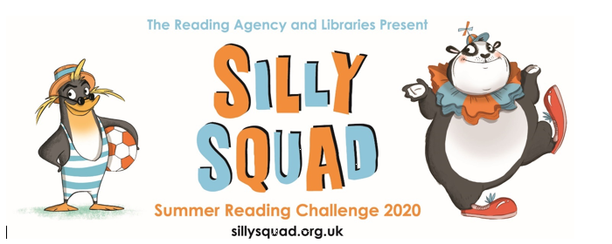

- Visit the Oxford Owl website. https://www.oxfordowl.co.uk/ Click on the My Class Login section
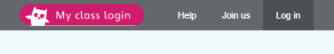
Use the following details to log in to the newly created beech class section.
Username: beechclass101
Password: pupil
Click on the ‘My Bookshelf’ section and select reading books that are right for you. Use the ‘Age Groups’ section to help narrow down the search.

- When completing guided or supported reading of an age appropriate text, focus on predictive questioning. Use the predictive section of this questioning tool to generate questions that challenge your child to predict what will happened in the story.

For example:
-What might happen next?
-Who could come with them?
-Where should they go?

Spelling/Grammar:
- Log on to Purple Mash and complete the spelling/grammar ‘2Dos’ which have been selected for you.
-Adverbs Quiz
-Apostrophes
-Noun Suffixes

Writing:
For the last few weeks of the term, we are going to focus on our new class book, Matilda.
- Reread or listen to Chapter 7 of Matilda: Miss Honey
- In this chapter, Matilda goes to school for the very first time. This week we want you to write a diary extract from the point of view of somebody in Matilda’s new class. You might like to choose:
-Matilda
-Miss Honey
-Lavender
-Nigel
- Imagine that you have just got back from school and are writing in your diary. Write in the first person and use the past tense.
- Before you start writing, ask yourself the following questions and record your ideas using bullet points on the planning sheet provided.
-What was it like when you entered the classroom?
-How did you feel as the first lesson began?
-Did anything unusual happen?
-How did this make you feel?
-What are your thoughts about going back to school tomorrow?
- Try to begin your writing with an ‘interrupted action’ sentence. Make sure you include a ‘show not tell’ sentence somewhere in your writing. You may also like to include some direct speech. If you need help using any of these techniques, re-watch the learning videos from week 13.
- Think of an interesting way to end your writing. Perhaps you could use an exclamation sentence to add extra emphasis.
- When your writing is complete, send it in to the class email address so we can read it, give you feedback and maybe even add it to the class blog.

Maths:
This week we are going to focus on selecting an efficient method for completing addition calculations.
- Watch the ‘Methods of Addition’ learning video.
- Examine the 2017 KS1 SATs arithmetic paper. Highlight all the questions that involve using addition. Talk through each of these questions with an adult and discuss which is the most efficient method of addition for solving each problem.
- Use and apply your addition skills to answer all of the addition questions in the 2017 Arithmetic paper. Make sure you use an efficient method and record your thinking where appropriate.
- If you need help on any of the questions or would like to check your answers, watch the ‘2017 Arithmetic Addition Questions’ learning video. In this video, I have modelled what I believe to be the most efficient way of calculating each addition problem in this paper. Please feel free to skip through sections in which you are already confident.
- If you would like any help or advice on a specific question, please do not hesitate to contact us via the class email address.
- We have added a range of addition MyMaths activities. If you wish to practise your addition skills, please select from the following:
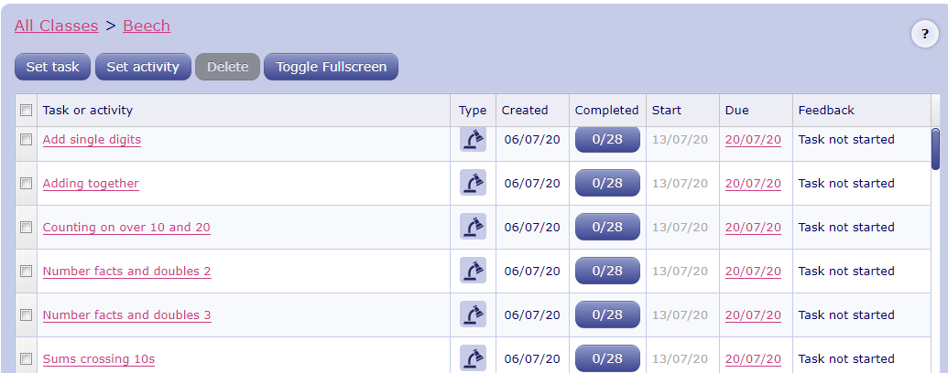

Number Fluency:
This week we are going to explore a calculation technique that we have not looked at yet in Year 2- it is called the ‘Nasty Nines’ method.
- Watch the ‘Nasty Nines’ learning video.
- Play the ‘Nasty Nines’ game as modelled in the learning video.
- Use this method to complete the addition and subtraction calculations on the ‘Nasty Nines Arithmetic’ activity. Make sure you use the ‘Nasty Nines’ method.
Wider Curriculum
- Pick activities of your choice from the Wider Curriculum Matrix. This is the final Wider Curriculum Matrix of the school year. If you are looking for extra activities over the summer holidays, why not revisit some of the previous Home Learning Matrixes and pick out activities that you missed. Alternatively, you can check out the Summer Challenge activities that will be posted onto the school website from July 22nd.
Well done for all the hard work that you have put in over the last 14 weeks of home learning. We are looking forward to seeing you back in September!

