Home Learning Plans
Beech Class
Week Beginning: Monday 29th June
Reading:
- This Wednesday, at 9:30am, we will use Google Meet to continue our class story. We will be reading Chapters 5 and 6 of Matilda. We will send out a parent-pay message with a link, which you can use to join our meeting. (Alternatively, you can watch a recorded version of Chapters 5 and 6 on the school you tube channel.)

- Complete the reading comprehension questions for Chapters 5 and 6 of Matilda.

- Sign up for this year’s Summer Reading Challenge. It started on Friday 5 June and runs throughout the summer holidays, finishing at the end of September. It is aimed at children aged 4 – 11 and is completely free! The challenge features games, quizzes and downloadable activities to incentivise and encourage children and their families to take part in reading related activities at home. Children can choose their own reading goals, create book reviews, play games and collect virtual rewards. Parents and guardians can register their children online at www.sillysquad.org.uk
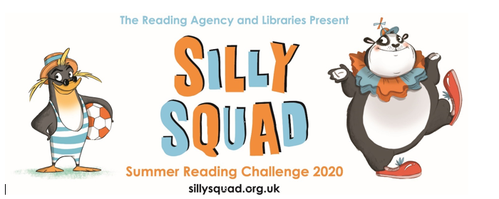

- Visit the Oxford Owl website. https://www.oxfordowl.co.uk/ Click on the My Class Login section

Use the following details to log in to the newly created beech class section.
Username: beechclass101
Password: pupil
Click on the ‘My Bookshelf’ section and select reading books that are right for you. Use the ‘Age Groups’ section to help narrow down the search.

- When completing guided or supported reading of an age appropriate text, focus on application/synthesis questioning. Use the application/synthesis section of this questioning tool to generate questions that challenge your child to apply their understanding and synthesise what has happened in the story so far.

- For example:
- -Why should they do that?
- -Why might they not want to do that?
- -How might the character feel here?

Spelling:
- Log on to Purple Mash and complete the spelling ‘2Dos’ which have been selected for you.

Writing: For the last few weeks of the term, we are going to focus on our new class book, Matilda.
- Reread or listen to Chapters 3 and 4 of Matilda.
- In these chapters, Matilda plays two separate tricks on her family: ‘The Hat and The Superglue’ and ‘The Ghost.’ Pick one of these tricks to work on for the next couple of activities.
- Split a piece of paper into 6 sections or use the ‘Matilda Story Board’ sheet. Pick the 6 most important moments in the trick of your choice and use pictures to record them on your story board.
- Watch the ‘Story Board and Sentence Construction’ learning video.
- For each section of your story board, write a simple sentence to accompany it written in the third person.

Matilda put glue around the rim of Mr Wormwood’s hat.

- Up-level each sentence you have written by using an adverbial sentence opener to begin each of the sentences you have created. If you are not sure how to do this, re-watch the ‘Story Board and Sentence Construction’ learning video.
Now all of your sentences should look something like this:

Just before Mr Wormwood left for work, Matilda put glue around the rim of his hat.

- Once you have completed all six sentences, please send them into us so we can read them and give you some feedback.
- If you are looking for an extra challenge, you can use a new piece of paper or ‘Story Board’ sheet to plan your own trick. You could either plan a trick for Matilda to play on her family or you could even plan a trick to play on your own family. (Please don’t actually play the trick on them. Remember- it is just a plan!)
Maths:
This week we are going to continue to work on addition and subtraction. We are going to play particular attention to the concept of Finding the Difference.
- Watch the ‘Finding the Difference’ learning video.
- Complete the ‘Finding the Difference on a Number-line’ activity.
- Watch the ‘Empty Box Calculation’ learning video.
- Use the skills that you have been working on over the last two weeks to solve the problems presented in the ‘Empty Box Calculation Stories’ worksheet.
- Once you are feeling really confident at using this skill, you can have a go at the following my MyMaths activity:
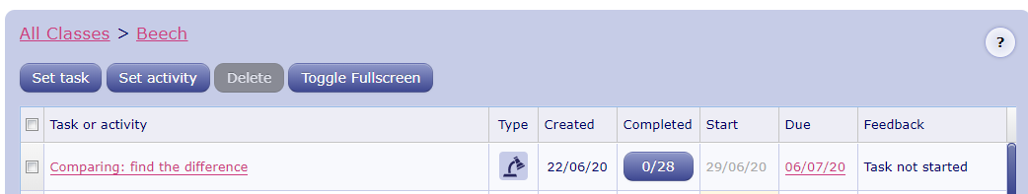

Number Fluency: This week we are going to use and apply our doubling and halving skills to calculate with efficiency.
IMPORTANT: This technique will only be useful if you are already fluent at doubling and halving the numbers up to 20. If you are not fluent at this skill yet, go and complete the Number Fluency activities detailed in the Week 11 plans.
- Watch the ‘Near Doubles’ learning video.
- Use the ‘Near Doubles’ cards to practise using this skill to calculate with efficiency.
- Use the ‘Near Double Cards’ to efficiently solve each near double arithmetic problem.
- Create your own near double arithmetic problems by following these instructions:
-Pick a number between 1 and 10- this is your first addend e.g. 7
-Pick another number which is 1 greater or 1 less than you first addend. This is your second addend. e.g. 6
-Use your near doubling skills to add these addends together efficiently.
e.g. 6 + 7 =
Wider Curriculum
- Pick activities of your choice from the wider curriculum matrix.

