Wider Curriculum Home Learning Matrix: Class (2 Weeks)
Weeks Beginning: 29th June and 6th July
 | Create | Investigate | Explain | Perform
Science and Computing | Make a new tune for Twinkle Twinkle Little Star.  Using PurpleMash, open the 2Sequence file ‘Twinkle, Twinkle’  Let’s make it a bit more exciting!  Choose different instruments and select where you would add them.  Can you change the tempo?  Are there any instruments or sound effects (SFX) which will help the tune to sound like twinkling stars? | Think about a favourite cartoon or film you have watched. Sometimes the music is loud or quiet depending on what is happening. Sometimes the music can make you feel very happy or very sad.  How are you feeling today? Can you use sounds to show one of these feelings? Which sounds would you choose to let people know you are happy?  Play some of the sounds and choose some to make a happy tune.  Would the happy tune be slow or fast? Try the tune at different tempos; which one makes you feel happiest?  Can you create your own happy and sad tunes? | Create your own soundtrack for a film or cartoon you have seen, or can you think of your own idea for a film or cartoon and make a soundtrack for that.  Go back to the Sounds section at the bottom of the screen and from this section select My Sounds. You will see a blank box with a big plus sign waiting for you to add their own selection of sounds.  Clicking on the plus sign will show a bank of sounds to choose from and the drop-down menu with a selection of even more sounds to choose from!  Click on a sound to choose it. Explore, listening to the sounds and choosing ones they think will be useful for your soundtrack. | Using the soundtrack you have created can you add your voice to create a performance?  Go back to the My Sounds section and select the plus sign, select the Record button.  You will now be able to record for 15 seconds. This could be your own voice or your own sound effect using instruments.  When you have recorded your sound, selecting Done will add the sound to your My Sounds section and the Sound icon will appear as a microphone. Only one sound can be recorded. Recording a second sound will overwrite the first.
Time and Place | Create a Yes/No diagram like the one Selvi and Chloe made last year.  (Photo at the bottom of this document)  Pick 5 creatures that you know live in a local habitat. Draw or find photos of them. Alternatively, you could pick 5 creatures from the ‘Animals for YES NO diagram’ sheet.  Use red arrows to represent NO and green arrows to represent YES.  Use YES or NO questions to categorise and then sub-categorise your 5 creatures, | Investigate different types of sorting diagrams.  -Venn Diagrams  -Carroll Diagrams  Can you sort your 5 creatures using either of these types of sorting diagram? | Explain to a member of your family how your sorting diagram works. | Teach a family member how to use a sorting diagram of your choice to sort creatures from a local habitat.
Design and the Arts | Blue and white ceramic tiles with geometric patterns are a very popular in Vietnam.  Create your own blue and white geometric tile design. Here is Mr M’s from last year:  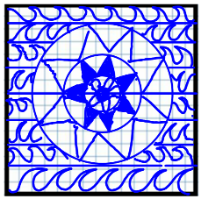 | Create several copies of your design. You could photo and print them or copy them out by hand.  Experiment with the orientation and arrangement of your tiles. e.g.  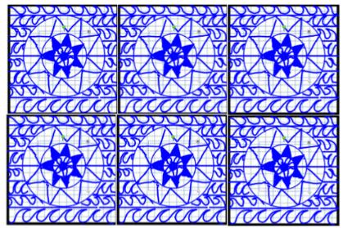  Which arrangement is most effective? Why? | Discuss your tile/arrangement with a member of your family.  Ask them what they like about it.  Ask them how it could be improved. | Use the feedback provided from discussion with your family to redesign and improve your tile/arrangement of tiles.
Religion and Values | Design a welcome booklet or create a welcome pack for a new member of our class or school. | Investigate the story of Ruth and Naomi  https://www.youtube.com/watch?v=UTZjvMzXQs4  Instead of going home after her husband had died, Ruth decided to go with her mother-in-law Naomi. She said “I will go where you go, your people will be my people and your God, my God”. Ruth chose to belong with Naomi.  What does this story tell us about where Ruth felt her home was?  What do you think home means?  Is it a place, a feeling or the people around you?  Extension: Investigate the flag of Israel and the Star of David. | Explore the main features of the synagogue using the PowerPoint provided.  You can also watch the BBC clip ‘In the Synagogue’ https://www.bbc.co.uk/bitesize/ clips/z834wmn  Explain what you have learned to a member of your family. | Perform the story of Ruth to your family. You could make paper puppets to act out the story.
Sport Exercise and Health | Make your own Da Cau ball/shuttlecock.  What materials will you use?  How can you make it stay in the air for longer? | What is Da Cau?  Watch this video to find out:  https://www.youtube.com/ watch?v=rVpYqBDE1aQ | Write instructions on how to play Da Cau. | Play a game of Da Cau at home.  What will you use for the shuttlecock?  What will you use for the net?  How can you change the game to make it easier for beginners?
Outdoor Learning | Create a slogan to help remind people of how to stay safe in the sun.  Use your slogan on a poster to promote sun safety. | Investigate the different ways of staying safe in the sun.  Watch this video to help:  https://www.bbc.co.uk/cbeebies/watch/sun-safety-for-kids | Explain to a member of your family what they should do to keep themselves safe in the sun. | Perform a play with members of your family to help identify the dangers of the sun.



